Agenda AGM / Paddler of the Year Awards and
club presentations of major trips Monday 23rd October 2023

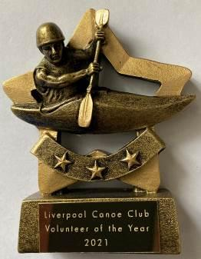
Location – Victoria Memorial Club, Church Road, Garston, Liverpool L19 2LW

7:30 – 8:00 pm – Catch up with Members - Slideshow of the club`s activities over the year.
Liverpool Canoe Club is open to all and aims "to provide the maximum canoeing and kayaking opportunities for all its members".

8:00 – 8:20 pm - AGM (Election of Club Officials, Paddler of the Year, Members Motions)
Welcome from the chair & review of the year.
1. Apologies for Absence.
Apologies – Frankie Annan, John Cooke, Craig Ford, Karl Tattum, Mike & Cameron Fletcher, Carol Atkinson, Martin Connolly, Josie Moss, Josh Cook, Andy Garland
Attending-Keith Steer, James Gerrie, Mike McCarthy, Roy McHale, Mark Benson, Martin Sinnott, Carl Leungs, Miles, Steve Bond, Richard Clews, Amy Newnham, Andy Bond, Christine Bond, Roger Coleman, Ian Bell, Paul Harwood, Harvey Harwood, Calum Cook, Benjamin Cook, Norman Cook, Aaron Jackon, Ian Bibby, Dave Lynch, John Allerton, Ian O’ Connor, Nick Coughlin, Eamon Hanlon, Liz, Courtney, Maddison Hanlon, Harry Ruggles, Jim Duffy, Alex Peacock, Rachel Peacock, David Gould, Paul Goetzee, Brian Green, Chris Marsden, Mark Garrod, Jack Garrod, Dom Fahey, Hugh Mantle, Adya Misra

2. Minutes of the previous AGM – Click here • Signed as a true record by the Chair • Matters arising.

3. Honorary Treasurers report Online Year End Accounts – Click here

4. Members Survey – Analysis of the responses given by Keith S

5. Brief reports from each discipline (2 minutes each)

6. Members motions – Please email any member’s motions (two emails please from the proposer and seconder) that require a LCC constitution change.

Proposer: Richard Clews, Seconded: Roy McHale
Introduction of full-time student membership and introduction of a 1 session trial (if a guest of a current member). Club members may bring a guest for a session after agreement with session leader if they take full responsibility regarding medical history, next of kin contact details etc. Several particulars to be ironed out to put this in place and the Stewardship group to take forward. Motion carried by all present

7. Members Questions – Please email any questions about the club, its organisation or its activities. (5 minutes max given to this item). None received.

8. Chair to thank all the volunteers that have coordinated and guided the club over the past year, especially those that have given up their time to run sessions for its members. Members are reminded that volunteers give their time freely to try and get as many people on the water as possible.

9. Election of Officers – Proposed list of those willing to stand for 2023 – 2024 (To be confirmed during the meeting with a vote from those present)
List of Officers Proposer: Chris Marsden, Seconded: Kevin/Rich Clews Motion carried by all present
Chair – Roy McHale
Vice-Chair – Gary Edwards
Secretary – Adya Misra
Honorary Treasurer and Grants– Craig Ford (Subject to confirmation of the auditing process going forward)
Membership Secretary, Volunteer & Safety Coordinator – Keith Steer (Subject to confirmation of the auditing process going forward)
Lead Safeguarding Coordinator – Amy Newnham
Assistant Safeguarding Coordinator Carol Atkinson
Junior / Youth Coordinator –Richard Clews
Coaching Coordinator – Keith Steer
Compound and Boat Maintenance Coordinator - Alex Peacock
“Discipline Coordinators” to develop a team to help develop the discipline within the club:
Canoe Polo Coordinator – Callum Cook
Sea Kayaking Coordinator – Ian Bell
White Water Coordinator– Harry Ruggles
Freestyle Coordinator –- Paul Harwood
Surf Coordinator – Karl Tattum
SUP Coordinator –Natasha Darling
Inland Touring Coordinator – Carl Leungs
Paddle-Ability Coordinator –- Chris Marsden
Open Boat Coordinator – Nikki Aldridge
Kayak Safety Cover Coordinator – Jim Duffy
Racing Coordinator – Colin Smith
Stewardship group members without specific responsibilities – (up to 5 members to represent the wider membership)
Mark Benson, John Allerton, James Gerrie, Martin Sinnott

8:20 to 8:45pm
10. Paddler of the Year Awards presented by the chair.
2023 Paddler of the Year- Eamon Hanlon
2023 Young Paddler of the Year- Hattie Goetzee
2023 Volunteer of the Year-Amy Newnham

8:45 to 9:30pm – Presentations from this year’s Club trips to Ireland and the French Alps

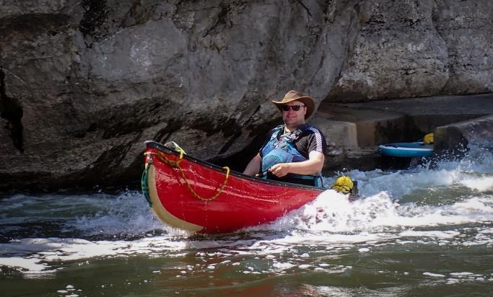  Multiday Open Canoe Trip to Massif Central | 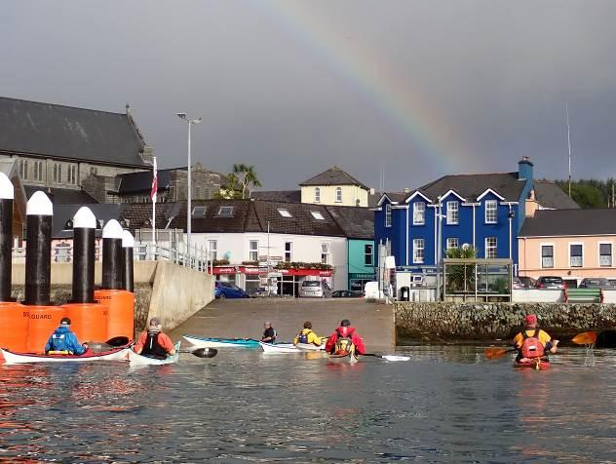  Celtic Sea Kayaking Trip (West Coast of Ireland) | 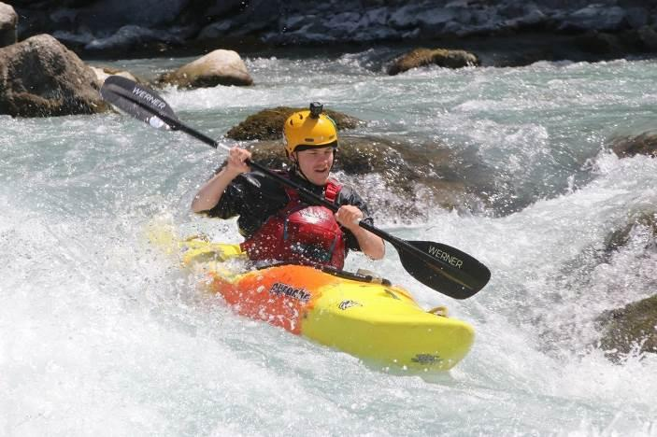  French Alps – Club Alpine Holiday

