Agenda AGM / Paddler of the Year Awards and
club presentations of major trips Wednesday 19th October 2022

Location – Liverpool Marina – Spinnaker Suite main conference room (Access from the bar)
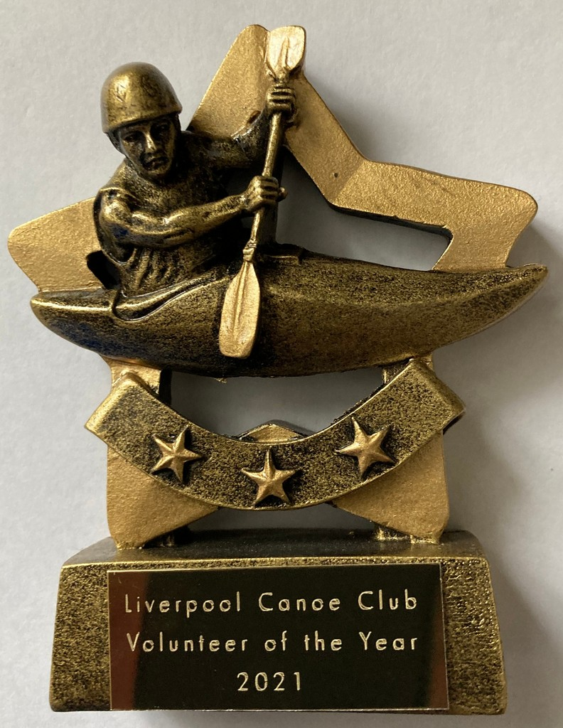
Apologies – Frankie Annan, Carole and Pete Thomas, Julie Brookes, Ken Johnson, Karl Tattum, Anthony Brockway, Sharon Walters, Craig Ford, Dave Lynch, Roger Colman, Josh Cook, Josie Moss

7:30 – 8:00 pm – Catch up with Members in the bar or enjoy a meal at the Marina - Slideshow of the club`s activities over the year.
Liverpool Canoe Club is open to all and aims "to provide the maximum canoeing and kayaking opportunities for all its members".

8:00 – 8:20 pm - AGM (Election of Club Officials, Paddler of the Year, Members Motions)
Welcome from the chair & review of the year
1. Apologies for Absence.
2. Minutes of the previous AGM – Click here • Signed as a true record by the Chair • Matters arising.
3. Treasurers report Online Year End Accounts – Click here
4. Brief reports from each discipline (2 minutes each)
5. Members motions – Please email any member’s motions (two emails please from the proposer and seconder) that require an LCC constitution change.
Members Questions – Please email any questions about the club, its organisation or its activities. (5 minutes max given to this item)
- With recent theft and arson attacks at other clubs can the Committee reassure members that Liverpool Canoe Club has valid and appropriate insurance cover? Roger
6. Chair to thank all the volunteers that have coordinated and guided the club over the past year especially those that have given up their time to run sessions for its members. Members are reminded that volunteers give their time freely to try and get as many people on the water as possible.
7. Election of Officers – Proposed list of those willing to stand for 2022 – 2023

Chair – Fiona Barry Andy Garland
Vice Chair - Roy McHale
Secretary – Carole Thomas
Treasurer and Grants– Craig Ford
Membership Secretary, Volunteer & Safety Coordinator – Keith Steer
Lead Safeguarding Coordinator – Sharon Walters
Assistant Safeguarding Coordinators – Amy Newnham, Lindsay Devine
News Coordinator – Mike Alter
Publicity Coordinator – Pete Thomas Notice boards Coordinator –Carl Leungs
Junior / Youth Coordinator –Richard Clews
Coaching Coordinator – Dave Reynolds Adya Misra
Kingsway pool Coordinator Monday / Thursday – Martin Sinnott [Team - Stuart Conway; Nick Coughlin; Richard Clews; Martin Eley; Dave Reynolds & Keith Steer; Roger Colman, David Allanson]
“Discipline Coordinators” to advise members/act as a point of contact:
Canoe Polo Coordinator – Callum Cook
Junior Canoe Polo Coordinator – Josh Cook
Sea Kayaking Coordinator – Ian Bell assisted by Roger Coleman
White Water Coordinator– John Cooke, John Allerton, Dave and Fiona Gentle
Freestyle Coordinator –- Harvey Harwood
Open Boat Coordinator –Mike Alter and Ruth Edwards Nikki Aldridge
Kayak Safety Cover – Jim Duffy
Slalom Coordinator – TBC
Racing Coordinator – Colin Smith
Surf Coordinator –Karl Tattum and Paul Harwood
SOT Coordinator – Julie Brookes
SUP Coordinator – Adya Misra John Fay
Inland Touring Coordinator – John Fay David Hendry

Compound and Boat Maintenance Coordinator - Craig Ellingham & Alex Peacock Steve Alcock? Dominic Fahey (Kingsway)

Stewardship group members without specific responsibilities- Martin Sinnott, Josie Moss, Mark Benson, Steve Bond and Richard Clews. Paul Harwood, Dave Reynolds,

8:20 to 8:45pm
8. Paddler of the Year Awards presented by the chair.

2022 Nominations for Paddler of the Year
Richard Clews, Tim Haines, Paul Harwood, Harry Ruggles & Craig Stoba

2022 Nominations for Young Paddler of the Year
Elliot Bold, Poppy Clews, Laura Evans, Luke Evans, Harvey Harwood & Marcus Smith

2022 Nominations for Volunteer of the Year
Richard Clews, Josh Cook, Kevin Corcoran, Dave and Fiona Gentle, David Hendry, Chris Marsden, Adya Misra & Martin Sinnott

8:45 to 9:30pm – Presentations from this year’s Club trips to Shetland Isles and the French Alps

