Stewardship group meeting 8pm
Monday, 7 July 2025 ⋅20:00 – 21:30
At the Marina.
The agenda will be finalised by Adya / Roy but if you have any items please send details to: chair@liverpoolcanoeclub.co.uk / secretary@liverpoolcanoeclub.co.uk

1/ Purchase of 4x Pyranha Rebels from Miles Bradshaw junior kayaks for £200 each– Action KS - Completed
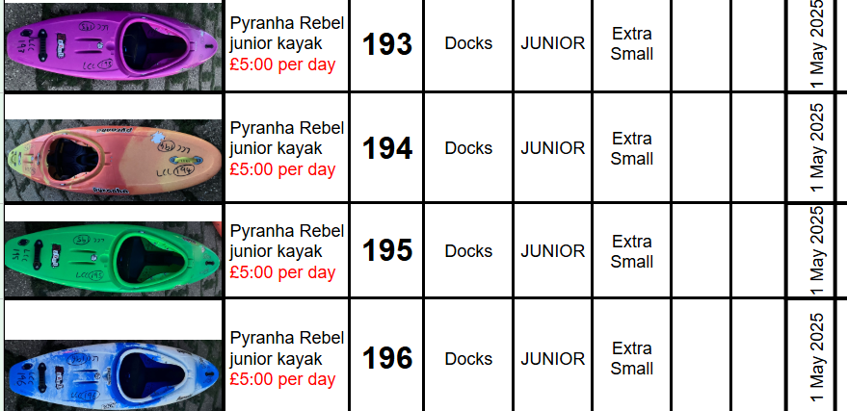
2/ Do we need new boats? eg sea kayaks? – Action Ian B / KS
3/ 10 x Larger / XL BA for the polo team – Action Callum C
4/ LCC Club Paddlefest – for club members and their guests only. – Completed – Review?
5/ Club messaging system going forward. What is the plan? Action KS – Completed and working well but needs incorporating into 3 year plan and other systems retired / deleted!
6/ Club Development Plan 2-3 year plan needed rather than last minute agenda points. Club Log?
7/ PUK standards for deployment update? Where do we stand? Review 7/7/25
Richrd and Amy - Work towards Paddle UK standard operating procedures
End 2026
Encourage more club group leaders to get a coaching award
Is Paddle Sport Instructor enough to run sessions on sheltered water?

Continue to encourage club group leaders to complete British Canoeing Awarding Body
- safeguarding e-learning
- code of conduct for coaching

If running trips to complete
- risk management and Risk assessment e-learning

Ensure those working with juniors have
- safeguarding e-learning as a minimum
See if any additional people need a criminal records check (if at a junior session, at least 1 leader should have this, with overview of all other leaders).
Ask assistant welfare officer to complete British Canoeing Awarding Body safeguarding training if needed.
- Juniors
Continue to provide weekly pool or docks sessions to develop enjoyment and skills.
Continue to offer junior trips to widen juniors paddling experiences. A trip at least every 2 months.
Provide older/ more experienced juniors with options to develop in particular sections, maybe as a small junior group joining in with sessions eg river kayaking, play boating, canoe polo, slalom.
It is the April 2024 version of standards for deployment on the Paddle UK website. I take it that is the most recent document that we should be working towards?
Thanks for all this info Keith. It looks like you've already put a lot of work into the development plan,which is looking good.
The website and new calendar are all working well, so I think that just needs to continue. My question is, how long do you personally spend updating the website and calendar, and could this workload be shared?

On behalf of Rich and I, in addition to the points about junior club 3 year plan I shared yesterday, can I please add
- encourage older, more experienced junior paddlers to lead short games or activities at junior sessions, to start to develop their leadership skills in an informal, non-pressured environment
I think the whitewater section is doing well with more trips available because of 2 reasons.

Chris Marsden : Regular led river trips.
The availability to offer peer paddles, I've been encouraging people to advertise peer paddles to the club.
We made some progress with leader training being taken up by club members.
Moving forward we need to encourage the students to work towards their assessments.
It would be good to encourage historical leaders and coaches to upgrade their qualifications to align with the latest paddle uk qualifications

