AGM / Paddler of the Year Awards and
club presentations of major trips Monday 28th October 2024

Location – Liverpool Marina – Spinnaker Suite main conference room (Access from the bar)
Apologies – Paul Harwood. Karl Tattum, Martin Aldridge, Frankie Annan, Sarah Gille, Mark Benson, Anthony Brockway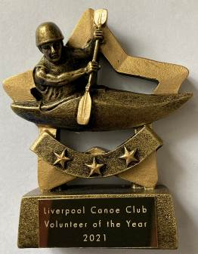
Attendees- Keith Steer, Callum Cook, Kai Hoettges, Sue Bradley, James Duffy, Craig Ford, Richard Clews, Clara Clews, Amy Newnham Carl Leung, Ian Bibby, Ann Lea, Laura Bevan, Frazier Bevan, Paul Goetzee, Stuart Conway, Peter Caldwell, Roy Mchale, Chris Murphy, Oliver Murphy, Jake Diprose, Martyn Murphy, Sue Lowndes, Colin Lowndes, John Cooke, John Allerton, Matthew Pegram, Kevin Corcoran, Andy Bond, Allan Blanchard, Terry Smith, Ben Cook, John Smullen, Norman Cook, Ian Bell, Nikki Aldridge, Eamon Hanlon, Dom Fahey, Mike Alter, Mark Garrod, Adya Misra
7:30 – 8:00 pm – Catch up with Members - Slideshow of the club`s activities over the year.
Liverpool Canoe Club is open to all and aims "to provide the maximum canoeing and kayaking opportunities for all its members".
8:00 – 8:20 pm - AGM (Election of Club Officials, Paddler of the Year, Members Motions)
Welcome from the chair & review of the year
1. Apologies for Absence.
2. Minutes of the previous AGM – Click here • Signed as a true record by the Chair • Matters arising.
3. Honorary Treasurers report Online Year End Accounts – Click here
4. Members Survey – Analysis of the responses. Gary Edwards
5. Brief reports from each discipline (2 minutes each)
6. Members motions – Please email any member’s motions (two emails please from the proposer and seconder) that require a LCC constitution change. None received by deadline 21/10/24
Members Questions – Please email any questions about the club, its organisation or its activities. (5 minutes max given to this item) None received by deadline 21/10/24
7. Proposed update of the constitution from Stewardship Group (Items in Green including “Stewardship Group” replaces “General Committee”, “Paddle UK” replaces “Canoe England/British Canoeing”)
On the day we agreed to replace “General Committee” to “Stewardship Group”. Further discussion on Paddle UK needed as it is only a trading name and legal name remains as prior name ie British Canoeing. Stewardship group to discuss further.
8. Chair to thank all the volunteers who have coordinated and guided the club over the past year, especially those who have given up their time to run sessions for its members. Members are reminded that volunteers give their time freely to try and get as many people on the water as possible.

9. Election of Officers – Proposed list of those willing to stand for 2024 – 2025 Proposer: Rich Clews, Seconded: Jim Duffy
Chair – Roy McHale
Secretary – Adya Misra
Membership Secretary – Keith Steer
Treasurer – Keith Steer
Honorary Treasurer – Craig Ford
Lead Safeguarding Coordinator – Amy Newnham
Assistant Safeguarding Coordinator Carol Atkinson
Junior / Youth Coordinator – Richard Clews
Coaching & Safety Coordinator – Keith Steer
Compound and Boat Maintenance Coordinator – Dominic Fahey
Volunteer Coordinator - Roy McHale

“Discipline Coordinators” to develop a team to help develop the discipline within the club:
Canoe Polo Coordinator – Callum Cook
Sea Kayaking Coordinator – Ian Bell
White Water Coordinator– Chris Marsden
Open Boat Coordinator – Nikki Aldridge
SUP Coordinator – Adya Misra
Inland Touring Coordinator – Carl Leungs
Paddle-Ability Coordinator – Chris Marsden
Kayak Safety Cover Coordinator – Jim Duffy

Co-opted members
Freestyle Coordinator – Paul Harwood
Surf Coordinator – Karl Tattum
Racing Coordinator – Colin Smith
Various responsibilities – Mark Benson

8:20 to 8:45 pm

10. Paddler of the Year Awards presented by the chair.

2024 Paddler of the Year
2024 Young Paddler of the Year
2024 Volunteer of the Year

8:45 to 9:30 pm – Short presentations from this year’s Club Trips

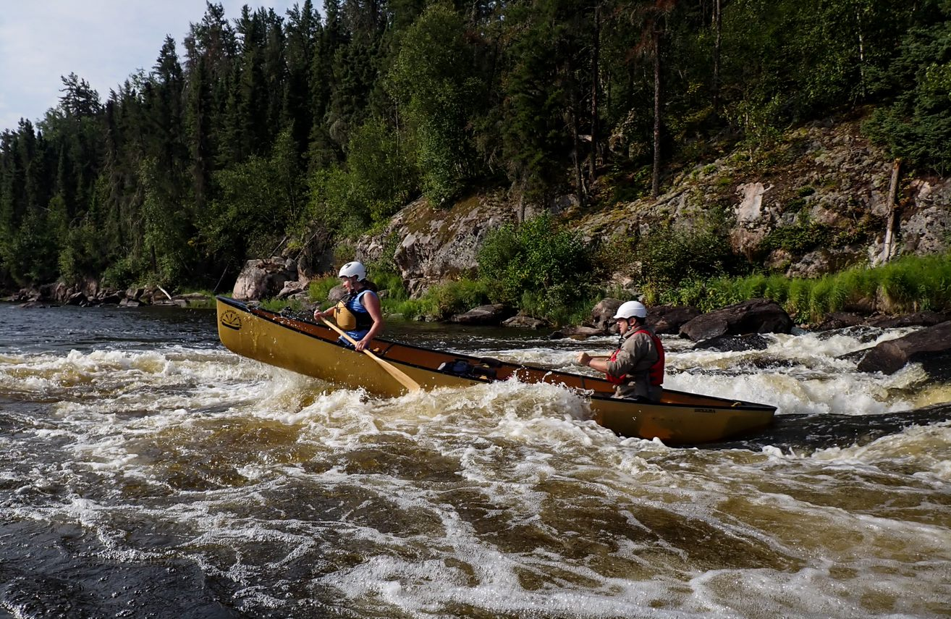  Bloodvein River, Canada | 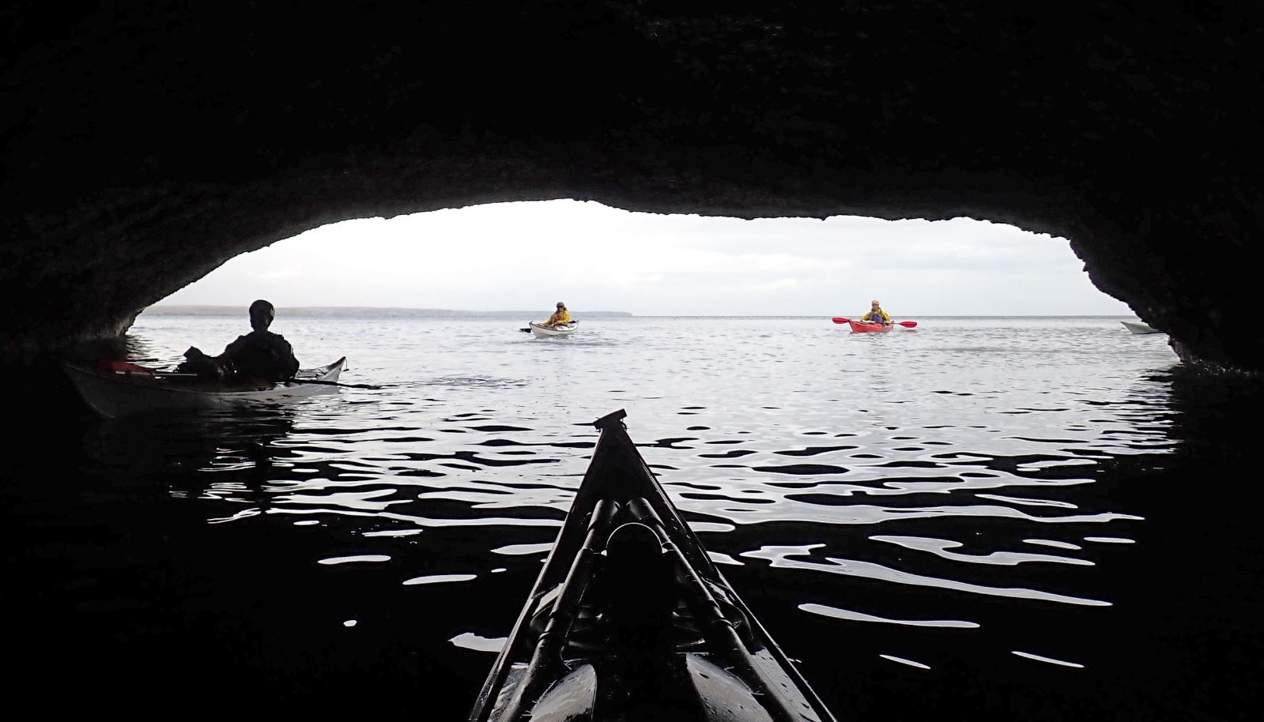  Outer Hebrides – Fuzzy Water
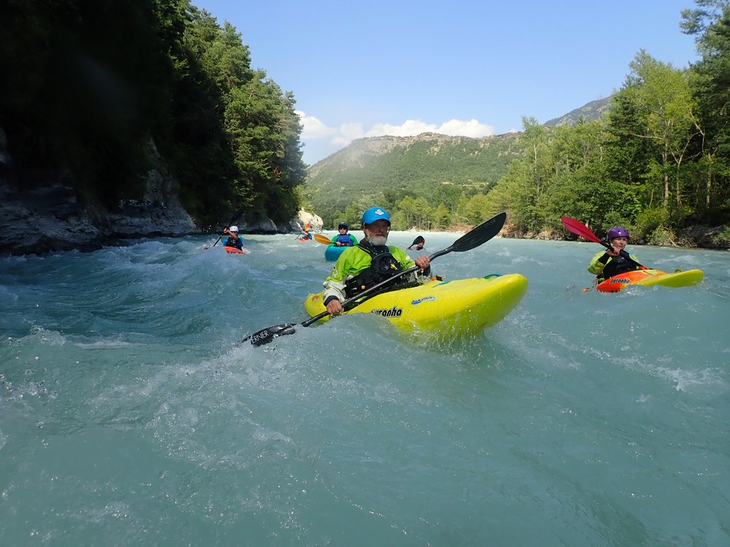  French Alps – Club Alpine Holiday | 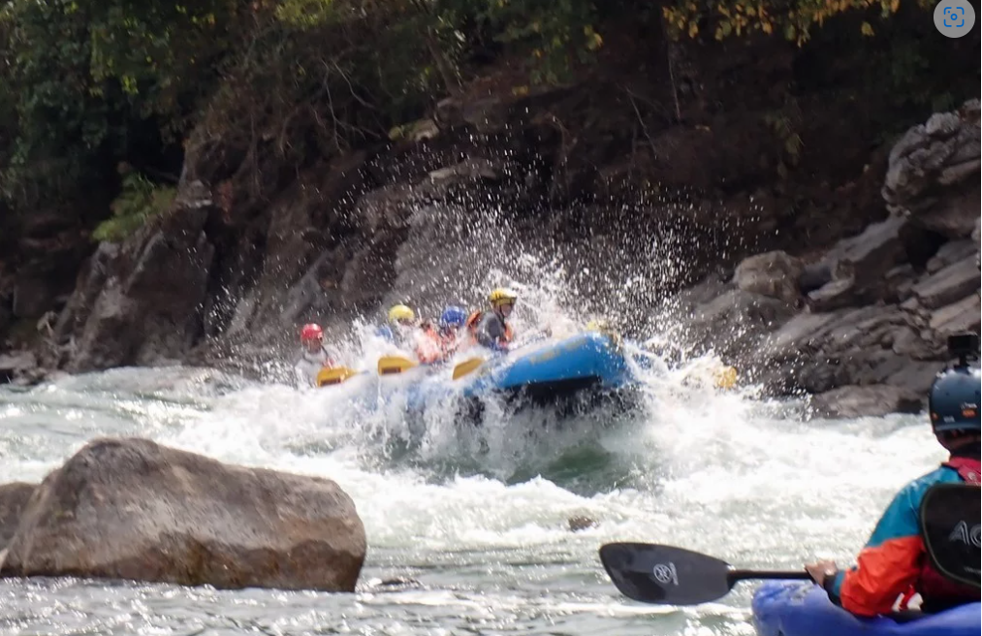  River Karnali, Nepal “Strip n Flip”

