Stewardship Log 2025
LCC Action Plan
Interested in joining the Stewardship group
A summary of key management decisions and developments within LCC

7/7/2025 Purchase of 4x used SUP from Liverpool Watersports Centre for £25 each
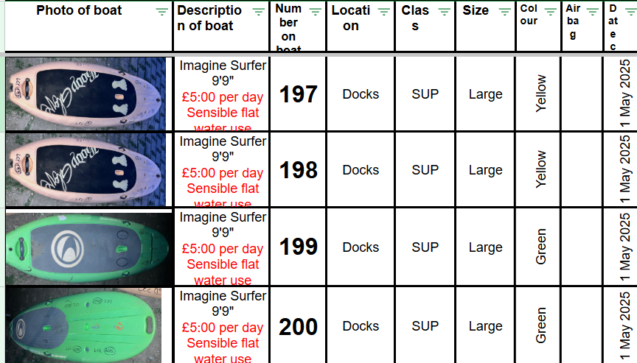

7/7/2025 Purchase of 4x Pyranha Rebels from Miles Bradshaw junior kayaks for £200 each–
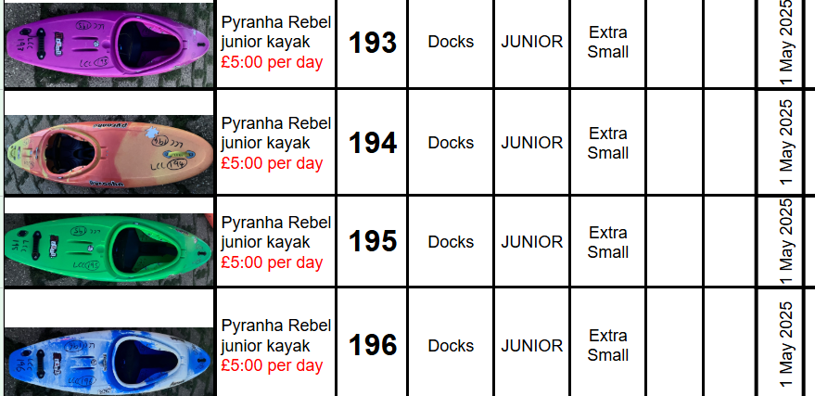

23/2/2025 Major overhaul of the menu system and pages on the club website
New “standards of Deployment” ready Club policies were made public on the Club website. (Risk Assessments still to be refined and made public). Yellow-coloured “select and hover text” was introduced to make it far more visible on PC.

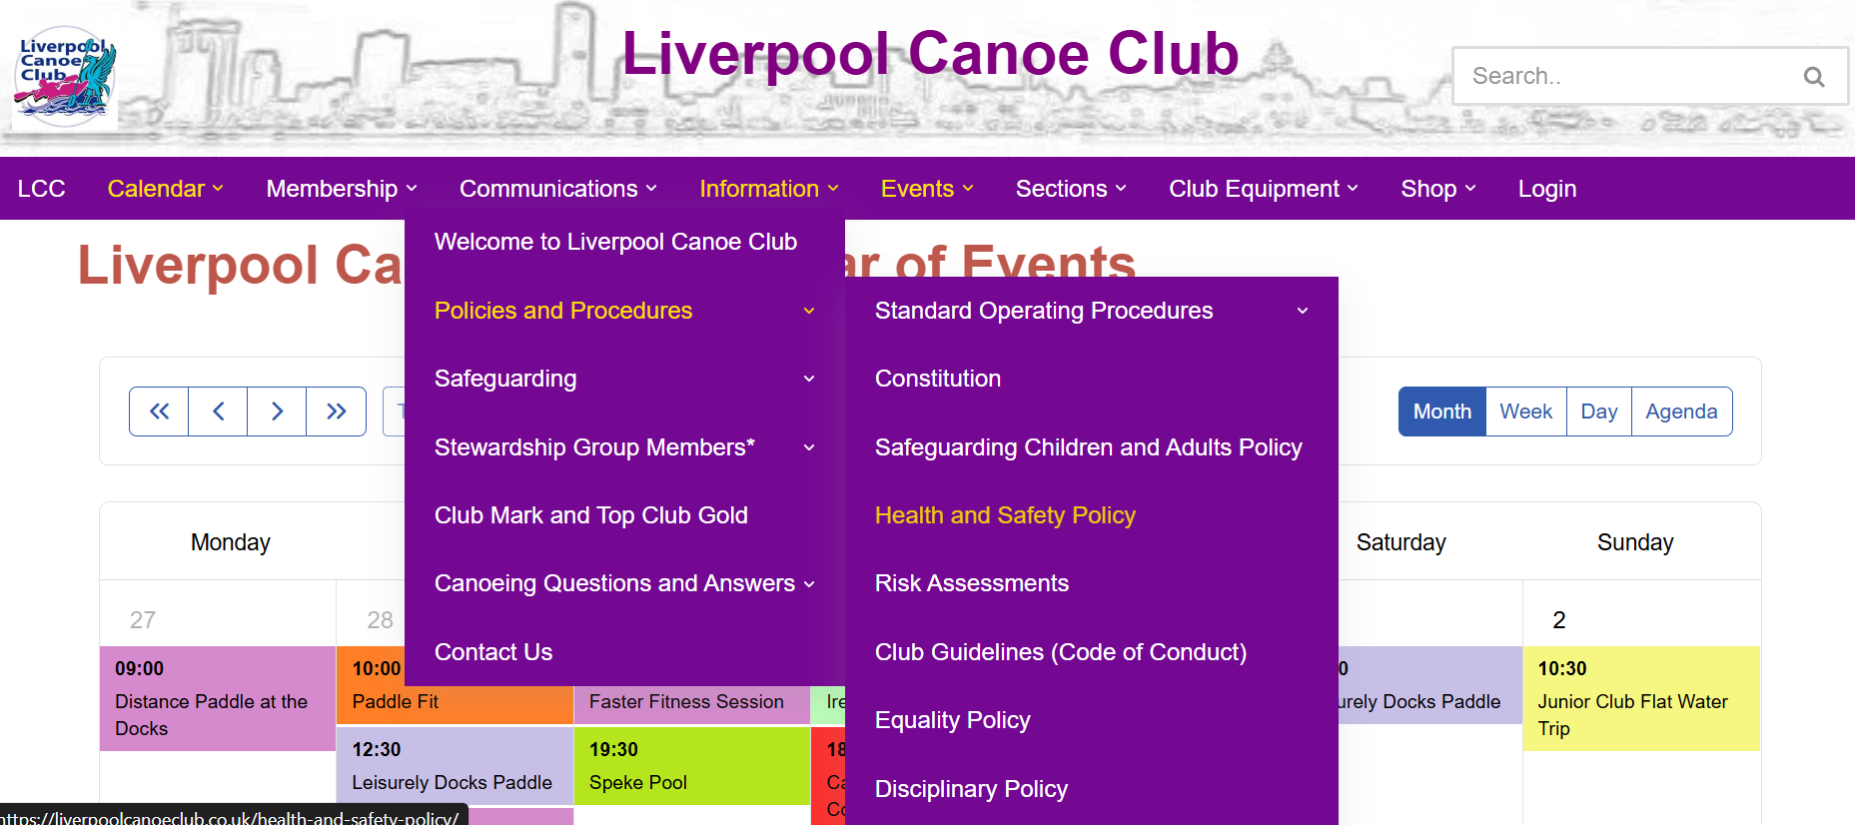

Menu Items were renamed and re-ordered to make things clearer to navigate. New pages were introduced including this Stewardship log to flagpost the major developments within the club.

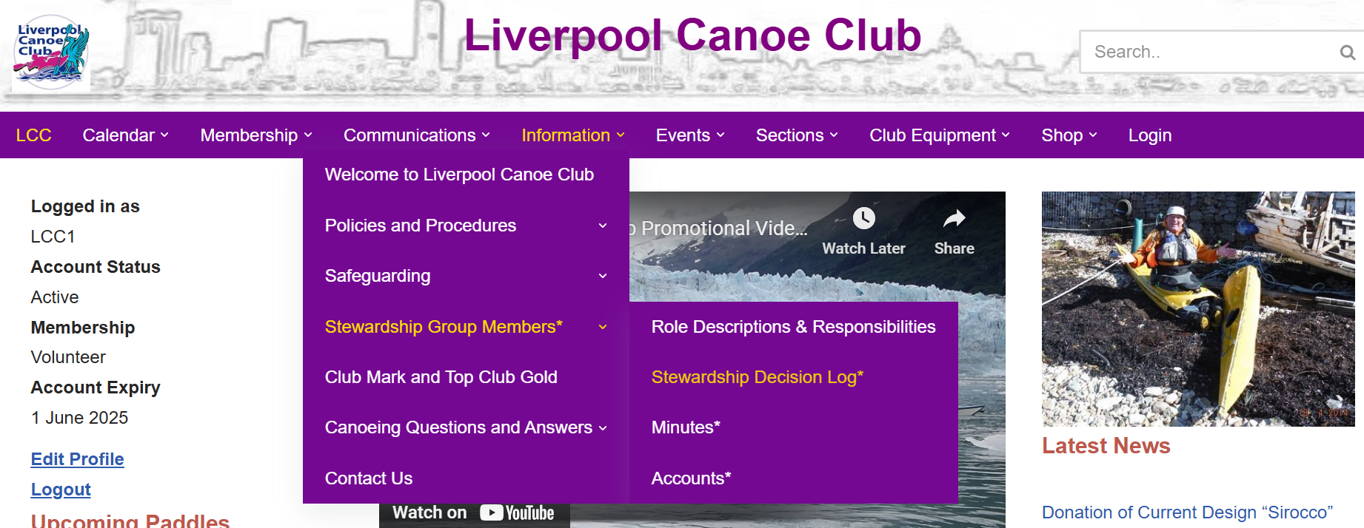
22/2/2025 Donation of Current Design “Sirocco”
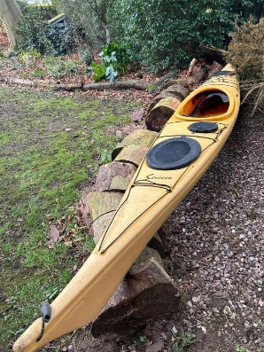
My father was associated with your club for a short time several years ago. He passed away a couple of years ago. We still have his kayak. Current Design “Sirocco”. Needs a clean, a little bit sun bleached … but otherwise sound. It is not being used, we wondered whether the Canoe Club would like it – free to a good home.
Thanks Helen Moore Collection by KS

25 January 2025 The new Calendar and Booking system
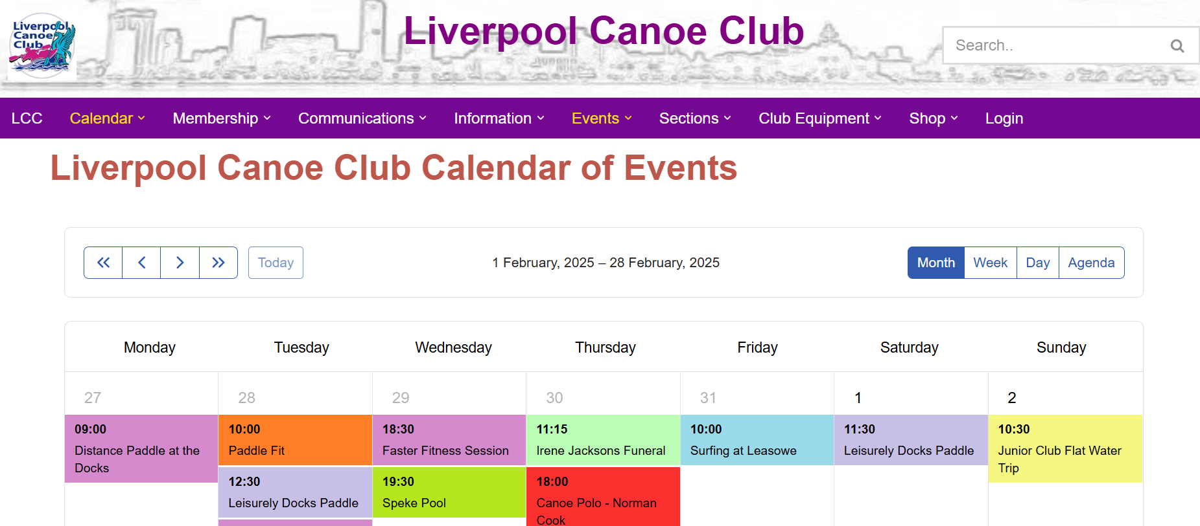
Please find the short YouTube video below to show the main parts of the new club calendar and booking system (4 mins). This will show you how to book a trip or session with the club.
How to submit a paddle on the new LCC calendar and booking pages.

This system combines both the old Google calendar and email me for places on my trip and the bookwhen booking system. All the club paddles are now in one place, are pre-approved and clearly show the participants. It will also save the club the bookwhen annual fee of £108.

The real benefit is that the event titles and calendar above are visible to all who look at our site but the details and booking tickets sections require valid membership with the club. Club members will now have to use their log in details regularly and this should reduce difficulties with renewals and passwords.

13/1/2025 Purchase of 10 Palm Derwent Decks for Junior Club
Purchase request submitted by A Newnham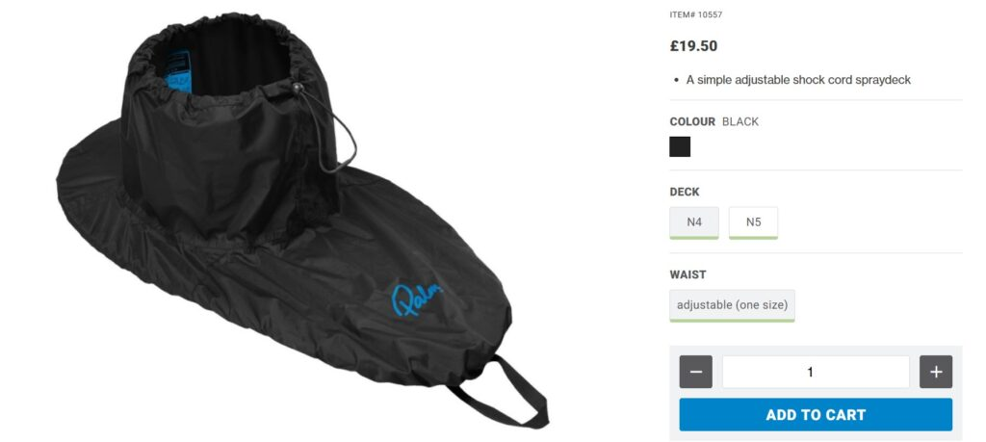

The best option would be Palm Derwent Decks as easy to put on and get off. As a policy, we do not have neoprene club decks.
Other option is that we swap out the smaller fabric decks from Speke and move to the junior club and replace them with the heavy-duty Palm Coniston Decks that the adults use.
Ordered by KS and passed on the Junior Club - Broadgreen

12/1/2025 Online WP form for suggesting purchases of club equipment
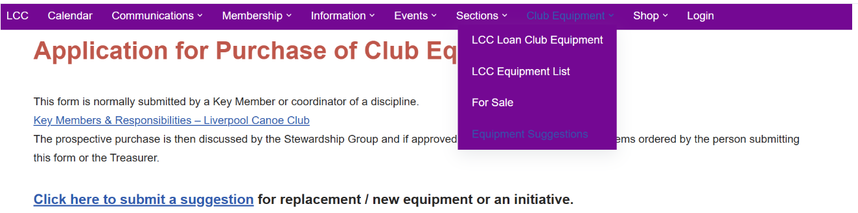

12/1/2025 Online incident and Accident form introduced online
Incident or Accident Form – Liverpool Canoe Club
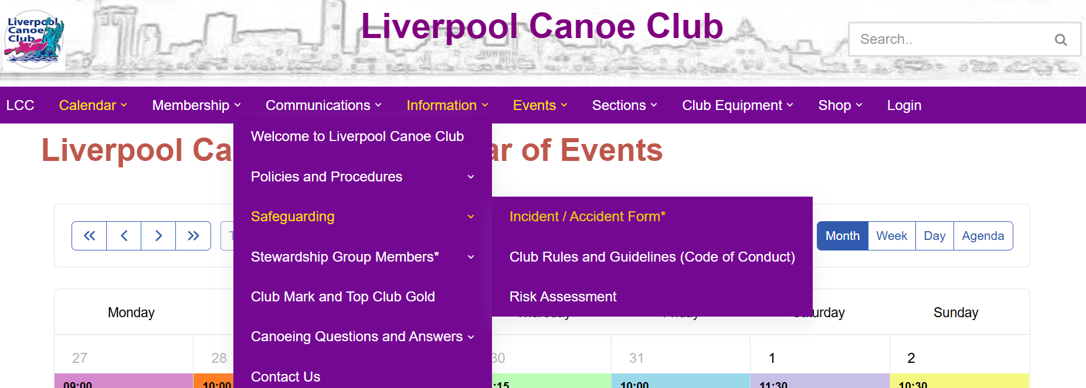

24 March 2025 Equipment update
New Sea kayak donated –
 | Current Designs Sirocco | 58 | Docks | Sea | Large | Yellow | N/A | 16 Mar 2025 | Donated to the club. 3 hatches all working
Nova Craft Prospector open SP3 added to the club fleet £450
 | Prospector 16 Open Boat (2 seats) SP3 £10.00 per day | 41 | Docks | Open | 2 seater | Green | YEs | 1 May 2025

4 plastic SUPs from Liverpool Water Sports Centre - £25 each!   | Imagine Surfer 9'9" £5:00 per day Sensible flat water use ONLY | 197 | Docks | SUP | Large | Green |  | 1 May 2025
 | Imagine Surfer 9'9" £5:00 per day Sensible flat water use ONLY | 198 | Docks | SUP | Large | Green |  | 1 May 2025
 | Imagine Surfer 9'9" £5:00 per day Sensible flat water use ONLY | 199 | Docks | SUP | Large | Green |  | 1 May 2025
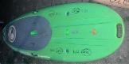 | Imagine Surfer 9'9" £5:00 per day Sensible flat water use ONLY | 200 | Docks | SUP | Large | Green |  | 1 May 2025

7 July 2025

1/ Purchase of 4x Pyranha Rebels from Miles Bradshaw junior kayaks for £200 each

