Club Log
LCC Action Plan
Interested in joining the Stewardship group
A summary of key management decisions and developments within LCC

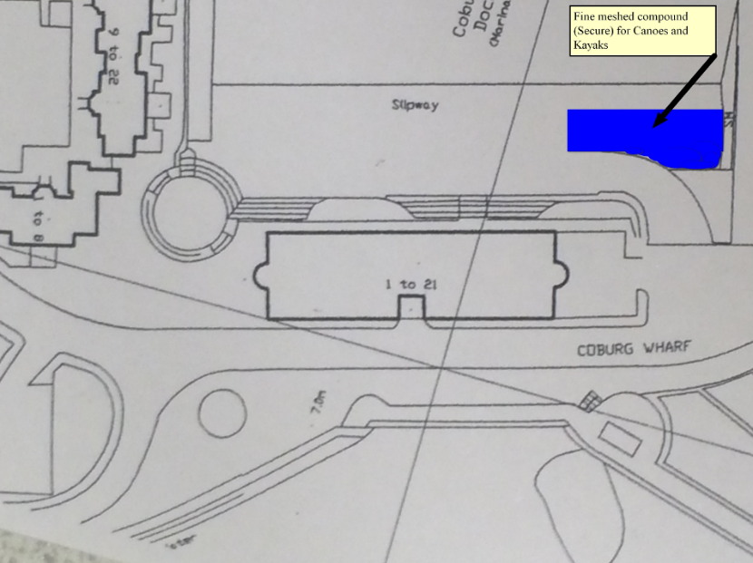
12/8/16 Secure storage area / compound / cage for our boats and equipment a few meters from the waters edge between the two slipways on Coburg Wharf beach.
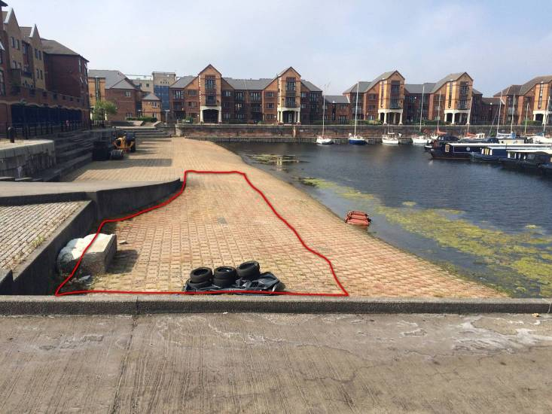
Good news – we are now finalising a company to come in and build the 43m of secure fencing and four x 4m wide gates in the area between the slipways. The area is owned and controlled by Canal and Rivers Trust but we have the tentative support of the Marina (see below). The area will have custom scaffold / adjustable racking for the boats and also house two plastic shed similar to one we have currently. These will be used for changing but we also hope to continue the association with the marina with use of the facilities and changing rooms. Details on the new arrangements will be circulated when finalised but members will be able to opt for this with the purchase of new (Gold) swipe cards when available.

Once the compound is finished we will need a working party to build the scaffolding and secure the mesh panels above, build the two sheds and transfer all the boats and gear. The custom gates will take about 4 weeks to construct so expect completion to be towards the end of September.
Response from David Beard from Liverpool Marina
No problem Keith. I think we could better use the space and the 'beach' is better for you guys. Let me know when you are moving. D
Sent from my iPhone

On 12 Aug 2016, at 07:21, Keith Steer wrote:
Hi David,
Hopefully you have had sufficient time to consider my email sent last Tuesday. Before I confirm the final arrangements for the move and pay for the materials can you just confirm that you do still want us to move from our current location behind the kitchen as this has been an ideal location for us in the past and you seemed to be a little unsure about continuing to ask us to vacate the area on Tuesday when we spoke.

11/8/16 Recent increase in removal of club boats for private use – Individuals identified and spoken to and club email sent out as below.
This is just a friendly reminder about the system we have for loaning club boats and equipment.

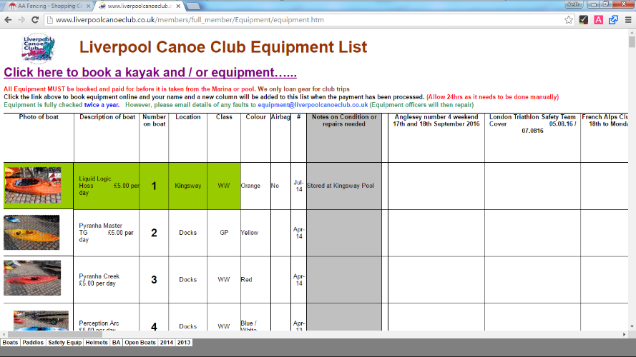
All our boats and equipment can be used by club members for free at the venue that they are stored at (eg pool or docks.) Please help by putting them away neatly.

If you would like to borrow one for a club trip this is ONLY allowed by using the club booking system but your must do this in advance and the numbered boat must be visibly booked to you on the webpage. (Please note that this can take up to 24 hours to process).

Please use the equipment link on the website or /members/Equipment/equipment.htm to find out more. By clicking on the link at the top of the equipment list you will find full terms and conditions and how to book. You MUST give the boat number……

If you are the named leader of a club trip or using it for a coaching course then we will loan club boats free of charge provided you ask first giving full details and dates by dropping us an email at website@liverpoolcanoeclub.co.uk

20/5/16 Proposed move to the jetty on the northern side of Coburg Dock

Following several months of discussion about the massive hike in costs of the proposed move we have been in regular further discussion with David about ways to move forward. We had discussed a number of initiatives etc and I was about to offer 1.5 times the berth rate (about £4050 per year). He is still keen to keep us there and the telephone discussion this morning and his text provide by far the best solution for us (Indeed, the only solution). We get everything that was proposed but not for £6000 rather £3000 per year to be increased in line with the Retail Index Rate each year. David is also going to look into loaning us the pontoon moored in Coburg Dock in the short term to allow us to access the water while we look at the best ramp or pontoon solution. It is unclear at the moment but we may have lost the use of the showers following the amount of water left by last nights no rules polo session. I will try to clarify this next week when we meet again but would hope for some kind of limited use related to a new swipe card that David is / was planning to introduce.
We urgently need to look at a working party to build new racks, put together the new sheds etc and move everything across.

Email / text from David Beard 20/5/16
Morning Keith. Last night our gents showers were put under enormous pressure of numbers by your members who I saw carrying large bundles of wet suit clothing and then left the floors in unacceptable condition. They are clearly using the changing room as a wet room in which to sluice their equipment. Apart from the unacceptable quantity of water left on the floor they also left the mop bucket half full which is an indication of the quantities involved. No one used the bar.

One of my berth holders was apoplectic! It is also clear that most of your members share access cards. I have no alternative but to terminate their access to the showers which simply don't have the capacity to cope with your numbers. If you want to stay at the marina it can only be that you relocate to Marinas Wharf and, if washing facilities are required we need to discuss how a folks tap or a more ambitious provision could be made. I have reconsidered the pricing issue and could let you have the berth and right to secure storage as discussed for an annual fee of £3000. Please let me know what you want to do. Regards. David.

Hi David,
Can I first apologise if the changing rooms were left in a poor state. I agree that we need to move as our numbers can overwhelm the facilities in the main building at times. We would be happy to accept your offer of the berth and secure storage facilities for £3000 per year as discussed along with and agreement that any annual increase be inline with inflation. I would like to speed up the move if we can. If you are around the marina today I am passing around 2:30pm and would love to discuss how we could expedite this.
Thanks Keith

05/3/16 Proposed move to the jetty on the northern side of Coburg Dock

David Beard

Hi David,

Following our meeting before Christmas you were going to write to me (Liverpool Canoe Club) to confirm the details of our proposed move to the Jetty on the North side of Coburg Dock. This would be a good solution as the area is currently underused. We are keen to make the move subject to confirmation of the points that we agreed. Ideally the works would be complete before the start of our main season at the docks (1st May) and would alleviate the current issues associated with our use of pontoons and your increasing number of residential berth holders.

1/ We would store all our canoes on our racks on the jetty leaving at least one pontoons width for easy access to boats moored there. We would also move our paddle shed to the area thus vacating the area currently used at the back of the kitchens.
2/ We would permanently rent the end berth (furthest from the gate) at the same rate as the other non-serviced berths on that side and that this berth would be used for access by the canoes to the water. Liverpool Canoe Club would build a suitable access ramp into the water in the area occupied by the berth.
3/ We would purchase two small sheds to place on the jetty to allow for discreet changing by our members.
4/ We will develop lighting of the area, probably through the use of marina solar technology.

5/ Liverpool Marina would improve the security on the gate to the jetty and maintain it.
6/ Liverpool Marina would ensure that there are no objections to such use of the jetty by other interested parties (Canal and Rivers Trust, other berth users etc)
7/ Liverpool Marina would continue to issue swipe cards to our members to use the main changing rooms, discounts at the bar etc. as per the current arrangement.
8/ Liverpool Marina would continue to welcome our use of the bar and restaurant area after paddling and for canoe club events as per the current arrangement.

As you can imagine we are looking to invest heavy in this project to continue our successful partnership with the marina,

I look forward to hearing from you

Keith Steer
Liverpool Canoe Club
keithsteer@gmail.com
mob 07719459942

24/2/16 Broadgreen Pool

Hi Craig,

Thank you for your email and support. We tend to agree with you and have always supported the junior club and the pool session 7-8pm. It is not merely the cost and if there were only 3-6 places short each week the club has and would continue subsidise both sessions. Looking back the sessions have had as few as 3 paddlers at both sessions and this is just not sustainable by either you or the club!

Historically the pool sessions are poorly attended in the first few and last few months – probably due to warmer weather and paddling outdoors. While the sessions are currently well attended it is likely that numbers will drop-off significantly again. Since October the Broadgreen sessions have made a shortfall of £488.65

For the first time we are also cutting the Thursday night session short and ending it at the end of March (again as numbers are likely to drop off as we approach summer / Easter holidays etc.

We have changed the wording on the booking page to reflect the cancellation of the 2nd adult session. Our intention is maintain the integrity of the junior session – parents are welcome in the pool but we will monitor the attendance of adults who are to be persuaded to attend Kingsway pool. If need be we will make it a junior session only!

You are correct that we are now committed to the single session for the rest of the season but I and the Stewardship group will review it again before next October. We are happy to book two sessions again next year if it can be justified.

Keith Steer
Membership Secretary
Liverpool Canoe Club

Broadgreen School Pool Junior Club 1 (7:00-8:00pm)
Tuesday, 1 Mar 2016 7pm - 8pm
- 10 spaces available.
- An online payment is required to book.
Broadgreen School Pool Junior Club 1 (7:00-8:00pm)
Parents or Guardians are welcome to book a session at the same time as juniors. If adults want to book as individuals this should only be done if there are 5 or more places free with 1 day to go - eg priority for this session always goes to the juniors. Adult paddling sessions are available at the Kingsway pool.

Boats and equipment are available on the poolside or bring your own. Please note only small and medium boats stored at the pool Coaching is available to help with gaining confidence, support strokes and rolling.
NB Entrance for boats is now around the left of the building through the side door opposite the covered bike shed. You may need to enter the building from the opposite side and hold the door open.
Liverpool Canoe Club is open to all and aims "to provide the maximum canoeing and kayaking opportunities for all its members". This is an extra, specialist event and is part of the provision provided under our Top Club Gold, equality policy.....

To the Stewardship Group

Having spoken to Dave Reynolds tonight about the demise of the 8-9pm Tuesday session at Broadgreen I understand that there are a number of factors due to lack of usage by members at both Broadgreen and Kingsway, which makes it financially non-viable. He has suggested that I write to the Group.

I attend with my wife and son, which is ideal as the Kingsway session for juniors is certainly too late. We tried this last week on both the Monday and Thursday, which as it was half-term was achievable, but certainly would not work during term time. It was good to see tonight 11 juniors at different levels learning the skills and have seen massive increases in my son's confidence since we joined in October.

You'll be wondering why I'm writing... I understand that a breakeven attendance on the Tuesday would be 18 members over the two sessions. I'd like to offer to make up the shortfall on the Tuesday night between the number booked and the 18. So if 10 book I'll pay the extra £32. Whilst I could just book 3 places in the 7-8pm session, I believe that the junior session works well without the intervention of adults in the pool.

I appreciate that this offer may be either too late or not fit with the overall Club's aim and so understand if the session is still reduced to the one hour for the remaining couple of months to end of April. If you wish to chat this through then do not hesitate to give me a ring on 07940824982.

Best wishes

Craig Ford

23/12/15 Safeguarding officers

We have safeguarding training on a regular basis as part of our job working with our clients but we don't get a certificate. I have therefore booked on a course to be held on 11/1/16 at Crosby which will give a certificate acceptable to the BCU.

I understand we would also need to complete the Time to listen course. John Fay

21/12/15 Safeguarding officers

Dear all,
I have been advised by British Canoeing that they are unable to recognise the safeguarding training that is provided as part of my job at Alder Hey. This means I am unable to continue in this role as work commitments mean I cannot attend any of the training sessions they are offering in the next few months. You have to attend 2 different safeguarding training sessions to be compliant with the BCU guidelines.
Sorry all but we will need a volunteer to take this on, if we need 2 safeguarding officers.
Frankie

Thanks John. Pete Massey has also replied to me. Training by other providers is recognised it's just that the hospital training does not meet British Canoeing's requirements.
If you are interested in the role we can check training suitability. You have to have safeguarding training plus the Time to Listen course run by the BCU.

This is a vital role within the club. We already have a second safeguarding officer in Jeanette Bond but she has only just come into the team and may also need to do the Time to listen course etc. If the BCU is now unable to recognise Frankie's experience and qualifications it may be a good time to revamp the team. They have accepted it for the past 5 years! The club will always pay full costs for any course(s) needed to fulfil roles required by the club.

A team of 3 would be ideal for such a large club (Jeanette Bond, Peter Massey and John Fay would be a dream team). However, British Canoeing would need a lead safeguarding officer as a primary liaison and contact. Could I perhaps suggest John Fay as he is often down at our main location, the docks.

Perhaps Frankie could manage this transition and pass on courses suggested by BCU to the three and organise the transfer of contact details with British Canoeing once we have sorted courses etc.

Many thanks all for so quickly suggesting solutions and to help the club.
Keith Steer
03/11/15 Proposed move to the far jetty for canoe and kayak storage and access to the water
Hi all,
Following the meeting at the docks all 11 Present felt that the move would be beneficial and an improvement. Concerns were raised over security of the gate but it was felt that the best place to position any racks would be the far end. To this end we would welcome the construction of a slipway using the far end berth but understood there would be a yearly fee, There seemed to be a lot of room and this would give us a home for the next few years.
I went back to David Beard the following week and said that we would be interested in moving the storage of the racks etc and would be interested in contructing the slipway / changing sheds etc. He promosed to give me a price by Friday 23rd before he went away on holiday. However he did mention that he would need to consider the proposal before putting an agreement in writing because he “needed to earn” from the canoe club. I think he was worried that we would no longer purchase as many swipe cards if we were based on that side.
However, he had not come back to me with a figure for use of the far dock and launching etc. I do not want to push things and will wait until he contacts me. As long as the price is not astonomical it still would be a good move for the club.
I will keep you all informed.
Keith Steer
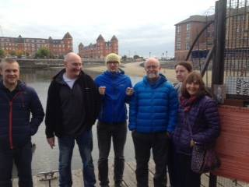 | 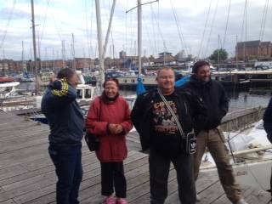 | 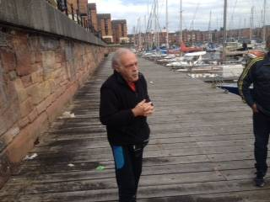

21/10/15 Proposed move to the far jetty for canoe and kayak storage and access to the water

Hi all on a the Stewardship Group and other interested parties,

I met with David Beard on Thursday 8th October to discuss the position of the canoe club within the Marina in light of an increasing number of complaints.

The good news is that David seemed very positive towards the club but he stated very early on that things would have to change.

The main points:
- There had been an ever increasing number of complaints / conflicts of interest.
- The marina is increasing becoming a floating residential facility with more and more live-on-boards. We must use only our little access pontoon in future and be very careful around the other boats.
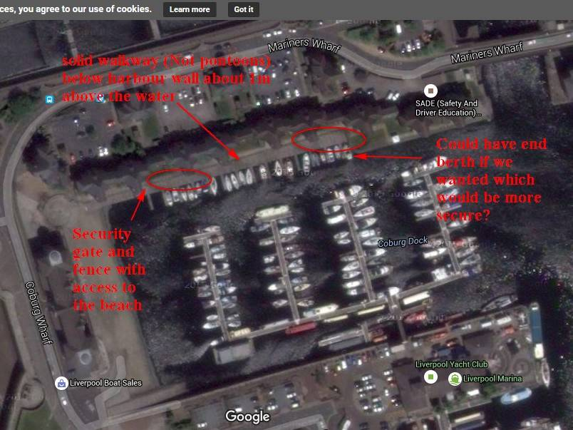
- There may have to be some restriction on the times we operate because of disturbance to the family’s etc living on the barges.
- We are guests at the marina and have no actual rights there.
- A new swipe card will be introduced in the new year with photo on and enhanced options for discount at bar etc (Not sure of cost as did not want to give him ideas)
- There have been improvements in the showers (new weighted shower curtains) but too much use causes excess damp.
- There may be a new facility / branch of the marina in the future for power boats (4 story complex built on stilts) in Queens dock by the Triathlon slipway. He was thinking of allowing us to have the whole of the area under the complex between the stilts to base ourselves. This will be a long way in the future and may not be ideal.
- David had been looking at alternative sites for our storage / access to the water. This included storing boats on moored pontoons at the south end of the marina or more interestingly a cage by the slipway next to the “beach” that we often use already. Both these would need permission (planning permission) and financial input from the canoe club to build the structures. CRT control the land on the beach, not the marina but he says there will be no objection from the marina.

I had already discussed an alternative proposal with several key club members just in case and given what I had heard it seemed a good time to discuss this with David. That is that we explore the use of the solid wooden jetty along the north wall of Coburg dock. This has a number of smaller boats including the red fishing boat moored there so would have far less possible conflicts of interest. This jetty has a security gate with combination lock and is below private residences. The jetty starts off about 6m wide and expands to the far end (100m) to width of about 10m. We would be allowed to store our boats there on the current racks using half the width of the jetty. We could purchase two more plastic sheds for male and female changing and possibly storage of clothes while paddling (at the paddlers own risk).
David offered to move the boat at the far end where we could build our own access to and from the water. If we wanted this there would be a cost per annum. (I am guessing £1500 per year but said that initially we would not really be interested in this)

Given that we will probably have to move anyway or severely reduce our paddling from our current location:
Negatives: Possibly not as secure but the gate security would be improved for us, no power on that side, a little removed from the main building so along way round should you want to use the showers / changing rooms. There is no fresh water there.
Advantages: With no live on boards there we should have far less conflict with other marina users. It will become our own area with possibilities of more permanent facilities or a clubhouse in the future. The boats are close to the water with easy launching from either the beach or our own pontoon or access ramp if we want to construct it. The area is a sun trap and is very sheltered. Possibilities of negotiating access to the barrier (CRT) for use of the top of the beach. It is also very near free on road parking and is better for those bringing their own boats as they can launch from the beach. It is close to both the shallow water and easy landing on the beach and the channel along the wall to Queens dock. It is also away from the pump out station and fuel berth.

Can I suggest that those with an interest (Stewardship Group and session organisers) meet at the venue to look and see the site and to discuss its Pros and Cons.
The best time might be next Saturday at 3:00pm 17th October Please let me know if you make it.

20/10/15 Club Bursary Award of £70 to help fund 4 star open boat training for Mark Garrod

Course is on 24th-25th October 2015. Mark has run many courses at the docks this year along with 3 star white water etc He has easily built up enough funds to cover this Award.
20/8/15 Recent work on the club website and membership system

The menu was tidied up and made larger so easier to use. The mobile page text was made larger with better line spacing so would be more mobile friendly.
Newsletters were moved in the public space and the free (web-only membership) was deleted with an email to all those that had signed up explaining why it had become redundant.
03/7/15 Encourage players to wear a helmet when playing Matchplay games in the bay area.

Copy of Email Below:
Please be reminded that we have a duty of care to our younger paddlers when on the water.

ALL Under 16yrs MUST wear a safety helmet when partaking in Matchplay games ie Canoe Polo, Murderball etc. It is also recommended that adults wear a Safety Helmet too.

Safety Helmets are provided in the shed at the Marina in various colours/sizes or please bring your own.

Thanks for your co-operation.
Karl Tattum.
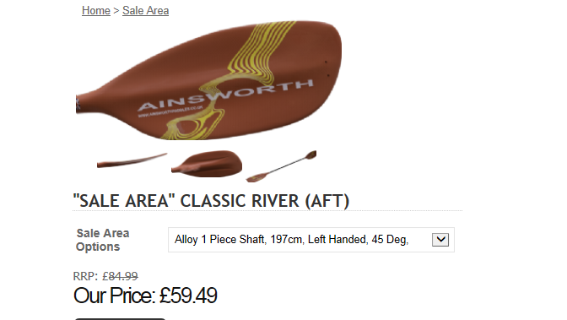
21/4/15 Mark Garrod has been Awarded BCU Bursary
Mark Garrod has been Awarded BCU Bursary of £100 and the club has awarded him £160 towards his Coach L3 Core Modules and hope that this will feed back into the club with quality coaching and courses.
31/1/15 St Helens Canoe Club has taken back the last of the kayaks and paddles loaned to us.
Paul Smee and St Helens Canoe club have taken back the last of the kayaks and paddles loaned to us.
We do not currently intend to replace the kayaks as there are still questions over storage at the docks. However, we have ordered 10 Ainsworth K102 River paddles as they are currently on their sale area. They have proved to be very reliable club blades and are of an asymmetric design. Sale price £59.49

29/1/15 Halewood Pool Fees
Knowsley MBC need to save £30 million and have removed all concessions / put up leisure centre fees. Despite some attempts at negotiation our pool fees have gone up from £45 per hour to £62.52 per hour. There have been discussion on their per lane charge rather than whole pool charge, cost of lifeguards if needed and discount / deal where travel costs for coach at disabled session once a month was credited to our account (Unfortunately this has now been lost)
As this pool is ideal for polo the polo group have agreed to pay the extra fees and now contribute £6 per hour of pool time for 3 teams of 4 (12 people). This may be a sign of things to come where our fees will inevitably go up. We will continue to pay in blocks of 3 months to avoid paying VAT but will continue to review the viability of this session. As long as we get 12 each week the session will cover itself for costs.

09/1/15 Email to LYC
Commodore
Vinny Reynolds
Liverpool Yacht Club

Hi Vinny,

I have met you briefly several times at the club and you may remember Peter Thomas who used to race “Billy Whizz” and “Skibbereen” at LYC. We are both keen to further strengthen links between the two clubs. I know that Dave Hardy has suggested opening up talks run by both clubs in the past and certainly we operate an open door policy to all members of LYC. We are keen to make the most of this in future and could advertise any relevant talks or information to our members.

More recently we have been asked to justify the contribution we make to Liverpool Marina by David Beard. Last Summer, as you know they brought in car park charging at the Marina and members of both clubs were affected. Our Committee are a little concerned where this may all lead. I have attached a copy of the document we forwarded to David recently in case it may be of any interest to you or your committee.

If there is anything that Liverpool Canoe Club can do to help or provide support to LYC in future or bring the two clubs a little closer together then please let me or Peter know.

09/1/15 Liverpool Canoe Club`s Contribution to the Marina
Hi David,
Happy New Year.

During our discussion at the Marina before Christmas you asked if I could put down in writing the contribution that the Canoe Club makes to the Marina; as you may not necessarily have been fully aware of the canoe club’s commitment to the venue and how much we actually support the commercial side of Liverpool Marina.

Attached is a document which I hope summarises some of the ways in which we do bring added value to the Marina.
Many thanks
______________________________________________________________________________________________________________

Liverpool Canoe Club’s Contribution to the Marina

Liverpool Canoe Club contributes much to Liverpool Marina and welcomes the partnership with the Marina built over the last 5 years. We hold the British Canoe Union / Canoe England Top Club Gold Award, one of the few clubs in the country to hold such a prestigious Award and certainly using the Marina as a base brings much kudos and publicity to the marina via the many press releases and stories submitted to the canoeing world. Sea kayaking has a special affinity with yachting and many participants enjoy both activities.
/About%20us/Top%20Club.php

LCC in the Media
Bay TV Liverpool article ***
LCC Local radio Interview (99.8 FM KCC Live) **
Article about the club from Canoe & Kayak magazine 2013***
Simon Willis & Jim Krawiecki Podcast
Article about the club from Canoe & Kayak magazine 2014***

The whole strategy; developed in partnership with the Marina over the past 5 years; was and is “to bring as many people to the Marina as possible, either to paddle, join courses, meetings and talks”. In this way people will use the Marina and spend money over the bar and in the restaurant. I am concerned that any change in this strategy may have the opposite effect.

Swipe cards
In the last 4 years members have purchased 432 Swipe cards. This is over £1000 a year to use the marina facilities to launch and change. This is seen as an ideal way to bring more people to the marina and certainly encourages them to use the bar and restaurant with their 10% discount.

Payment for parking.
Since the summer 2014 our members were asked to pay for parking at the Marina. This was supported by the canoe club committee as a fair contribution towards the Marina’s running costs. However, the weekend fee of £5 is a little excessive for members wanting to paddle and then go to the bar taking them over the 2 hours maximum for the lower parking fee. Perhaps a £2 fee for four hours would be a good way to attract more members into the bar after paddling at the weekend perhaps allowing them to use the ticket against food purchased in a similar way to the £1 for 2 hour ticket currently used by members on a week night.

Regular use of the Marina bar and Restaurant after club evenings
Tuesday (Summer only) and every Thursday evening
Saturday Mornings
Sunday Mornings
Club members often meet in the bar after all these sessions – numbers vary between 5 – 25 people but it is not unknown for many more to meet up afterwards.

Canoe Club Talks
Approximately 40 -70 people attend our talks which have traditionally been held on 2nd Monday of each month. Most purchase one or two drinks and many members buy a meal before hand. A reciprocal agreement with the Yacht Club means that our talks are open to members both clubs. We advertise the location all over the region (3 canoe shops, local recreation centres, climbing walls and the two Universities.)
http://liverpoolcanoeclub.co.uk/talks/

Reel Paddling Film Festival held in November each year
http://www.reelpaddlingfilmfestival.com/
We host the only UK showing of this festival and again bring in people to the marina from all over the NW. Additionally, it puts the marina on the map with international advertising through a large international publicist. http://liverpoolcanoeclub.co.uk/film/

Courses and events.
We hold numerous courses and events at the marina bring people in from all over the NW. Most buy drinks and / or food. Examples include:

- BCU lifeguard Swim Event Safety courses(s)
- VHF Radio course
- FRST Moderators Course for BCU coaches
- NW region Development meetings
- BCU Canoe Tour of Liverpool Docks
- BCU L1 Coaching Course.
- Numerous beginner and improver courses run in house by our volunteer coaches.

Polo tournaments and training sessions
Youth Canoe polo Tournament (Air Training Corps)
Youth canoe polo training for youngsters from Fleetwood (Outdoor Adventure Group)

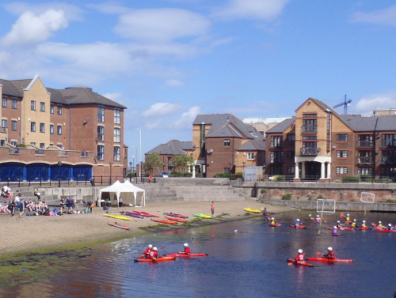  10/6/14 Canoe Polo tournament held at Liverpool Marina  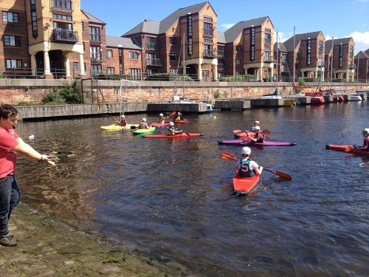  On Sunday 8th June 12 local ATC groups took part in the annual canoe polo tournament at Liverpool Marina. The weather turned out to be very sunny and the groups all enjoyed watching the teams play. Prescot put up a small marquee and Liverpool Canoe Club provided much of the equipment and boats. Many thanks to all those that helped to referee, organise teams or to generally help out.  The Final was held between Prescot A and Ormskirk with Prescot A the eventual winners by 4 goals to 3.  More photos……. | Results  Prescot A 4 v 0 Maghull  Ormskirk 1 v 2 Neston  Prescot B 2 v 0 Bootle  Wavertree 0 v 1 Maghull B  Hoylake 1 v 1 Northwich  Ladies 4 v 0 Scratch  Prescot A 3 v 1 Ormskirk  Neston 1 v 1 Maghull A  Prescot B 1 v 0 Wavertree  Bootle 0 v 3 Maghull B  Hoylake 2 v 0 Scratch  Ladies 3 v 0 Northwich  Prescot A 1 v 1 Neston  Ormskirk 3 v 0 Maghull A  Prescot B 0 v 3 Maghull B  Bootle 0 v 2 Wavertree  Hoylake 1 v 1 Ladies  Scratch 1 v 1 Northwich  Quarter_Finals  Maghull A 2 v 2 Maghull B.  (Maghull B win 2-1 on penalties)  Ormskirk 3 v 1 Ladies  Semi-Finals  Prescot A 4 v 0 Maghull B  Ormskirk 3 v 0 Neston  3rd Neston 2 v 0 Maghull B  Final  Prescot A 4 v 3 Ormskirk
Come and try it days.
BCU Taster Courses and come and try it sessions do bring many locals to the Marina bar and facilities.
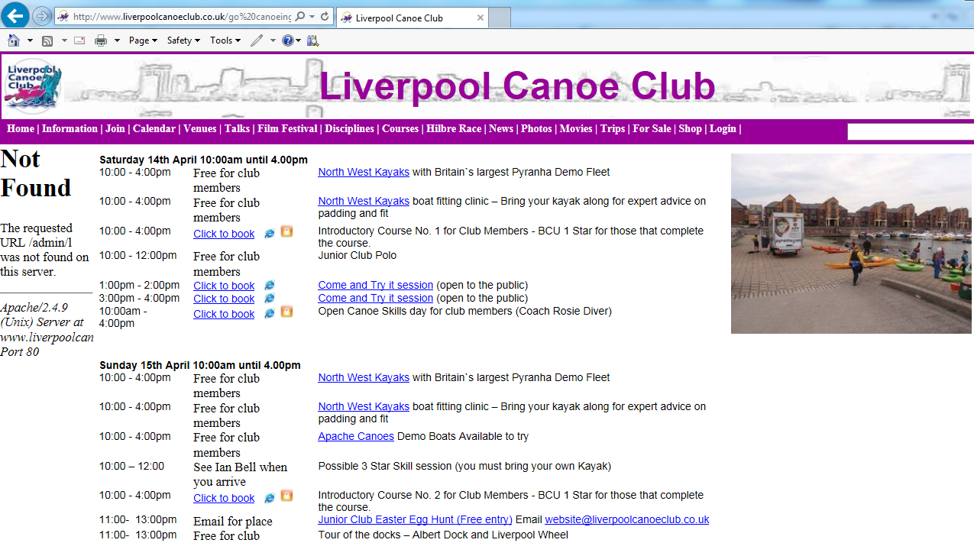

Annual General Meeting in October
Approximately 70-80 members attend each year and we always purchase a buffet for those attending. All buy drinks and some of us meet early to set up and eat before hand.

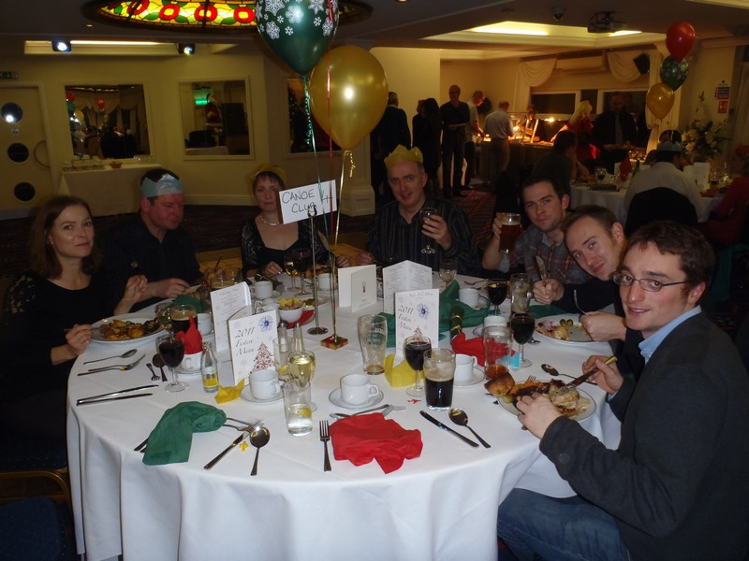
Canoe Club Christmas Meal
Booking for 40 – 50 Christmas Meal places every year since 2009.

Use of the Marina for family, friends and business meetings
Having been introduced to the Marina many members now use the marina for socialising or for business meetings. It would be extremely useful to use the swipe cards to analyse this trade as your staff may not realise that these customers are actually canoe club members.

Links on the website
We have numerous links on our website main page and venues page directing people and traffic to the Marina Website. In addition we have numerous pages giving the address and location for our many courses and activities.

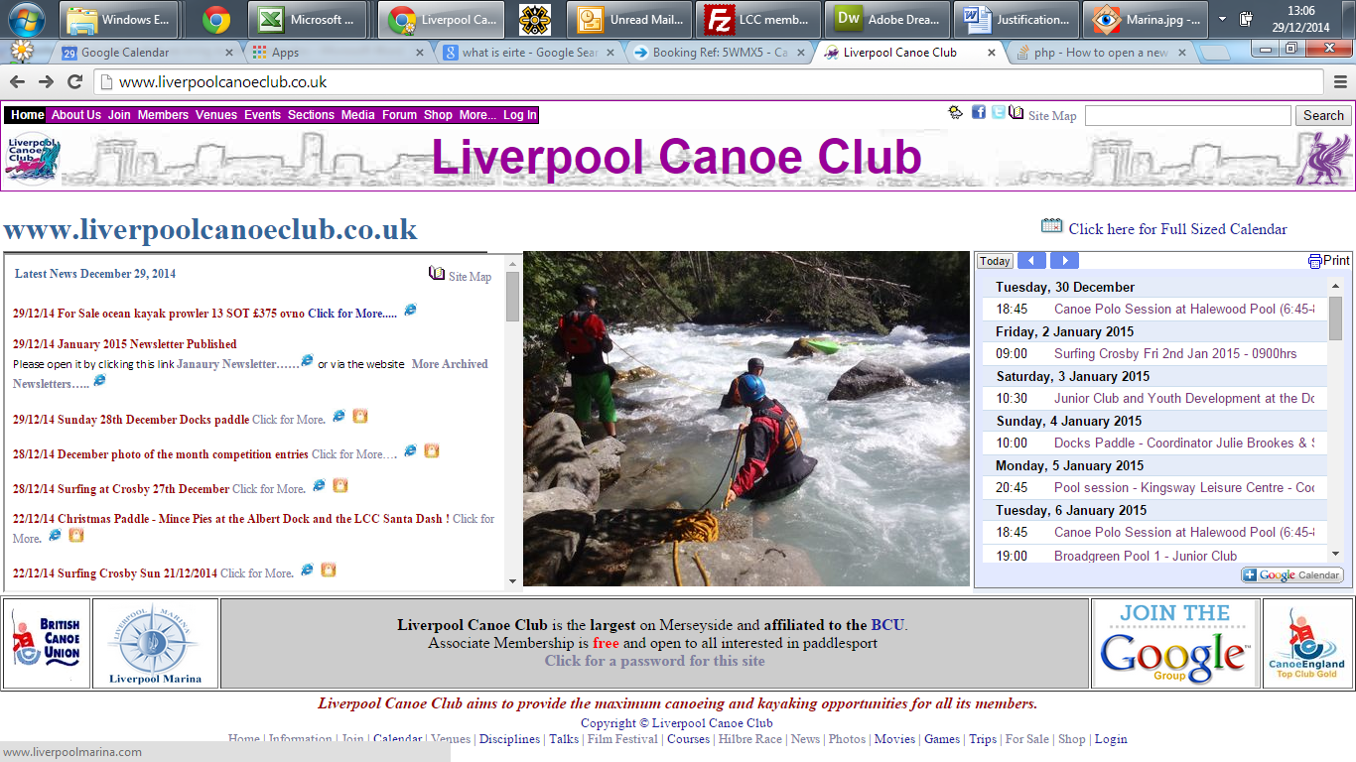

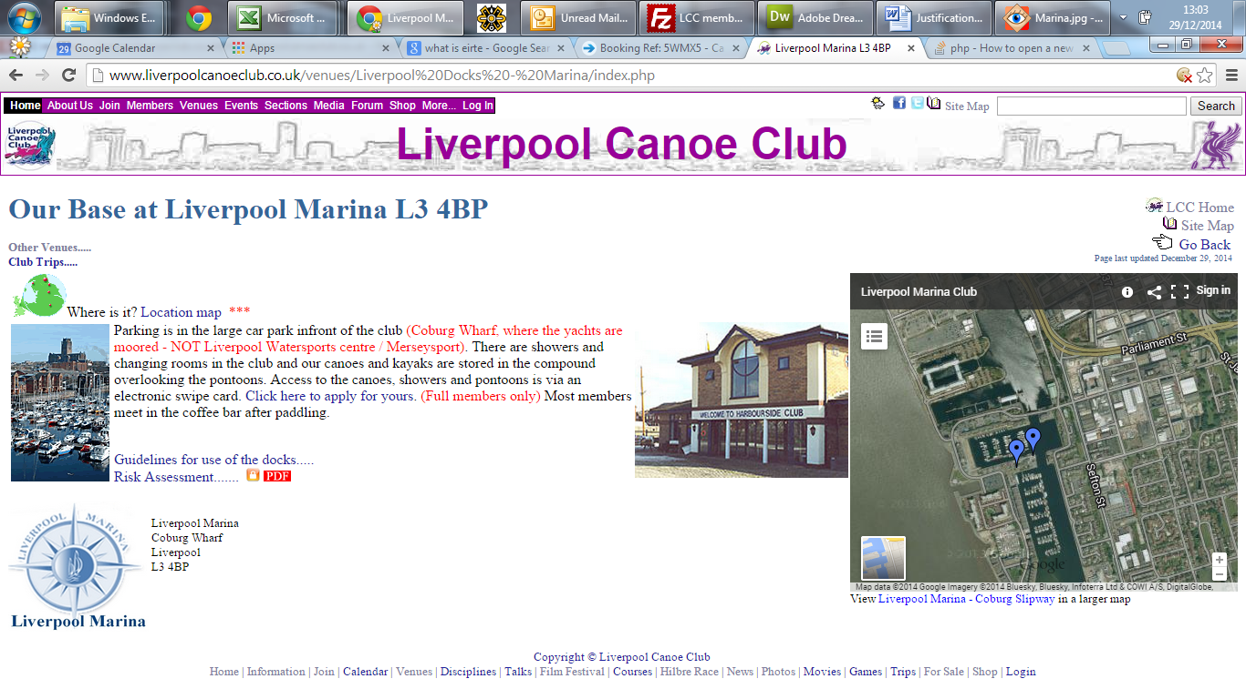

Google review of Liverpool Marina and facilities.
Canoe Club member Jonathon Fox (Not known by me) over a year ago wrote the best review of the Marina and Bar on Google Reviews.
https://www.google.co.uk/search?q=liverpool+marina&oq=liverpool+marina&aqs=chrome.0.69i59j0l5.7320j0j4&sourceid=chrome&es_sm=93&ie=UTF-8#lrd=0x487b20d6cad26d41:0xa20d6938c6e8228e,1

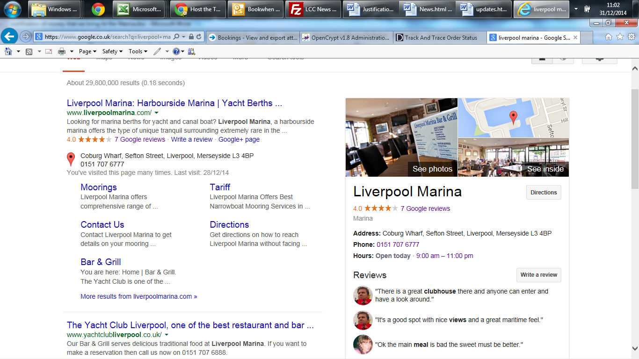

Easter, Halloween and Christmas Fancy dress Paddles.
Each year the social committee organise fancy dress paddles which start and finish at the marina. These are well attended and again bring good publicity and people to the bar and restaurant.

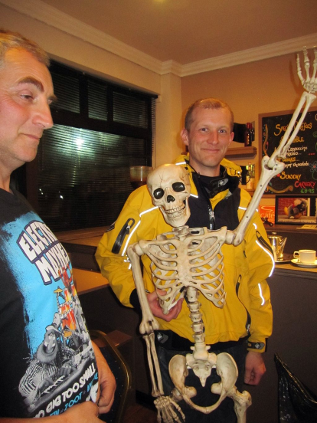 | 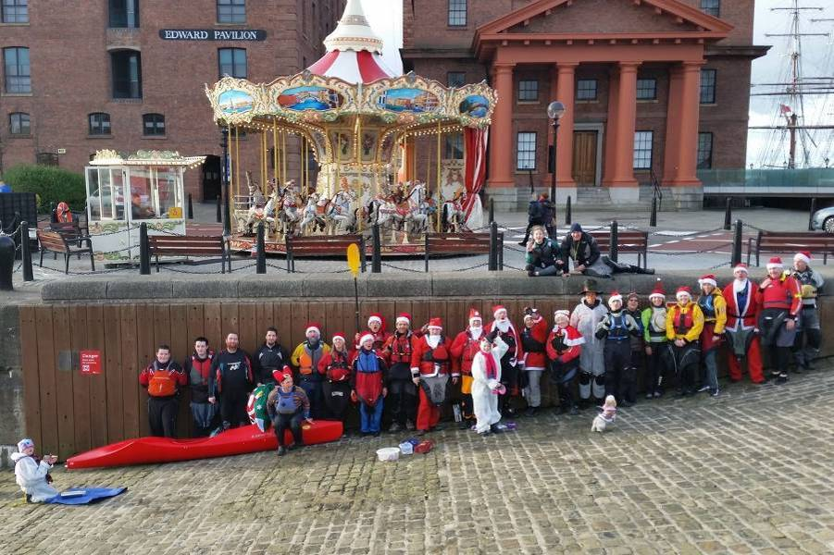
Halloween paddle 2013 | Christmas paddle 2014
We do store club boats and equipment at the marina.
Historically we have used the area between the bollards and winching machinery behind the kitchen. This area cannot really be used for anything else and used to cause problems with the residents complaining over its use – the area is supposed to be used for boat storage only. Since the canoes have been stored here there have be no further complaints as they hide the Camper Van and other items well.

Liverpool Canoe Club launching steps.
The club has paid for and maintained two small launching steps placed in areas unusable for mooring by larger craft. (Please note that the one at the western end of the jetty was removed last year when you extended the pontoon there and it was never returned. It was last seen on the pontoon that used to be moored to the three red buoys to the eastern side of Coburg Dock. Both of these launching steps were valuable safety aids for the marina should anyone fall into the water. It is extremely difficult to get fully clothed people out of the water without ladders or lower pontoons, especially if they are on their own or in full waterlogged clothing. Most marinas have ladders or steps on every jetty for safety.
Links with other clubs.
Over the years we have had much discussion with several venues and clubs regarding links and development.
Tranmere Sailing club were offering use of their facilities and were certainly looking to increase their numbers 3 years ago. At the time we agreed to stay at the Marina as this was our preferred location.
Liverpool Sailing club – We have had several paddles from their club house over the years and did discuss using the venue and slipway for evening paddles on the River Mersey.
Dee Sailing club – we hold the annual Hilbre race from their club house each year. Their social committee provide the BBQ and club house for our event. The 4 rescue boats liaise on the day to cover both sailing races for the Cats and the 3 kayak races. We have discussed joint evening paddles on a Wednesday evening during the summer paddling with their cruising fleet.
West Kirby Sailing club – Liaising over our Hilbre Race and attending joint Canoeing talks held at their club house.
West Cheshire Sailing Club – Where it all started in 2008. Liverpool Canoe Club was formed from paddlers attending a Sea Kayaking talk by Justine Curgenven at the West Cheshire Sailing Club in Nov 2008.

Rationale for the above summary
David Beard (manager of the Marina) had asked for information on how the canoe club added value to the Marina as he was not necessarily fully aware of the canoe club’s commitment to the venue and how much we actually supported the commercial side of the Marina. Hopefully it will now be clear how much we do actually contribute to the revenue, atmosphere and positive recommendations and praise for the venue; especially given that we only tend to use awkward areas of the Marina that would be difficult to use commercially.

02/12/14 SUP GoSea Stand Up Paddle Boards x 3 purchased and 3 Ainsworth SUP Paddles

Paul Harwood is to be the Representative for SUP for the next season and will use the three boards to develop SUP within the club. GoSea SUP….. SUP purchased for £240 (Normally £347) from eBay and Paddles from Ainsworth for £29.75 (Reduced from £59)
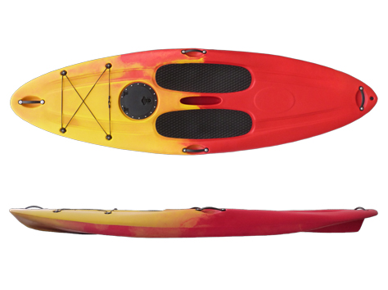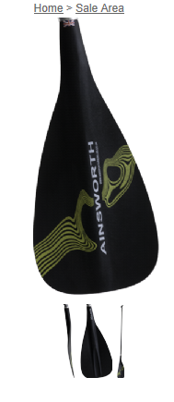

11/10/14 Perception Kayaks wavehoppers 3 purchased
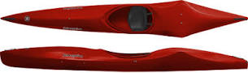
3 Wavehoppers ordered from Manchester Canoes. H3 delivered to Kingsway pool
27/9/14 Sea Kayaks purchase.
We purchased 1 Ex demo Scorpio £700, 1 Ex Demo Capella 166 £475 and had a new set of side rails for the Large Burn No. 105 (one of which had snapped) KS to repair footrest Boats have been numbered and marked LCC and are now on the racks at the docks. KS to follow up purchases for wavehopper(s) £439.99 each and small H3 Creek kayak from Sara B now reduced to £150 from £200 to the club but has been professionally repaired by Pyranha.

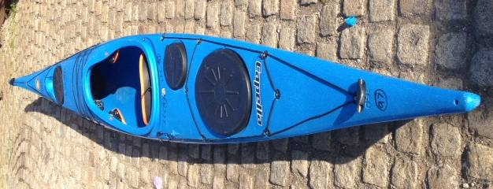
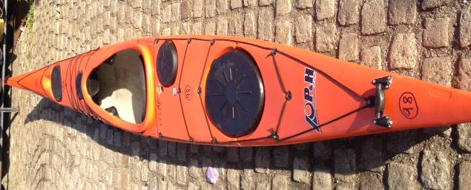

I moved all the longer boats together on the middle tier of the racks and we now have sufficient numbers to make this a sea kayak and longer boat space. Shorter boats will go on the bottom tier. Action: Club members and key holders.
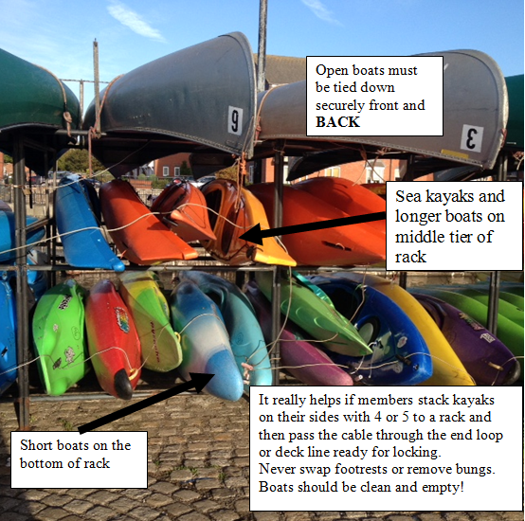
Club Equipment at the docks
If you use club boats at the docks please try to help key holders lock up by reading the following advice. We have been losing a lot of bungs and these will not be replaced. Similarly footrests have been moved between boats and securing nuts lost resulting in damaged or missing footrests. Boats have been returned full of sand or not secured correctly. Please help to look after club equipment. Last year we spent over £8300 on club equipment alone. List of club boats and equipment…..

24/9/14 Sea Kayak purchase.
Fran from Go Kayaking (Kayaks NW) has got back to me with best price for demo Scorpios: I would suggest that we purchase one of them to add to our fleet, I might try and get a deal for an Easy 15 as well but will not spend over £1000 on the two. The sea kayaks are hired out a lot and are certainly well used. Will probably go for the cheapest provided there is nothing wrong with it. Are most on the Stewardship group in agreement with this purchase? NB We currently have plenty of funds with £8000 in the bank with around £2000 allocated for equipment purchases and a further £1000 allocated for training courses. NB this is money that has been raised for the purpose of developing the club (Coaching courses, hire fees and donations)
“In terms of the Scorpio Ex demos. We have 2 in stock, one which is slightly more used than the other. One is on for £800.00 we would sell this to LCC for £700.00 and one on for £900.00 which we could sell to LCC for £800.00.”
Agreed: Fiona Barry, karl leung, Ian Bell, Dom Buckley, Fiona Barry, Mike Alter, Pete Thomas, Kirk Williams, John Pegram, Frankie Annan, Peter Massey, Chris Murphy, Dave Reynolds, Scott Gibson. Action : KS to purchase
23/9/14 Perception Kayaks have just moulded new wavehoppers

Machester Canoes can get them for us there are 6 in the UK. – Action : KS to obtain best quotes. Given the difficulty we have had getting hold of second hand ones we should look to purchase at least one and maybe three so that we have a racing fleet to promote flat water paddling.
Retail £495 - £550
Agreed: Dave Reynolds
22/9/14 Purchase of Junior Inazone Kayak
Club agreed to purchase junior Inazone from “Will Rickards” for £140 Action : Keith Steer.
6/9/14 New Spraydecks
21 spray decks moved to Kingsway after reports of not enough for some sessions (John Fay)
10 new Palm N5 decks ordered from Go Kayaking Runcorn and placed at the Docks Action : Dave Reynolds, Keith Steer, Ian Bell

3/9/14 Coaching Bursary
We agreed to pay for Roy McHale`s 4 Star WW Assessment with Andy Grimes - £150

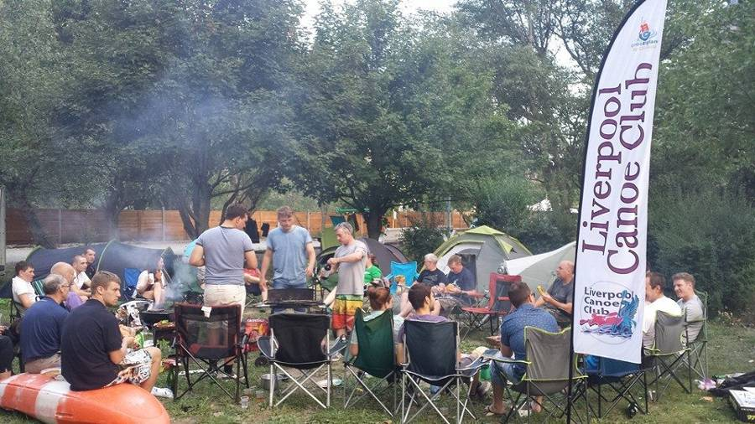
20/7/14 Feather Flag for Events and Camps
Following Club members comments at Anglesey No 3 with Ribble Canoe Clubs` feather Flag in the middle of their campsite we are to look into ordering a Feather flag for the club Action : Keith Steer

20/7/14 Loss of a significant number of bungs from kayaks from the docks
A large number of drain plugs are either lost or being taken from kayaks stored at the docks. We are now only going to replace them with corks cut off smooth with the rear deck as rate of loss is unsustainable. Stephanie Preston has a number of different sizes and will bring some down when next at the docks / pass on via Sam.
Action : Bungs replaced by corks Keith Steer
17/7/14 Diesel Spillage at the Docks
Members reported a significant Diesel Spillage in Coburg Dock.
From: billyc [mailto:billy@liverpoolmarina.com]
Sent: 18 July 2014 05:34
To: Keith Steer
Subject: Re: Diesel spillage in Coburg Dock

Hi Dave R / Keith.
Thanks for the information, I am not sure where this has come from it certainly wouldn't have been from our diesel tank as we do not issue fuel after four thirty pm and the tank is bunded as per the current legislation requirements.
I did send two men to investigate the spillage when I received your email unfortunately it was then starting to get dark so they couldn't identify where it was coming from they did spray what they could with special dispersant.
We will investigate this incident further today Keith and we will do our best to clean up any remaining spillage. Thank you for informing me about this incident Keith we take such incidents very seriously and there are very heavy fines for those who contaminate the marina waters but as is often the case it is trying to identify those responsible especially when these incidents often happen of an evening.

Thank you for reporting this incident Keith we will continue to do our very best to make sure and to stop these incidents from happening.
Best regards.
Billy.

15/07/2014 Pay and Display Parking at the Marina

You will probably be aware Liverpool Marina are introducing car park fees from Monday 21st July. We have been trying to get accurate details to pass on to our members.

1/ Parking is free from 7:00pm to 12:00 midnight. For 2 hours it is £1 but this is refundable at the marina bar if you make a purchase. You will get two tickets, one for the screen and 1 for the refund. Parking over 2 hours is £5 and currently this is not refundable but we are still working on this.

2/ There is a small amount of roadside parking near the Marina on single yellow lines but plenty a little further away if you take the time to look for it (Unloading any boats first) Restrictions apply Monday to Friday between 9am-5pm. You can park on these at weekends and evenings but please check the signs carefully (Especially during events when the police have been known to put alternative yellow signs over the top of the current ones!).

3/ I have been told that any Marina car parking passes that have been issued in the past will become invalid after 21st July.

4/ Currently there is no facility to buy a year car parking pass but again we are trying to negotiate on this.
14/07/2014 Excessive water in the Male Changing rooms following showering

On 14 Jul 2014, at 15:37, mail <mail@liverpoolmarina.com> wrote:
Hi Keith,

Hope you’re well? Sorry to bother you but we had the attached images sent to us from one of our boat owners after the canoe club were in the shower room at the weekend. The boat owner who took the pictures said the excessive water was from people washing their gear off. Our director has asked me to email these to you and ask for some suggestions on how we could manage this?
Possibly canoe club could bring a mop to clean up any excessive water or possibly wash their gear outside? Do you have any suggestions?

Thanks for any help you can provide.

Kind regards,
Shelby O’Donnell
Liverpool Marina.

Hi Shelby / Billy Cosh / David Beard

We discussed this last night at the canoe club talk at the marina and via our committee email group. While the changing rooms are normally left reasonably after most Tuesdays, Thursday Saturday or Sunday canoeing sessions this is clearly an excessive amount of water. I will investigate more with those who attended last Saturday but we suggest taking the following action to ensure it does not occur again.

1/ I will inform all members that canoeing clothing MUST not be taken into the shower cubicles for rinsing and to try to keep the floor as dry as possible. I would like to put up a notice to this effect provided that you are agreeable.
2/ We will place a tank for washing canoe clothing by the shed next to the canoes at the back of the marina. There is a water tap there but currently there is a lot of kitchen junk piled up on the side of the plastic shed. We are happy to move it along the wall a little to make room provided this is acceptable. (These broken shelves, tables etc probably need to be removed anyway)

3/ Realistically a mob and bucket will not be sustainable or practical unless it is easily available in the shower room. If a mop and bucket were provided, our members are more than happy to mop the floor and this worked well for a short while in the past but unfortunately the mop and bucket disappeared after a very short amount of time (possibly borrowed to mop out a boat)

Hopefully this will provide a suitable solution and ensure it does not happen in future

16/6/14 14 Application for Bursary Award
We have received an application for Bursary fund for Open Boat 4 Star training with Ray Goodwin from Mike Alter and Ruth Edwards. Agreed to granted fund £150 towards this 3 day course which is £255 per person. Action : Keith Steer

10/06/2014 John Hulley Cross Mersey Swim. - Concerns over Safety going forward.
Meeting with Jimmy Tinsley last night and John Worswick, Keith Steer, Ian Bell and Dave Reynolds.

LCC Committee
Liam Hanlon liam.hanlon@theforshawgroup.com
Jimmy Tinsley jimmyjtp@gmail.com
Brian Henners brianhenners@btinternet.com
Joe Coy jcoy@btinternet.com
tugboatcath@googlemail.com
Robin Baynes robinbaynes@hotmail.com
Martin Suzan martin@swim-safety.co.uk

Hi Jimmy,

It was good to meet with you last night to discuss a number of issues with the event. I am glad that you managed to stay to see the talk later that evening on sea kayaking in Greenland.

I would just like to highlight several of the points discussed.

1/ I am very glad that you seem to agree that the only way to effectively cover a cross channel (Mersey) swim is with 1:1 shadowing of an individual swimmer by an escorting kayak. There is no course to follow and swimmers all fan out and take totally different lines and are often spread out by well over half a mile. The danger of being swept into piers and structures by 4-6+ knot tides soon after the crossing window make this event extremely risky.

2/ Our position is that we have never supplied safety kayakers for the event. Frank Vaughan from FOA Canoe Club had always been your contact and emails were sometimes passed on by him to us asking for help. Some of our members had turned up on the day to help out in the past. However, given concerns expressed from those that helped last year, communication, expectations and procedures all need to be vastly improved to ensure the safety of the event. What you probably need is an event sign up web page similar to those used for most other swim events. Here information could be displayed which details what is expected of the kayakers. Individuals could then sign up giving details of their experience, kayak they are paddling and emergency contact details for the kayaker in the event that something happens to the kayaker during the event.
Please take a look at:
http://swim-safety.co.uk/2014-recruitment/
or using free bookwhen.com software eg https://bookwhen.com/vz52x/201407061000/asp

There are many clubs and individuals in the NW – you would almost certainly need to draw on all of these in future to coordinate enough paddlers who are sufficiently experienced to volunteer for the event.

It would be for the event organisers to take full responsibility for any volunteering safety kayakers and to write risk assessments, determine experience / qualifications / procedures for all the volunteers.

When drawing up these risk assessments the Cross Mersey Swim group may want to consider:
1:1 ratio of kayakers to swimmers to allow for close contact
Use of Tow floats or wetsuits to give kayakers a chance of getting to a body before it submerged
Minimum standards for paddlers on such strong tidal water (as a club we would suggest 3Star standard as a minimum recommendation ideally with SESA award)
Minimum standard of kayak for such an event. (eg Large volume kayak with toggle, full buoyancy bags or hatch compartments)
Equipment to be carried by the safety kayaker – especially communications if you have leaders / more experienced paddlers (Radios, whistles etc)
Exactly how slower swimmers and their escorting kayakers are to be extracted before they are swept downstream in to the jetties and piers.
Weather forecasts and maximum wind strengths

Yours truly,

Keith Steer
Liverpool Canoe Club
www.liverpoolcanoeclub.co.uk
website@liverpoolcanoeclub.co.uk

29/5/14 Canoe England / BCU affiliation
KS as membership secretary has analysed our membership and filled in the renewal form which gives us numerous benefits including 3rd party liability insurance for club activities. We currently have 479 members which means that our renewal fee is £818 this year. This is up slightly from £784.20 last year.
29/5/14 New CDO Tom Doyle

KS met with Tom Doyle, our new Canoe Development Officer for the NW at the Marina. Tom has a background in skiing and is just getting to know the clubs / centres in the region. We had a wide ranging discussion including Broadgreen Satellite Club, Halewood canoeing for the disabled, how LCC can support other clubs in the region and what makes a successful thriving club. Our club structure was discussed along with members experience, development etc.

Target : develop more networking amongst NW clubs, re-establish quarterly coaching seminars held at the club.
28/5/14 14 Flood Light in the Store Shed
This had failed but was still under guarantee. Item returned and then new light offered in exchange. This has now been installed in the shed. KS
28/5/14 14 Missing footplate from the docks
Fortunately the footplate from the large yellow burn has been found on top of a barge moored to one of the pontoons at the docks. Many thanks to Julie Brookes for her inquiries. Many club members spend a lot of time looking after the equipment which now numbers over 135 kayaks and canoes. If you use club equipment can you please ensure that it is always returned to the racks in at least as good condition as when it was borrowed.
- All club paddling should be on the calendar and open to all members. Risk assessment…… Club rules and guidelines……
- The shed should only be unlocked by the club member responsible for overseeing the session. They must prepare the white board and check all paddlers are safe on the water.
All paddlers should add their name to the white board when they go on the water.
- All club equipment is to be logged on the equipment list before it is removed (hired) from the place of storage.
- Never remove footrests or other fittings.
- Buoyancy Aids must be zipped up and hung neatly in the shed.
- Kayaks should be returned, drained of all water and stored on their sides on the racks (please fill a rack with 4 or 5 boats before starting a new rack space – leave the middle until last)
- Once a rack space is full, the locking cable can be threaded through ready for locking.
16/5/14 Update
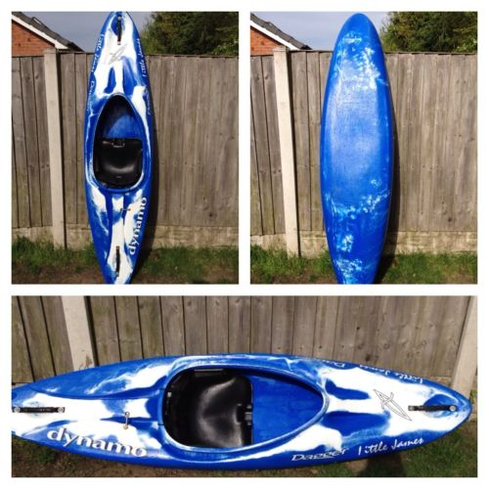
Website update KS has been working on a new “updates window” using our twitter feed. This would enable a number of people to control announcements on the front page and info to be sent to the website on the fly from smart phones and similar. If anyone has time please take a look at the demo page and pass on any feedback.
/index1.php
Junior Kayaks Paul Smee has taken back the two green junior Rebel Kayaks loaned to the club from St Helens. KS and Dave R have been looking for replacements.
We have recently purchased this Dagger Dynamo 7.4 from Ebay to replace one of the rebels – KS to pick up this weekend.
Kingsway pool Several of the rotobats are in poor condition. Dave Reynolds suggested buying footrests and sealing up holes etc. KS is trying to pad out thigh rests as members have been claiming problems when rolling. Dave R later suggested trying to purchase unused Manchester WildCatz Pyranha RX300 that they were offering to clubs in the region (They had 5 for £250 – Yellow) These would have footrests and thigh braces and could be used in the pool. NB Manchester Wildcatz have just received a large grant of £10,000 for boats and equipment.

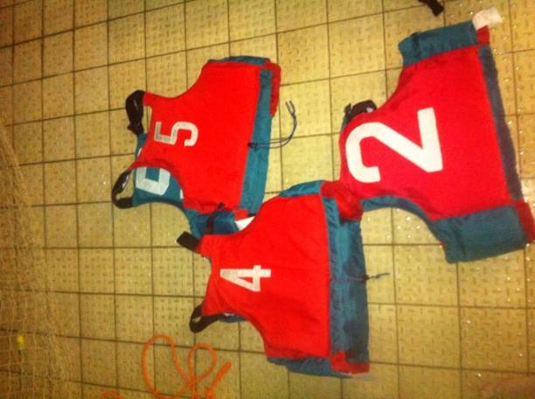
KS managed to purchased them for £200. 3 were nearly new – value £1350 and 2 were older but still serviceable with a little work.
KS to check out the kayaks, secure better seat bolts etc.
Kingsway pool 2/3 of straps to store the kayaks vertically is now in place. Many thanks to Frankie and Dave for sewing etc. We hope to finish off the remainder next week and remove the old racking from the poolside.

Talks at the Marina Monday night talks sorted for Monday 9th June 2014 “Icy East Greenland” Jim Krawiecki and Monday 14th July 2014 “Paddling around Menorca” Pete Thomas and the team
Buoyancy Aids We could do with a few more stored at the docks. Rather than purchase new from Decathlon KS bid for 2nd hand Manchester CC ones £70 for 8 good quality polo style BA to be stored at the docks. These will be used by all.
7/3/14 Kingsway pool

Kingsway Leisure Centre has a new manager, Bradley Lang. He has done some canoeing in a pool in the past and is very pro the canoe club. I met up with him today to discuss a number of items.

1/ We will replace the racking at Kingsway which has now corroded and is missing at least 3 supports which having broken off. The club will provide the stainless steel eyebolts as per Broadgreen pool. We will use a double plastic buckle and webbing system rather than bungees (which decompose in a pool environment) as the base of the kayaks will be mounted on the 2 foot high wall.

The leisure centre will fit the new eyebolts (as they have to use their own contractors) and remove the old racks for us. We just need to specify where they are to be placed. KS to purchase eyebolts from Screw Fix direct and mark wall for positions. Approximately £131.52 depending on number of brackets needed (21 pairs at £5.48) for 21 boats - we only have space for 18 at the moment, Update KS purchased top grade stainless Steep pad eyes. Update (Top grade 316 / A4 standard) purchased from Chris Taylor Marine £112.70 + £22.90 for A4 screws. Plastic buckles and webbing for £54 – Frankie is sewing them to fit.

2/ We have been given permission to put up our own notice board next to the swimming clubs` board. We supply they will fit it for us. I propose to purchase Classic Lockable Notice board Aluminium Framed - Single as it will fit in with the swimming club board next to it, is relatively good value and less hassle than getting Mike Bell to make a custom one. 1.2 x 0.9m £131.40 including VAT and delivery. KS to order and get delivered to Kingsway Centre from TeacherBoards (1985) Ltd £131.40

3/ We discussed the relationship between our club, its sessions and duty managers / lifeguards. Bradley was very sympathetic to our position and was keen to develop paddling at Kingsway. He mentioned summer clubs / kids sessions during the holidays. I mentioned possibility of a staff training session(s) for his pool staff

4/ Bradley also offered us the free use of meetings room if we needed it for the odd meeting

7/3/14 Purchase of Jackson Dynamic Duo Tandem Kayak

Thanks to John Cooke for spotting this local eBay sale – to be stored at Kingsway pool if we can or the docks

118 | 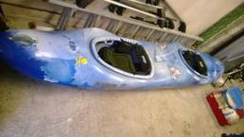 | Jackson Dynamic Duo Tandem Kayak  £10:00 per day | WW | Blue / White |  | Arriving soon

Supported by Keith S, Dave R, & John Cooke


6/02/2014 John Hulley Cross Mersey Swim. - Concerns over Safety going forward.
Copy of email sent to the organisers of the event

LCC Committee
Liam Hanlon liam.hanlon@theforshawgroup.com
Jimmy Tinsley jimmyjtp@gmail.com
Brian Henners brianhenners@btinternet.com
Joe Coy jcoy@btinternet.com
tugboatcath@googlemail.com
Robin Baynes robinbaynes@hotmail.com
Martin Suzan martin@swim-safety.co.uk

Hi all,

For a number of years now Liverpool Canoe Club have been a little concerned at the difficulty of securing qualified / experienced paddlers and the problems with ratios of kayakers to swimmers, and the overall coordination of safety cover for the John Hulley Cross Mersey Swim.

Because of these increasing reservations and following concerns specifically raised by some of the safety kayakers who volunteered to help at last years event, Liverpool Canoe Club will not be recommending the event to any of our members this year.

We do have a number of trained Swim Event Safety Kayakers who do volunteer to help cover events all over the country. These events are all coordinated and overseen by a qualified / contracted event safety officer. They provide a measure of insurance and professional coordination for large swim events. Event specific safety procedures are written for the venue and safety guidelines regarding experience / qualifications, ratios and coordination are followed. http://swim-safety.co.uk/

If Liverpool Canoe Club were to support the Cross Mersey Swim in future we would want assurances that this level of event supervision was guaranteed. Indeed, I would suggest that Martin Suzan (Swim Event Safety Ltd) is contacted for advice and possibly contracted to provide coordination of the various safety teams and to oversee the event.

Yours truly,

Keith Steer
Liverpool Canoe Club
www.liverpoolcanoeclub.co.uk
website@liverpoolcanoeclub.co.uk

7/1/14 Purchase of Delphin 155

New style skeg and skeg box – refurbished factory stock
108 | 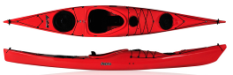 | Delphin 155 £15:00 per day | Sea | Orange |  | Delivered 10/1/14 Needs Numbering

Supported by Keith S, Ian B, Pete Thomas & Frankie Annan

29/10/13 LCC Bursary Applications

I have agreed in principle to fund 50% of course as usual.

Mark Garrod – 5 Star white water training and advanced WWSR – Location Fort William – 50% = £100
Matt Pegram – L1 Coaching course – Helen Bolister – Location West Kirkby – 50% = £100
Mark Garrod – L2 conversion course – Location Liverpool Docks – 50% = £25

Supported by Keith S, Ian B, Dom B, Dave R, karl leung, Steve Bond, Pete Thomas, Sam Godsell, Mike Alter & Frankie Annan

/Coaching/

One thing LCC is good at is being transparent with all financial and any other dealings.
If it was a wealthy dude looking to get a bursary I would think twice but, as long as Matt and Mark have documented a good case and as long as we have the cash, I think these guys are both good candidates. Good luck to them.

Maybe we should consider a limit to the overall bursary level granted in any one financial year and also consider a limit of occasions in a year that any one person can ask for a grant? Pete Thomas
The Bursary Scheme is self-limiting, It uses the funds raised by coaches running coaching courses and not claiming any petrol expenses. When it runs out (never has reached anywhere near) bursaries have to be carried over to the following year. Multiple awards would only be granted to those coaches / leaders running lots of courses or trips and all bursary forms are stored on the website. KS

No problems here at all with these - well done those paddlers.
Each person should be considered on individual merit, but going forward I wonder if we should keep bursaries to a more general "club" level that gives most bang for our buck back to the club members. Higher "out of club paddling" awards at personal cost as these are more likely to be of use in personal paddling arena. So:

In - for consideration: 4* leader, L1, L2 MWE in (after previous supply of 4* leader service) Disabled endorsement ( a few within club only)

Out 1-3 & 5 star (training or assessment), L3, L4, L5, AWE FSRT Any WWSR (basic or advanced) First Aid Coach Updates Modules Performance awards

Obviously would need reviewing as BCU changes awards round etc. Mike A

While I understand exactly where Mike is coming from with this proposal I am not sure that I see the need for list of approved courses. Each person is considered totally on merit and active coaches who run courses & trips for the club are encouraged to apply for the bursary Award. Most club coaches prefer to fund their own courses and will not apply – I would like to give more awards and constantly encourage people to apply. Everyone who has filled out a Bursary form so far has been fully deserved of any partial funding offered.

There are many very experienced coaches in the club or coaches / leaders who hopefully will wish to develop their leadership or coaching to a high level. These coaches probably run the bulk of the basic courses for the club or indeed lead on moderate and advanced water with the club thus provide an essential service. They also probably oversee much of the coaching, or experienced paddlers leading sessions or trips within the club and provide vital role models and mentors. It is these people who top up the Bursary fund by running such courses (ie the £5 and £10 booking fees alluded to above) and they should be able to apply for bursary funds to develop their own experience as the club will nearly always reap the benefits. All those granted funds so far have agreed to run improvers, beginners / introductory, and BCU certificated courses for the club and consequently will add more to the bursary fund than they could ever take out. Indeed without them the club would not have progressed to where it is today KS

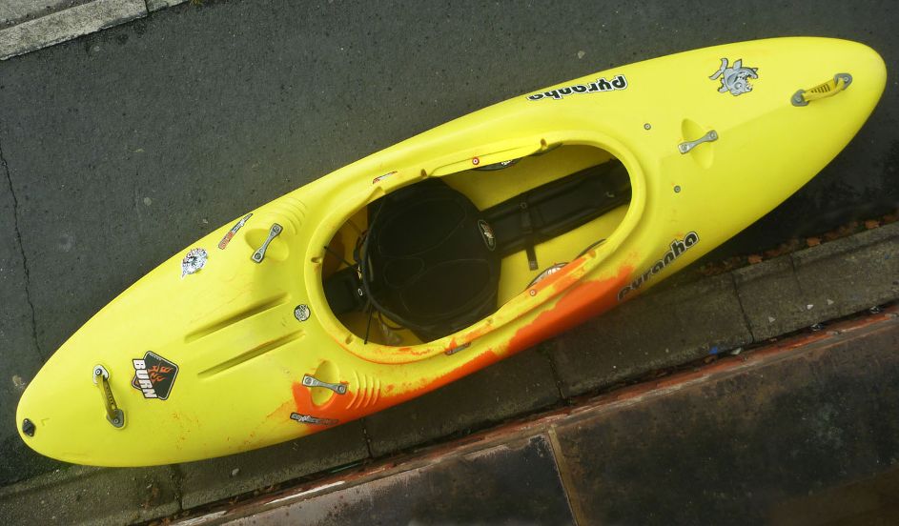
29/10/13 Equipment purchase – Large Burn

Offered to buy for the club a second hand Burn – Large from a club member. This high quality boat was just too good a chance to pass especially as we are still a little short on large cockpit boats.

Nearly new - £375.

Action Point : K Steer, Supported by Ian B, Dom B, Dave R, Steve Bond, Pete Thomas, Brian Green, Kirk Williams, Frankie Annan.

28/10/13 Hilbre Race 2014

Given that we have people coming in from all over the country with race specific craft, I wonder if we should consider doing any of the following:

1) Split the categories into touring and racing in a similar manner to that which they split the Oban race. Normal sea kayaks in touring, Waveskis, Tarans, Pace's, Epics, Nelo's, Rapiers etc into the racing category. (see here for example http://www.obanseakayakrace.org/results.html )

2) After the fantastic effort by Joe Boote as first member in - have an award specifically for first club member - (or first club man and first club woman).

Reason being is that I like to see everyone having a chance regardless of the kit they have, and secondly to ensure that the fastest club members are guaranteed a prize - keeping some glory within the club and rewarding effort.

Apols if the above has already been discussed and moved on, I think the classes may have been, but hey.

Mike A

26/09/13 Equipment Purchases – Kayaks North West £1572.10

10 x K102 paddles 3 x Left, 7 right handed 194cm length with 45 degree feather
10 x Junior River PC/ABS paddles 3 x Left, 7 right handed 180cm length with 45 degree feather
1 X Prospector 16 (Ex demo)

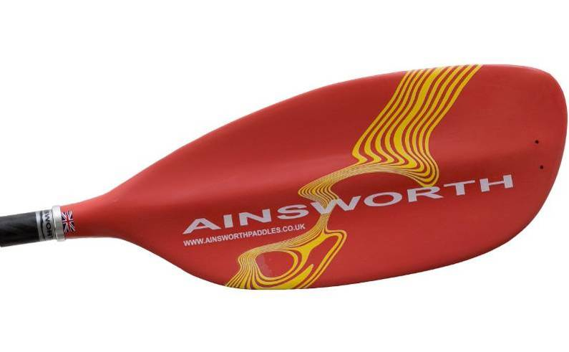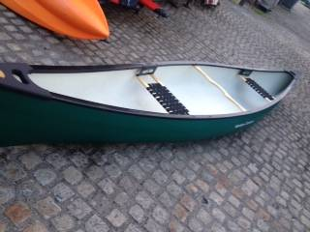

26/09/13 Equipment Purchases – Manchester Canoes £831.22

8 x BLH001 Buoyancy Blocks RUK for open boats (ie 4 pairs)
20 X 85cm RUK Air Bags (pairs)
10 x Palm Economy Spray Decks Red N5

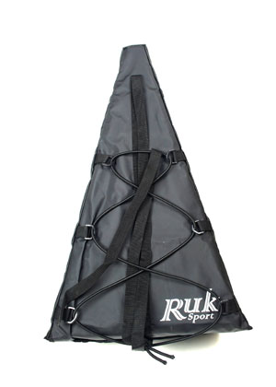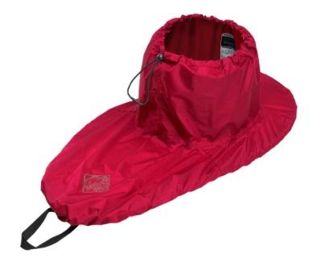

Kayaks North West.  Marina Village  Preston Brook  Runcorn WA7 3DW  Phone: 01928710770  Email: sales@kayaksnorthwest.co.uk  www.kayaksnorthwest.co.uk  10% off for members of Liverpool Canoe Club | Where are the nearest kayak shops??? | Manchester Canoes  Unit 14-15 Rufford Court  Warrington  WA1 4RF  Phone 01925 818437  Email: sales@manchester-canoes.co.uk  www.manchester-canoes.co.uk  10% off for members of Liverpool Canoe Club

31/08/13 Equipment update.
Liverpool Canoe Club are looking to purchase the following asap: Please quote your best price(s) for each

20 x Pair of Stern airbags to fit creek boats RUK / Peak or similar 85cm?

6 x neoprene deck covers for sea kayaks – large cockpits

10 large nylon decks – to fit largest cockpits – Master TGs (Grey / black pyranha ones or similar)

Paddles
10 x K104 paddles 3 x Left, 7 right handed 194cm length with 45 degree feather

Paddles
10 x Junior River PC/ABS paddles 3 x Left, 7 right handed 180cm length with 45 degree feather

Ranger 16 open canoe or similar – Preferably ex demo???

11/08/13 Coach records of Membership
All coaches have now been transferred to a yearly update requirement.

/Coaching/Revalidate%20Membership/index.php

19/07/13 Block Buoyancy for the opens (Frankie Annan, John Pegram)

Buoyancy for open boats

I measured a triangle foam block from Kayaks NW the other day

The dimensions are:
30cm high
730cm long
42 cm wide at the front

It is slightly rounded underneath to sit in the bottom of the boat.

Once the 8 blocks are made Frankie may be able to make some covers – they are velcroed round to make a snug fit. – some kind of heavy robust material – colour really does not matter.

The club will pay for all materials

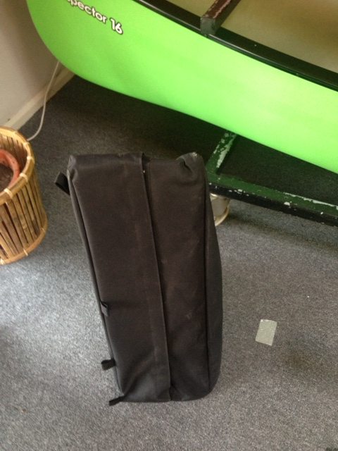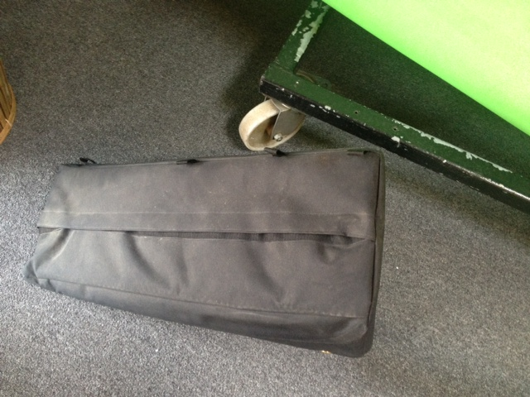

15/07/13 Junior Pool Session from October at Broadgreen
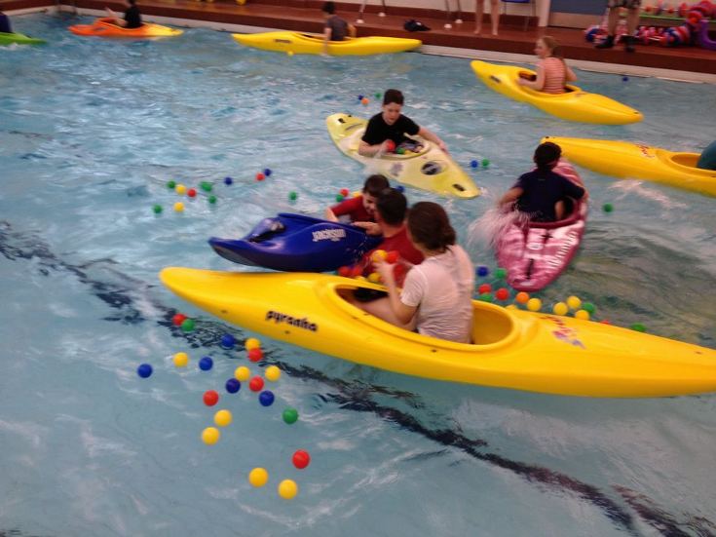
I have managed to negotiate 3 hours from 6:00pm next season so we will have the pool from 6-9pm. We could perhaps have two junior sessions; under 11`s at 6, under 16`s from 7 and a general session from 8pm. We can obviously adapt as we go or following your thoughts or feedback.

We will almost certainly take on the full hour on Monday nights at Kingsway pool from end of September but we just need to make sure it fills over the summer following Stuarts and John / Ben`s good work.
10/07/13 Coaching Membership Category
We have now tested the update procedure for coaches registered with the club. The online request form can be view via links on the website or directly below:
/Coaching/Revalidate%20Membership/index.php

23/06/13 Coaching Membership Category
Currently the category gives our online system a few problems as it sets the expiry date as infinite. This means that over the last 4 years much of the data has become out of date. We need our coaches to regularly update their information (once a year). One way around this is to set it as a paid for membership like everyone else except that coaches will need to contact the membership secretary each year to declare either :

1/ Confirm that all their Documents have been updated (BCU No. First Aid, Coach update etc)
Or
2/ That they have helped out running a coaching course or other significant contribution to the club and are working on validating their coaching or leadership Award.
The Membership Secretary will then confirm the details and change their record giving them a years free membership. If they do not contact the membership secretary (via a link / simple online form) then they will need to pay to keep their membership up to date.

I have experimented with a variety of different techniques to sort out this anomaly. This seems to be the best solution, although not fully automatic. Downside is that we may loose some coaches from our lists but gain would be up to date records for our membership lists. It also rewards coaches who do update and jump through all the hoops or who are most active. It will not require any change in the constitution as this type of membership is only for fully updated coaches or 4 star leaders.
23/06/13 Dave Blake has manufactured 10 uprights for our canoe rack at the docks
With the open canoes now being stored on top of the racks Dave has fixed 10 uprights to help stabilise the boats in strong winds. They still need painting with Hammerite paint. We currently use orange tape to lash down the boats. Stern painters are also fixed to the back rail. We will experiment with tying down systems over the next few weeks to find out which is the most stable, easiest to use.

23/06/13 Aspirant Coach and Leadership Training each Monday at the Docks from 6:30 - 8:30 pm (except for weeks where we have a lecture or talk from a visiting speaker)

Aspirant Coach and Leadership Training
We run an Aspirant Coach and Leadership Course for any club member who is interested in developing their skills and knowledge to either:
a) prepare for a L1 coaching course,
b) prepare themselves to help as an assistant coach at club sessions
c) develop leadership skills to progress through 4 and 5 star leadership awards.
The course runs informally each Monday at the Docks from 6:30 – 8:30 pm (except for weeks where we have a lecture or talk from a visiting speaker). Places are limited and you are required to book a place (free) online each week.
Initially we will concentrate on teaching 2 and 3 star skills, FSRT and rescue skills. We will also try to widen your knowledge of paddle sports as the course develops. You will also be offered a mentor within the club to help you with your goals. In time, it is hoped that you will be able to help the club run courses and trips and generally help develop paddling within the club.
Course tutors will include: Ian Bell (RCO), Dave Reynolds (LCO), Dave Cook (CDO) and Keith Steer (Club coach)
The first session will start on Monday 1st July 2013
To book, go to our booking page /members/Bookings/

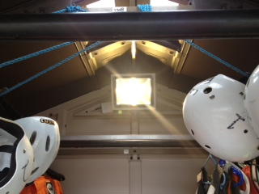
22/06/13 New LED floodlight installed into shed

A new floodlight (LED) has been installed into the shed. This is far more robust than previous ones and is fully automatic and should need little / no attention. It comes on and goes off automatically.
20/06/13 Junior Kayaks, Helmets and opens
Chris Murphy has spotted another Dagger Dynamo for sale locally. A last minute bid has been placed. We may also be offered 1 or opens from Outward Bound Aberdovey. KS to follow up. The club is also looking at purchasing more junior helmets for easy river trips (eg Chester Weir). Currently we are evaluating BMX style helmets and Cheaper Canoeing helmets (Nexus and Osprey) at around £18 each.

Open boat solid buoyancy is also on the list but given the price I wonder if we can cut our own polystyrene (can anyone source polystyrene blocks?) to shape and someone to make a cover for them (a velcroed fabric wrapping for the block to go in the end of the canoes) (Frankie?)
Buoyancy bags quotes are still awaited from both Manchester Canoes and Kayaks NW.

20/06/13 Hilbre Island Race
Frankie has spotted a conflict of dates with the Anglesey weekend. KS is contacting Dee Sailing club with a view of using it as venue for the start of the event. Depending up on the outcome we may have to move the Anglesey Weekend.

20/06/13 Top Club Gold
KS met with Dave Cook to go over the final submission of the Top Club Gold documents.

20/06/13 New racking and lights at the docks
Dave Blake is making 10 uprights for the opens which are now to be stored on top of the racks. KS put two new bars on the side rack to encourage paddlers to store boats on there side. We can then break the welds (Peter Stone) with a grinder and move the top bar higher to allow for 3 rows of kayaks on the middle rack, KS has purchased a LED floodlight to fit in the shed so hopefully it will be more reliable and totally automatic during dusk.

18/06/13 Disabled Group Sessions at Halewood Pool
A new manager has taken over at the pool (Eric Drew). Dave Reynolds and Keith Steer are contacting him to discuss canoeing developments at the pool (Polo and the Wednesday lunchtimes disabled group). Hopefully he will be as pro canoeing as Kevin Lynch.
10/04/13 Monday Night Pool Session Extended throughout the year
Stuart Toulson, Ben Cooke and John Cooke are willing to run the session throughout the year – Provided that it covers the costs of hire.

10/04/13 Offer to buy 2 of these for the club – Michael agreed but have over sold them so will get back to us.
For Sale: 11 x Dagger Charleston 15 foot £100.00 each NOW SOLD
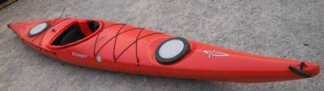
We have 11 of these for sale. All come with hatch covers.

We are looking for £100 each.

Contact Michael Alexander…….

3/03/13 Work on the goals at the Docks
Mark G, Keith S with help from Sunday morning paddlers managed to right the goals and put them back into their normal positions. They have blown over twice this winter but still look to be intact.

3/03/13 St Helens Canoe Club joins forces with Liverpool CC
We have been given loan of (possibly permanently) of their fleet of kayaks (9 Inazones 232s, 3 G3 and 2 Junior Rebels) together with 15 spraydecks, and 15 paddles etc. They are to be stored at our pools / docks with the possibility of Paul Smee running some sessions over the summer at Kingsway on our Monday night slot.
Currently
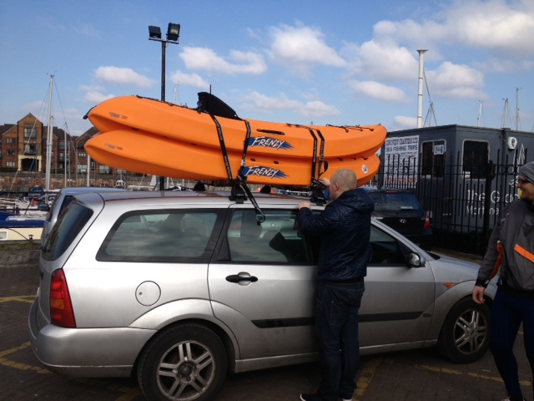
9 Inazones at the docks, 2 Rebels to Junior sessions at Broadgreen, 3 G3s to Kingsway with 2 of our large Z ones going to the docks. The small double wheelbase trailer has been stored temporarily at Wallasey Scout Headquarters. It is thought too small for use behind a minibus.
3/03/13 Disabled Canoeing at Halewood Pool
We have been asked for help with coaches etc by Kevin Lynch the pool manager to run a couple of midweek sessions for a disabled group at Halewood pool.
Sessions at the moment are:
Monday: 2pm – 3pm
Wednesday: 11.30pm – 12.30pm

We have 4 (5) potential coaches that may be available to help. Dave Reynolds has volunteered to coordinate / oversee the running of the sessions.

Mark Garrod delivered the sit on tops today to the pool (although he was not keen to be seen with the boats on his car)

Garrod | Mark | Mark_The_Maniac@hotmail.com | 07522614221 | 01512807382
Reynolds | Dave | daverey129@yahoo.co.uk | 07946793118 | 01514897286
Jackson | Keith | keithandjennie@talktalk.net | 07952169216 | 01925726786
Brockway | Anthony | brock99@btinternet.com | 07880 933135 | 0151 608 0425
williams | Dave | dsam.williams@gmail.com | 07759682329 | none

13/02/13 Plastic Doubles
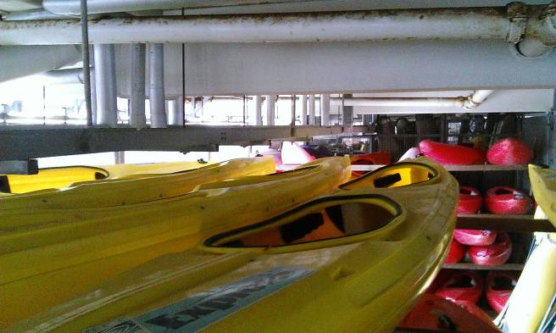
We have been offered some of the plastic doubles (K2) from Liverpool Watersports centre. After discussion we have been offered them at half their advertised second hand price of £200. I suggest that we purchase 2 to replace the green fibreglass double donated by Jimski.

Agreed by : Keith Steer, Dave Reynolds Action : Keith Steer to arrange deliver / purchase
Purchased for £50 each Feb 2013

Nb after initial discussion to buy eBay Dagger junior kayak from Bolton it was purchased before we could put an offer in.

05/02/13 Updated Equity Club Mark Documentation

Analysis of past media (Stewardship group and Brochures etc)

3.1.1: The club has adopted and has implemented the BCU Equity Policy
/members/Clubmark/index.php?dir=3.1.1%20Club%20Equity%20Policy/

Summary
We have made progress in terms of the numbers of women, juniors and ethnic minorities in the club. We had achieved this by providing positive role models in key positions and publicity material. To date Gareth Fields / BCU have provided not provided any statistics on diversity within Canoe England as whole it is there fore difficult to know how our membership compares with the country as a whole. Indeed, as Merseyside has its own breakdown it may be of little relevance how we compare to the whole country.

We need to continue to develop positive role models, especially in the key areas of Youth, women, ethnic minorities and especially the disabled (although we may have some practical limitations with facilities at the Marina). We acknowledge that we are particularly strong in relation to middle aged and older male paddlers in the club.

04/02/13 Junior / medium sized play boat
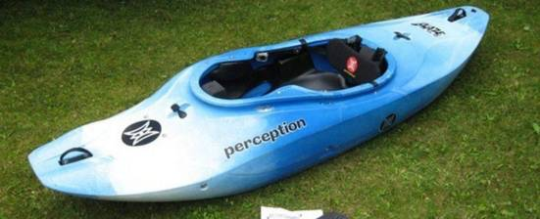
Kurt Toulson has had his boat on the club site for some time. Having demoed it last Thursday I think it will be a good addition to our fleet. Stuart who runs Monday night sessions is replacing some stainless bolts for us. I would like to offer £220 (the asking price) for the boat. It will be good for juniors, adult playboaters etc.

Agreed by : Keith Steer, Dave Reynolds

We are still looking for more wavehoppers, plastic sea kayaks and especially junior kayaks (Dagger Dynamos, Pyranha Rebels)
04/02/13 Broadgreen Pool is gaining in popularity
The junior club has been thriving recently and should provide continuity between the dock and the pool for the section in future. The school have now allowed us to keep 8 kayaks inside the pool. We have purchased stainless steel eyelets to hold the boats in place. This a great development as it means we will not have to build a rack and makes the session far easier to manage.
04/02/13 Pool Sessions next year
KS has received pool session applications for Kingsway pool next season and will send of information in due course. Some members have requested that we keep the option of a pool session throughout the summer. There would not seem to be any problem with this provided:
1/ It pays for itself (Needs an average of 6+ people attending to break even)
2/ Coaches or experienced individuals available to run it.


Proposal is to try to keep Monday night at Kingsway (half-pool) running throughout the summer. John / Ben Cooke seem keen to supervise. In addition L1 coach from St Helens (club member) has set of pool boats and wanted to try and run sessions in our pool over the summer as St Helens pool no longer available. We would keep the payment system and online booking as per usual. I will ask John and Stuart to ask Monday night paddlers if it will viable.
04/02/13 Membership form reviewed and modified to reflect Ethnicity and Diversity Policies

4 extra questions were added to the membership for to help monitor our membership. Only the Membership Secretary will have access to the data and it will only be used to help monitor the success of any membership initiatives. The questions were adapted from Warrington`s employment application form and address: sex, age, ethnic background and disability.

New members will be required to select an answer and existing members will be required to update the fields if they review or modify their details in account manager.

To review please go to /cgi-bin/oc/manage.cgi or via the account login tab on the website.
Action Membership Secretary.

04/01/13 Reel Paddling Film Festival world tour 2013
Although we made a small profit (£71.69) on last years RPFF 2012 which was well received despite a few technical issues it was always a little tight and the fees charged (£9.00) seemed quite high.

"2012 Reel Paddling Film Festival costs = £219.95 and £210.94 (Total costs £430.89) Total monies received £502.58


Dan Caudwell and Rapid Media seemed quite keen on having us involved so I asked for a discount if we were to commit early for the 2013 schedule. This he has confirmed he will do and we have halved our costs.

Sorry for the late reply on this. I understand that you are a smaller club and since you only require the films so we can do it for $300.

I've attached a Host Form filled out with info from last year and the new dates you provided (with notes the payment is to be only $300 due before we ship the films).
If you can double check the info is correct and add anything that is missing and send it back in the next week we can make sure it gets listed in the magazines before they go to print.

Thanks and let me know if you have any other questions.

Dan

We have sent the forms off for this years Film Festival and set the date as Monday 11th November 2013.
11/12/12 Merseyside Maritime Museum have asked for help with photos and film for a display
I'm a curator at Merseyside Maritime Museum. I'm planning to display a canoe early next year, made c.1900 in the Far East but very similar in design to a Rob Roy canoe. I'm trying to source some local modern images and film footage of canoeing that I could use in on gallery interpretation (on panels and possibly also in a short film) and on our website, and wondered if you could help. We would credit the club on any panels/film/website use etc. Ideally I need any images by the end of next week, but appreciate this is short notice.

Any assistance would be greatly appreciated.

Kind regards, Ben

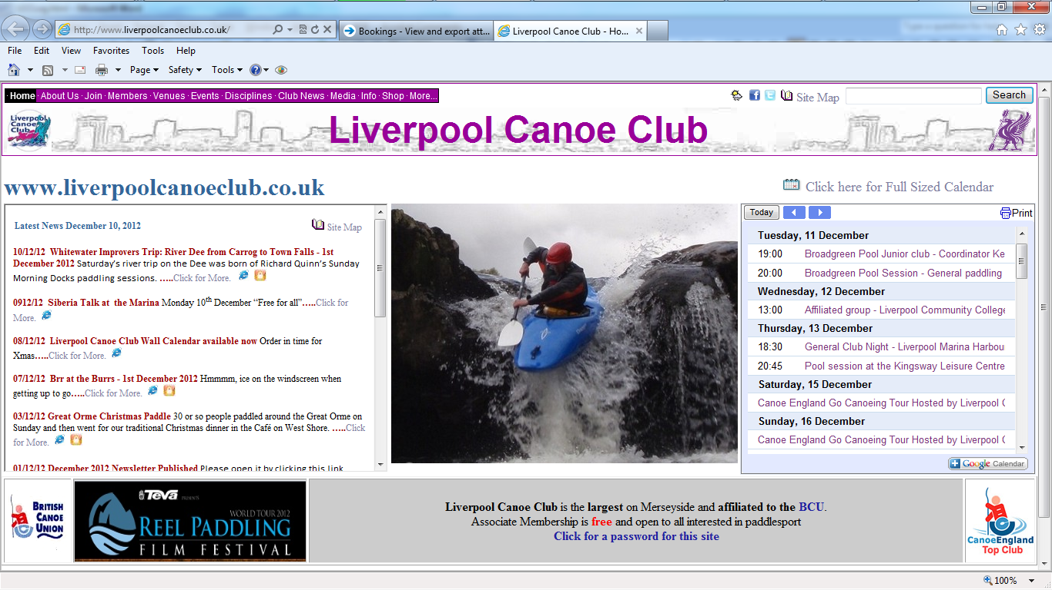
Ben Whittaker
Curator of Port History
National Museums Liverpool
Tel: 0151 478 4401
Fax: 01517087316

www.liverpoolmuseums.org.uk

Action KS to send off jpegs of pictures requested and offer links to LCC movies on YouTube

10/12/12 Website Update
Some the main pages have been updated with a top down menu system. These are all PHP and load very fast with server side menus and footers. This should mean that google will index our pages better and we do not rely on frames anymore to give the site its distinctive look.
10/12/12 Pool Update
We now have 3 pools with a number of sessions at each.
Kingsway Pool Mondays (Half the pool) and Thursdays 9-10pm
Broadgreen School Pool – Tuesdays 7-8pm (Junior Club) and 8-9pm General rolling practise (Not during school holidays)
Halewood Pool – Canoe Polo Mondays 9-10pm
These numerous sessions and courses in the summer needed an automated system for booking. We have adopted the services of Bookwhen.com which costs £6 per month. The system seems to be working very well.

Dave Cook and I have had several meetings with the Manager at Halewood. He has brought over 7 pool boats from other Knowsley Pools and is very keen to get more paddling at the centre. The Plan is for Dave C to run an Ergo session next year and possibly have follow-up sessions. These could either be staffed by freelance coaches, Knowsley outdoor leisure staff or possibly volunteer coaches from the club with a trade in for pool time for the club.
20/11/12 Purchase of club Equipment
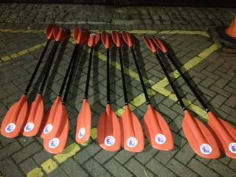
We have collected the 10 x K104 paddles and 10 x spraydecks from NW Kayaks and added them to our equipment list.
12/11/12 Reel Paddling Film Festival
Film festival seem to be enjoyed by all. Perhaps 3hrs was a little too long for some. In the end it cost £430.89 and we made £502.58 (£71.00 profit). As bonus the club was able to keep the DVDs. (Fiona W and Dave R have them)
10/11/12 Purchase of club Equipment

I have been looking at our resources again – especially in light of the two new venues.

We already have 20 Pyranha spray decks on order for 2 months now but they will be further delayed as they come from Taiwan! (Probably Feb) I have ordered 10 alternative YAK ones as offered a similar price with 10 Pyranha ones to follow in the new year.

We still seem to be struggling for larger cockpit boats for adults when at the pool. I believe that we need to continually need to evaluate our fleet. Fiona and I dropped in at NW kayaks again today and they have a surplus of boats so very keen to sell. I did my usually tour round asking for best price etc I then took a little off and then negotiated an extra £200 off if we took all of the selection below.

1 x G3 (large cockpit boat) £150 sound but with thinner plastic in places so not for use on WW)
2 x Acrobat 275 £150
1 x Karnali M £200 low spec but they will put in thigh braces.
1 x Karnali L £350
2 x Z-ones L £350

Total £1700 but if we take all 7 then only £1500

They also have an open boat – hunter 17 with 4 seats – we could have it for £400. This would replace the open that was loaned to the club and has now been sold.

I recommend that we take all of the above as they are considerably less than advertised and we have about £4000 in the bank.

Priorities for future boats would be: Junior kayaks (I went in looking for rebels but the two on offer had gone), another 1 or 2 wave hoppers, 2 or 3 touring / sea kayaks - Capella / scorpio / Easky 17`s or Flex`s.

Discussion on open boat from Dave, Ian and Mike. Action KS to look for a shorter boat.

Proposal to purchase the kayaks but not the Open Boat. Action KS . Agreed by Ian Bell, Frankie Annan, Dave Reynolds, Kirk W, Dinny Davies, Darren Bohanna, Keith Scott, Carl Leungs, Brian Green, Pete Thomas, Mike Alter, Samuel Godsell

28/10/12 Google Group and other media

I am aware that the facebook group used by the polo group is fairly active. Unfortunately it does mean that we have two systems for communicating (Polo googlegroup and polo facebook group). While I am still unsure about having two groups it may be time to take a look at our communication systems again.

I am looking for views / advice from anyone who knows about this stuff. Especially people like Kirk, Dinny, Darren B, Pete etc

Options seem to be:

1/ keep it as it is with four google groups with a self sign up page for members only. /admin/Message%20Board.html
2/ Open up the Facebook page to make it a discussion group and possibly close the current polo Facebook group so that all are included in all discussions.
3/ Replace or close the google group(s)

Main problems are:

We do not want sub-groups forming or cliques with in the club. All paddling / discussion etc is open to all members.
How do we ensure that members renew or join in the first place. This is not a big problem as most / all that paddle with us are members but there is no way to prevent non-members joining a facebook group or is there? Would this then be automatically tied in with our membership system. Keith S

Agree wholeheartedly that we don’t want schisms or cliques developing in the club; just the opposite, would be good for everyone to see what’s happening in other disciplines so they can consider cross-over opportunities.

Personally I hate face book with a passion. I work for a large Internet Infrastructure firm with a lot of techies. Facebook is banned and filtered upstream so nobody has access from within any of the company domains as its opened up security vulnerabilities in the past where hackers have caused lots of big problems.

I can see the need for separate groups, such as this stewardship thingy but wouldn’t like to see the main paddling disciplines splitting off into discrete sections and only communicating among themselves. I really appreciate the inclusiveness of LCC and enjoy reading the whitewater mail as much as the sea mail. It makes me feel like I want to try different things.

I think that Google Groups has the advantage of restricting access only to people who have signed up as a member. Facebook’s viral approach is different and its one of the things I don’t like about it. I realise I might be out on a limb with facebook but I prefer to see the Google Groups routes developed. If facebook was our main means of communication, I’m sorry but I would just have to dip out and look to other methods to find out what’s occurin’.

Just my thoughts. Pete T

First, I don’t really understand what “open up the Facebook page” in option 2 means. The page I set up is open to anyone by choice, all you have to do is find it and like it. You can then post to the LCC page and all other subscribers can see it, comment on it, even get personally notified of all posts to the page if they’ve chosen not to kill that option. As far as I can remember the only thing restricted to the admins is changing the page settings and posting as “Liverpool Canoe Club”……Don’t see why anyone really needs any other forum for discussions (on FB at least)? If anything further needs opening up then it’s either just an oversight that’s easily corrected, or a “page” is the wrong medium for what people want to do…..

Couple of general observations from my personal and work experience first:
- We’ll never ever get a consensus on “which social network” as you’ll just end up in with personal preference emphasis on the advantages of one over the other (if you were to ask my opinion in context of a social/voluntary club I’d say by far and away the biggest current differentiator the massive established penetration/reach of Facebook….), and
- We need to concentrate on what the club “officially” does rather than trying to reflect and/or control what individuals or groups of people within the club do. The very most I’d suggest we consider is a “policy” for people setting up their own subgroups, eg, they should all be open or open to club members at least (I agree with email Keith has just sent on this subject).

In that general context I think we really need to look again at our club social media objectives and strategy before we start trying to choose groups over pages, google over facebook etc:
- We need to decide what we are actually trying to achieve via a social media presence. My initial understanding was that the club wanted another popular channel to complement the website and group mailing list in disseminating information to all club members. This is why I set up a Facebook page, as opposed to a group.
- We need to balance how much effort the club wants to put into managing/moderating that channel against keeping it open/dynamic as a mechanism for all individual members to use for sharing club related content and tailor our solutions accordingly.
- Once we understand that we can decide what to set up and where to meet those requirements, but whatever we choose we need to be wary of viewing social networks/media too much in traditional structure/control context (ie, part of the power of the thing is it’s essentially open and chaotic nature…!)

So, having said all that, I probably think we should leave things pretty much as they are but do the following:
- Encourage all members to “follow us on Facebook” (or Google or whatever…) by liking the LCC page either manually and/or via a link on website (you can easily include “like button code” rather than current weblinks) and/or included in welcome email),
- Ask the subgroup members why they feel the need to have a separate group and don’t want to just post, discuss etc on the club page. It maybe that I’m missing some requirement they have/limitation of page format, or maybe they just want to have limited audience discussions to save “bothering everyone” rather than for any cliquey reasons. Interesting debate that one. I certainly wouldn’t go as far as closing anything down without agreement of the creator/admins, unless they break club agreed club rules/policy, eg, refuse to admit club members), and
- Focus “official” club efforts on keeping the content in chosen media alive and dynamic to give it value to members and encourage its use….

Cheers, Kirk W

Just answering some of the questions at the bottom:
- There is no way to stop non-members liking (joining) a Facebook Page,
- You have the choice of making a Facebook Group open, closed (anyone can ask to join but have to be approved by admin) or secret (invite only), so you could certainly manually restrict it to members only, but
- I don’t think there will be an easy way to automatically tie in Facebook with our membership system (almost certainly require some bespoke integration work/coding) but don’t really know enough about either the membership system set up or what we would be trying to automate to really comment….;-)

More info on difference between Facebook Pages & Groups here
http://www.facebook.com/help/155275634539412/?q=facebook%20groups&sid=0Sywr7Gdpp2SypG7s

Our communication strategy needs to be as open and inclusive as possible, though it is probably wrong to assume that people choose to use a Facebook group to exclude others.

We do I assume (?) need to consider the issues that relate to welfare, safeguarding, equality and diversity in our communication strategy.

Frankie

Summary of the current communications with in the club:

4 google groups (General, Polo, Stewardship, coaching),
LCC Facebook page set up by Kirk, LCC twitter account set up by Kirk. Relatively little used.
In addition Admins can log in to the clubs membership system and send emails to different membership categories – eg coaches, expired accounts etc.

More recently
Facebook group called Liverpool Canoe Club originally set up by Josh Cook for polo communication but little used, asked to take it down as it confused a lot of people.
Darren Bohanna then set up a new Facebook Group originally called Liverpool Canoe Club Polo and automatically enrolled those in current polo teams – agreed to change it to Liverpool Canoe Polo A, B, & C Teams. This is now used a lot by some of the people in the teams but those who are registered only for google polo group do not get messages as people tend to use one or the other.

We need to consider some of the suggestions above – specifically do we have too many methods / groups to communicate effectively to all? Will their effectiveness be weakened if too many. Why do some of the polo people prefer to use the group rather than the clubs page?
I am trending towards suggesting that we look at advantages of only having only 3 groups - LCC general google group and LCC Facebook page and the specialist Stewardship google group (which currently any member can join!) Keith S

I'm not particularly bothered either way - but my quick thoughts are as follows:

I personally prefer email to Facebook (mainly as I find it easier to use emails, as I'm not supposed to use FB at work, and don't spend all my spare time on it)
Though I can see, if you are a person who's life revolves around FB (as many lives seem to these days) - then that would be your medium of choice).
Similarly not everyone wants to join FB - and they should not have to, just to be involved in polo in LCC. But if it helps get people playing polo and training regularly - then it certainly should not be prohibited.

I do think it is sensible to have a separate group for polo (be it FB or email) - does everyone in the club really want 10 to 20 emails about who is polo training on a given night, twice a week?
I know I wouldn't....

Those posts of more interest to all members (which is a fairly small minority in my opinion) could be sent or forwarded on to all members via email anyway?
Those posts that are only on FB could continue to be forwarded to the polo google group (for the benefit of those players who don't want to be on FB) - though it is a pain for someone to have to do that (perhaps the" polo google group", could even join the FB group?)

Dinny

I think that Dinny’s point about few people wanting to wade through lots of polo emails may well be valid but, like any email, if I don’t want to read it I simply hit the delete button, no big deal.

I also think that most of the club would accept that there needs to be separate “stewardship” group and since communications within this group are generally published on the website for all to read and anyone who feels they want to join is can do so, there’s no danger of things getting out of hand.

So far so good.

However, I feel that the main point of this thread appears to be getting buried in some clutter so, at least from my perspective, and I’m willing to be corrected, I thought the main question is .... “what means of group communication best suits the club”.

It appears we now have Facebook, Twitter and Google Groups with Google being the most commonly used method. Keith’s summary below and his comments “I am trending towards suggesting that we look at advantages of only having only 3 groups - LCC general Google group and LCC Face book page and the specialist Stewardship Google“ describes, probably inadvertently, what already amounts to the seeds of a split within the club.

I can easily visualise the group within LCC that would prefer to use Facebook and I can just as easily visualise the group that would prefer Google Groups so, we already have potential for a split right there.

In response to Keith’s original posting on this topic I’ve already nailed my own colours firmly to the mast and stated that I will not use Facebook, Dinny has commented that “I personally prefer email to Facebook (mainly as I find it easier to use emails, as I'm not supposed to use FB at work, and don't spend all my spare time on it) “ and goes further to say “not everyone wants to join FB - and they should not have to, just to be involved in polo in LCC“ and Frankie says “I don't use Facebook that is a personal choice“ . It might be the case that Facebook does indeed have extensive “penetration” but there again, so did the bubonic plagueJ From just a small sample, it already seems that there are quite a few of us who don’t particularly want to use Facebook so I’d like to suggest that the sample size is increased – to the whole membership.

A simple vote would sort it out fairly and the question to ask needn’t be any more complicated than “Given the choice between our current system of communication, Google Groups or an entirely different system using Facebook, which would you prefer?”

I’ll be happy with whatever results come in and would still refuse to use Facebook. Used it once years ago and decided it wasn’t for me. Pete T

Lots of considered points in this discussion so far. I was recently reprimanded for saying “I hate Facebook” and was told should that not be “dislike”!. Anyway personal preferences aside we need to decide what best suits the club, which is its members. . It may be time to take up Pete`s point to ask the members. However I guess Kirks earlier point that you will never get a consensus and it may well come down to personal preference.

However, this discussion is taking place among the Stewardship group through the medium of Googlegroups. Darren Bohanna has not replied yet, maybe because he mainly uses Facebook hence we may not be communicating effectively with “all” those on the Stewardship group or all in the club if we were to widen it out. We would be forced to post on all mediums that we currently use to reach everyone – 5 times the effort.

I do not ever want to exclude any member of the club by forcing them to use one form of media over another, however. If we have more than one method of communication inevitably people do not post on both, so as an existing or new member do I have to join 2, 3 5 or all 6 groups currently to get all the information.

To balance things up / muddy the water further, I do like the chaotic nature of Facebook and the way it causes people to respond but maybe this does or could happen more with our current google group – especially if we turned on reply to all function (but this was designed to stop people getting too many emails) Keith S

Surely the key is that whatever method is used for communication, it must :
1) Be inclusive to all that want to be involved in the activity
2) be affective for the purpose that is intended.
3) Does not act as a perceived closed door, even if that is not actually the case / intention.
So, as long as there is the ability for all members to be aware of an event via the clubs calendar or other format open to all, and a top write up on the website afterwards, then the actual minutia of organising the event or any banter surrounding that event can go in whatever the easiest / most applicable format that is able to reach all who are interested.
With regards to communications in general, trips and one offs work very well with communication through the e-mail / calendar system as a starting point, however for regular training groups then a more free flowing system such as facebook or a web forum is probably the way to go - on the proviso that any member who wants access, can access. How you keep track of conversations on two communication tracks though is something that I wouldn't want to get involved in, but if it works for those involved then hey, get on with it!
BUT, especially with regards to Facebook or other social media, whoever is organising must recognise that not everyone is comfortable using / able to use facebook, and they must have systems in place to ensure that members who are not comfortable using the "normal" communication systems can be included in all relevant information. That is the easy part, slightly harder is ensuring that members not part of the banter does not feel excluded from the banter / social / organising side.
As an aside, new website looks and more importantly works far better on my mobile devices, so thanks to whoever put in all the hard work. I would however recommend that some of the content is improved and we make better use of the clubs Facebook page, even though I think Facebook is on the decline at present, because the current FB page undersells the club and all that we do.
Suggestions:
1) Club talks / events for non-members are advertised on the FB page. This makes it easy for other websites to pick up on our events and spread the word.
2) When a member submits an article for the website with picture. One picture is posted via the admin onto the FB page with comment such as "LCC river trip", "LCC polo tournament", "LCC coaching update event" - this would allow people to comment / encourage postings / show the world how great we are without risking identities.
3) On the discipline pages, we need a bit more information about the ones we actually do, and how you can get involved. So, for example:
3a) Rivers - state that we have numerous river trips throughout the year. Many are run as just a group of friends on an assumed risk basis, however we do have qualified coaches / river leaders who are able to provide training / guidance as required. See calendar for type of trip being offered
3b) Polo, why not sell the fact that we have a relaxed "Stupid ball" session on whatever nights, open training sessions for all as advertised on the club calendar and that we have multiple teams who go to competitions. Let members who are not in the know, and are perhaps a little intimidated to ask, understand how they can access the sport and then progress up the ranks and into one of the team. As a top class polo player myself, nose nearly went through the screen then, how do I get in the teams? Do we have tryouts, are the teams fixed for the season, is it whoever is able to make it on the day? Without such information it could appear that the teams are a clique, even though they are not.
Apols if lost it a bit in there, but its getting late. IN conclusion. Not too many forms of communication, but as long as the chosen format meets the need and is accessible by all that want to access, then whatever works Mike Alter

For those who don't know me, here's a brief intro & overview of my paddling involvement;
I've been a member of LCC since it was formed and I've been a member of FOA for a number of years before that.
I'm the paddling co-ordinator for the 1500 or so cadets from Merseyside Wing Air Cadets and have some involvement with the Territorial Army.
I'm a new UKCC Level 2 moderate water river kayaking coach, I get involved with many of the clubs river trips, I've done a bit of canoeing and sea kayaking with the cadets, and I'm the new LCC polo rep. Not that its necessarily been inferred but it's sometimes a miss conception of polo players, I'm not exclusive to canoe polo and I am all welcoming of cross activity within paddling.

As you know from the comments in this thread I'm the person who set up the facebook canoe polo group. This was done purely to be a practical form of communication to the members within the 3 teams, maybe naively on my part as I didn't anticipate that it would generate a discussion about splits or cliques, but I want to be clear that that is definitely not my intention. All but 2 players from the 3 polo teams are on facebook and approximately 80% of those are regular users on the group, often replying to posts about training etc within minutes. The intention is not to cause clutter or yet another medium for everyone to follow, but for the reasons its success and use has proven. If paddlers from LCC who are not part of the polo teams and wish to join the group and learn a bit about polo then I will be happy to accept their requests to join the facebook group. In fact if more of the 700 or so members want to get involved with polo then surely its got to be good for the LCC teams.

If I need to shut down the group to fall in line with any policies of the club or a club vote then I will, but it will be a shame to slow down the progress that the facebook group has contributed to.
Other than a couple of members of the A team, and practically no one over the last few months, the google polo e-mail doesn't seem to generate much discussion activity. Not sure if this facebook preference is a generation thing, given that the majority of the polo players are aged 25 +/- 7 years.
Kind regards,
Darren Bohanna

General polo update and Answers to 3b) below,
To be honest I've only attended a few Thursday sessions and none recently, purely because I have other commitments on a Thursday so I can't give you much of an update on the ''Stupid ball'' sessions but I agree that it should be advertised more widely. The limited rules/ relaxed format polo seems to be a good stepping stone between general dock paddling and the full form of the game.
We have 3 national league teams, the A team which is in division 3, and the B and C teams which are in division 4. We also have 2 teams in a new developmental local league (North West & Central) the A team in division 1 and the B team in division 2. The 2 NW&C teams are mostly a mixture of players from the 3 national league teams with a couple of river paddlers who are having a go. Again, I welcome any advertisement of our participation, I published an article in the summer and Liam Wong has published an article this week, more and other forms of advertisement are encouraged (for anyone who is involved with various media inc the club website).
The allocation for this current national league season (October - April) is currently over subscribed. Each team should have a squad of at least 5 but generally 8 players and no more than 10 for the whole season. For the 3 national legue teams we have approximately 30 players who have either registered and payed for the tournament or have expressed and interest to train and be on a stand by list. I have recently negotiated LCC's involvement in what was an FOA ran university league, we entered 2 teams in to the first set of competitions a couple of weeks ago with 3 more local tournaments to follow. There is the opportunity for many LCC teams to enter in to this including new novice teams from the club who are not yet involved with the sport.
A brief history up to the current season of polo with LCC
3 years ago the original team (A team) with Keith, Dinny, and co was formed from their old FOA division 3 team.
Last year the B team was formed by me, a combination of old FOA players, and newer players from the Air Cadets and LCC general paddlers.
This year the C team was formed through discussions between river paddlers on trips at Scotland and the Alps.
The teams have trained a lot more this summer than ever before. There has been a little bit of to-ing and fro-ing but the teams have finally been selected and registered with the league organisers. It has been decided that any changes to this seasons teams would have to be agreed between the team captains and any individual concerned.
Team captains - National League - A team Dinny Davies, B team Darren Bohanna, C team Roy McHale.
NW & C League - A team Keith Steer, B team Roy McHale.
Currently the best players are not in the best teams but this is likely to change for next year with a squad selection, teams and new captains likely to be decided between the current captains and polo rep.
Currently the teams are all playing at a standard not suitable for complete beginners; the lower teams are a combination of new players and players with at least 1 seasons experience.
Next year I hope to enter a new team in to a lower level novice league NW & C div 4.
3b) Polo, why not sell the fact that we have a relaxed "Stupid ball" session on whatever nights, open training sessions for all as advertised on the club calendar and that we have multiple teams who go to competitions. Let members who are not in the know, and are perhaps a little intimidated to ask, understand how they can access the sport and then progress up the ranks and into one of the team. As a top class polo player myself, nose nearly went through the screen then, how do I get in the teams? Do we have tryouts, are the teams fixed for the season, is it whoever is able to make it on the day? Without such information it could appear that the teams are a clique, even though they are not.

Bit to add on,
During the summer Months training has taken place down the dock on a Monday and Thursday night and this is open to anyone who wants to get involved, however the Monday night session is thought to have been at a slightly higher standard but no one has been turned away and all new comers have been welcome.
Now that we don't have natural daylight during the evening the Monday polo dock sessions have stopped, I think Thursday sessions might still be happening.
Add hock Saturday afternoon sessions have been happening and will continue when there's been enough interest and we've not been at a league competition.
Delicate negotiations have taken place with FOA to allow all registered LCC national league polo players access to their pool session at Speke as guests and this is a work in progress.
When the clocks go forward in April we can look at evening sessions back at the dock, hopefully with new players from the LCC membership. If there's enough interest we could possibly run a Saturday morning session for new/ interested players from elsewhere in the club.
Hope this has been of some use, Darren Bohanna

Cheers Darren, very useful info on user requirements/usage that needs to inform debate.
I think this highlights a very important distinction between the two distinct forms of communication - email groups (Google or otherwise) and social media/networks (FB, Google, whatever). They are fundamentally different ways to interact & communicate, and email was not designed to become a sharing/chat/discussion forum, it just evolved to be (mis)used that way ;-). Telling bit of info there is that Polo FB group is dynamic and active whereas email list is pretty quiet.
It seems clear to me that although I set up LCC FB page for what seemed like good reasons based on the objectives I understood, there is also a demand for a group with it's differnet functionality behaviour (it's much m,ore focussed on dialogue/exchange between a defined group of people rather than publishing information to the world....) So maybe we should just make the LCC Polo FB Group the "LCC FB Group" and encourage anyone who wants to join it to do so and use it for sharing/comms if that is their preferred medium? In that case we would:
- Keep the LCC FB page as the main info publication medium to complement the website and reach the large number of members on FB, plus attracting interest contact from non-members
- Change current LCC FB Polo group to be an overall LCC FB group to be used by any club members who want to join as individuals to share, communicate collaborate as they see fit, and
- Keep the ("googlegroup*) email group as the standard all inclusive mechanism of exchanging comms with all members, or creating/managing necessary subgroups like stewardship etc.
Doesn't that satisfy all requirements and keep everyone happy?
Btw Darren, noone thought you were trying to set up a splinter group, just trying to address tendency for things to fragment if we don't keep up to speed!
Cheers,
Kirk

All of the comments received so far have been very useful. None of the discussion should be thought of as critical of the way anything has been done or evolved – the club continues to expand and grow at an exponential rate. This is clearly shown by development of canoe polo over the last few years. However, this discussion was started by me as I have had an increasing worry that we may inadvertently be stifling the growth of the club or its effectiveness of communicating with its membership / between its membership. We could just leave alone and let things take their course or maybe we should try to make things better / simpler for new and existing members. I am still not convinced of the best way forward yet.

The discussion has been put into order on the LCCLog page….. to make it easier to review and keep track of. Incidentally it is also available as a thread on the Google group Stewardship page. This is extremely similar to the Facebook layout online or on a mobile App!

Just a couple of comments to throw in:

The polo Google group has still been active over the last few months with numerous posts – It has 43 members who have signed up over the years – many of which are not on current teams and have not been added to Darren`s group. The Facebook group has 32 members, some of which are not on the Polo Google group and some of which are not yet members of the club. This is not really a problem as most (all) join the club if they want to paddle. The same tends to go for people joining as web only members of the club via the website and later upgrading their membership to full when they want to paddle.

The problem, as I see it, is that we have two groups of people who think they have signed-up to receive all relevant information about canoe polo (and indeed LCC Google, LCC Facebook page and LCC Twitter), however, they have only received several messages that have been common to both Polo Facebook group and polo Google group. It has understandably been difficult to post to two groups. Clearly Darren has done a good job recently posting to Facebook, but has not been as effective posting to Google group. I and several other members interested in polo have been forced to join Facebook to receive all the information!
The same will be true of LCC Facebook Page versus the General Google Group. The key question seems to be “do the advantages of having both (mainly user preference) outweigh the disadvantages (mainly confusion of which to join or more importantly that if not in both of missing important information)” or mostly irrelevant info J!!!

Do we keep both, try to post to both? Look at Google group joining Facebook group or vice versa (probably blocked by opposing highly competitive companies). Do we sign-up everybody to both groups or advertise both groups to new / existing members allowing them to choose some or all of the groups to join (action point KS to look at developing a better / clearer communications sign-up page) Do we provide a good enough service to those who refuse to join up to any of our communication channels or do not have access to them?

Frankie’s point of inclusion “welfare, safeguarding, equality and diversity in our communication strategy” is probably even more pertinent here. We need to include all (whether they are young! Facebook users, more experienced (rather than older!) email users, people without access to computers or indeed from all sections of the population.

Whatever we decide (including to do nothing) should be in the interests of all the members of the canoe club.

Keith Steer

15/10/12 Pool time and development
Peter Stone has made some excellent progress on a second pool for us. While it is a little small it would make a fantastic addition and has some early evening slots etc. It is at Broadgreen School at the end of the M62

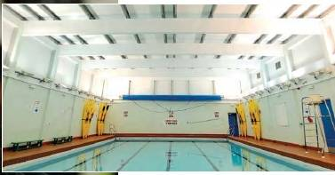
It already has 8 boats stored there and there is some room just outside to store securely some more of our own. (Maybe another 8 boats)

Available nights would be.

Monday 8-9
Tuesday 7-8 or 8-9
Wed 8-9
Thurs 7-8 or 8-9

We would need to have a BCU coach with FRST to run a session but costs are very, very favourable. We would have links with another school and would hope to run sessions for their pupils. Peter Stone and Richie Burgess would do most of this but would like support and back-up from the club from time to time. I am thinking of asking for Tuesdays and Wednesdays. We would of course need people to run these sessions. Booking would follow a similar routine to that currently so no cash is involved.

The only downside is that the pool is not big enough for canoe polo.

I am still trying to get Sunday and Monday Nights at Kingsway (9-10pm).

Keith Jackson has also made contact with Halewood Leisure, Kirby and Huyton Pools. These also remain a possibility.

27/9/12 Kingsway Pool

It was agreed to look for an alternative pool / sessions this year because of the anticipated massive demand again. We may need to subsidise these sessions initially to ensure they get off the ground. Consequently it was decide to put up the price of an hour session from £3.50 to £4.00 this year. Action Keith Steer
KS had a meeting today with Debbie Byrne at the Kingsway pool. They are still looking at freeing up the Monday 9-10pm slot (This may be on a share basis with the swimming club and a lane roped off). Also a Sunday slot - possible 8-9pm part share and then 9-10pm slot on Sunday is also be looked into. Although not ideal, it may prove ok if people returning from weekends etc drop into the pool. Sunday evenings have worked in other clubs if that is all that is available.

The small learner pool was considered but is far too small to be practical. Debbie will get back to me in a week or so.

27/9/12 Hilbre Race

Online booking are progressing well. Trophies have been donated by Mike Bell of Cedar Boats of Europe / MB Models. We have 4 person kayak safety team and two rescue boats.
Stop watches x 2 and air horn for start purchased by KS.

27/9/12 AGM

Room and Buffet booked; Nominations and voting for Paddler, Junior paddler, Volunteer and Swimmer of the year well underway. Mike Bell has agreed to make the trophies again this year, small token in appreciation will be given to him.
For this years AGM we would like each discipline representative to give a (very) short report of the season activities. To ensure there is something to report even if the representative is unable to attend, even at the last minute, we are asking for a short written paragraph outlining the key aspects of the year in advance.
Alps Video may not be ready, a slide show of the photographs will be shown instead.
14/8/12 Third Canoe Polo Team

Following a massive rise in interest in canoe polo a third team has had to be created and entered into the vacant Div 4 place in national league to play alongside our B team. Paul Harwood and Roy McHale would run the team which currently has 11 people interested in playing. Paul has asked about Buoyancy Aids as the current sets will be used by the A, B and C team at the same tournaments. Keith is looking into buying a new set in club colours. Agreed by : Keith Steer, Paul Harwood, Dinny Davies, Darren Bohanna, Roy McHale
Update 21/9/12: 10 BA`s on order with Kayaks NW – Peak ones in club colours.

04/07/12 Liverpool Triathlon Invoice

An invoice was sent for 6 kayak teams and leaders and 1 entry / exit team (with two lifeguards) for £1500. This has now been credited to the club account (14/8/12)
18/06/12 Mark Garrod Bursary Application

Marks application for help with his L2 transfer course has been received. I suggest that we fund 1/3 of it as usual. Mark is running the July Introductory course for us and is an active coach within the club.

Agreed by : Keith Steer, Dave Reynolds
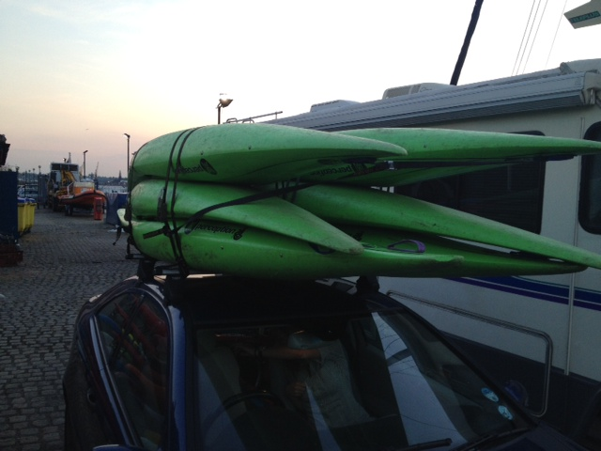
27/05/12 Six Perception Fox`s (Slalom Kayaks)

Following Mike Alters tip-off from an advert from Matlock Canoe Club we purchased six plastic slalom kayaks yesterday to try and develop slalom within the club.

At the very least the boats would be ideal junior kayaks. They are well built, in good conditions and had a paddle thrown in as well, all for £100 each. They make a very welcome addition to our fleet.
KS drove over to Matlock to pick up the boats from Sally Vetta on Sunday

Agreed by : Mike Alter, Keith Steer, Dave Reynolds, Ian Bell, JOHN PEGRAM

14/05/12 Wavehopper

We did bid on a Wavehopper from Battersea CC recently but were unsuccessful. Following Mike Alters tip-off from the River Guide Blog I managed to purchase one from near Mold Yesterday. It is in very good condition (new footrest etc) and only cost £150 instead of £165. It is now on the racks to help the development of Long Distance or Sprint paddling. Hopefully we can develop this area of the club in the near future.

Keith
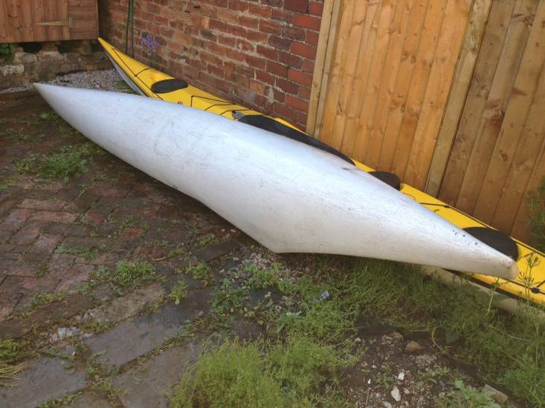 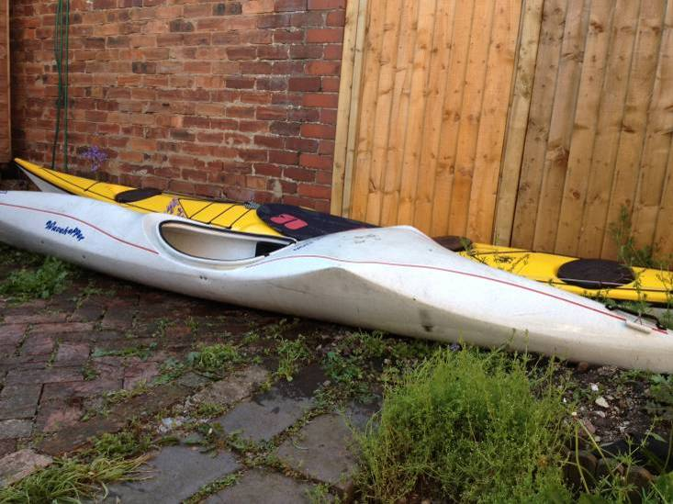 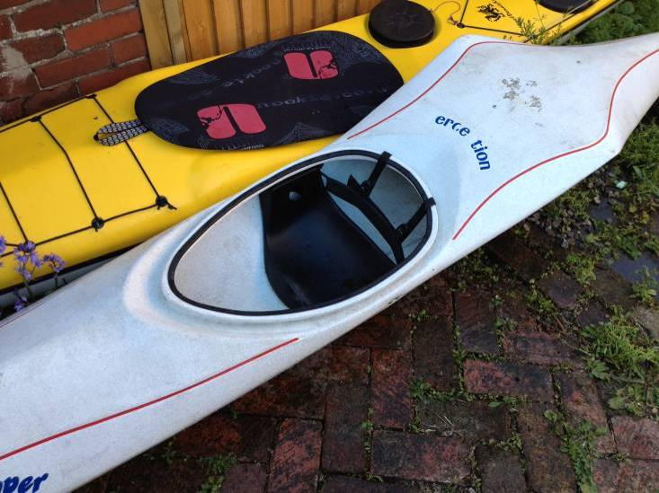
14/05/12 Purchase of junior paddles (Update)

Ainsworth Paddles Vs RIM junior Paddle

Ainsworth Paddles are much higher quality and as we can get 20% off instead of 5% If we order from Kayaks NW then no postage. I am proposing to buy 7 x Right handed 180cm and 1 x Left handed 180cm. £252.80
If we still have a need of even smaller paddles for the very small juniors we should order 2 x RIM junior paddles 170cm (Total cost £59.98)
Keith
____________________________________________________________________________________________________________________________________________________


Hi LCC,
Yes we can get you the ABS90 JNR paddles then you will get your 20% discount off retail price. And they retail at £39.50 so your price for 8 would be £316 – 20%= £252.80

Junior TNP asymmetric junior paddles at £34.95 each, then 20% discount. So price: £34.95x8 = £279.60 – 20% = £223.68

Hope this helps,
Thanks, Leanne. Kayaks North West

Devon Watersports
if you purchase 8 paddles or more in one transaction we will give you (£239.92) 5 % discount off the total price (£11.99 off). this also has free delivery. £227.92

We can offer a 20% club discount to you.
Quote 1:
8 x ABS90 Junior @ £31.60 = £252.80 inc vat
Carriage = £18.05 inc vat
Total = £270.85 inc vat
Quote 2:
8 x RTM90 Silver Junior @ £119.20 = £953.60 inc vat
Carriage = £18.05 inc vat
Total = £971.65
Kind Regards
Andrew Ainsworth
Tel: +44 (0)208 898 4839
Web: www.ainsworthpaddles.co.uk

17/04/12 Equipment - Move to the docks (paddle storage)
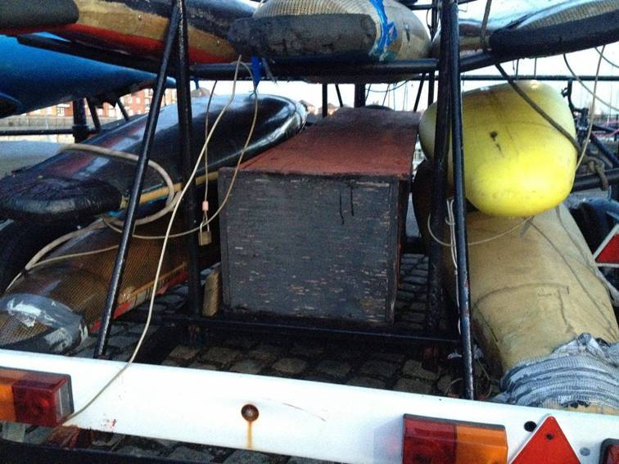
The last thing that does not really work at the docks is storage of the kayak paddles. They are just too large for the shed and continually fall down or across the entrance etc.
Last weekend a few of us tried to come up with some ideas to improve the situation.

In the end the best idea seemed to be to extend or preferably rebuild the wooden paddle box (see below) on the black trailer so that paddles could slide in horizontally. It would be extended so that came out beyond the lighting board (which will probably be removed). It would have an easily lockable end with a club padlock and could be expanded to the inside of the middle frame (ie be twice as big as it is now). Ideally it would be split into a top layer and bottom layer to have less paddles piled up onto each other.

It could be wooden with metal angles on the outside as currently or entirely metal. It needs to have a smooth internal surface to aid sliding the paddles in and out.
Does any of you have any other ideas / solutions or perhaps willing to help construct it. With measurements it could be built elsewhere and slid in and bolted on.

Please reply to all with any suggestions (would be nice to get something in place before we start back fully in May.

Keith Steer

Chris Murphy Steve Hitchen owns his own engineering company and although I am speaking on his behalf here, I don't think it would be difficult for him to get his guys to knock up a steel box from scratch. (he has already spoken to me about getting them to build a kayak trailer for us in there quite periods).

He is on holiday until Thursday but I will chase him up and see if he can help with this.

John Pegram I would be willing to coordinate with who ever - I'm afraid are beloved education minister has scraped our technology status so I cant offer materials as I have previously done but I still have my brain which he cant have - I could come up with some plans - just a thought white interlocking cladding is good as it will out last ply and wont rust - would have to do some research though it can be expensive - mind you a 8x4 sheet of marine ply is at least 50quid these days plus the angle iron might touch £80+

Sam Godsell If we decide to make it out of timber (it would probably be decking timber I guess?) I should be able to provide the majority of materials. If the design is developed to use timber please get in touch.

Steve Hitchen has got in touch from his hols to say that a metal box would be no problem at all, if we wanted to go down that route so let me know what you prefer.

17/04/12 Purchase of junior paddles

Hi All,

We do need a few more paddles (to replace a few broken ones) I would like to propose that we look at purchasing 6 or 8 or these for the club as currently juniors are using adult paddles. Clearly these are not suited to them, means that adults paddles are in short supply and it would tick a few more boxes for top club gold.
Its also cheapest way to ensure enough adult paddles available (ie would cost at least £60 each for an adult paddle)

I will check prices with NW kayaks and any discount from Devon Watersports.

Proposal is to purchase :

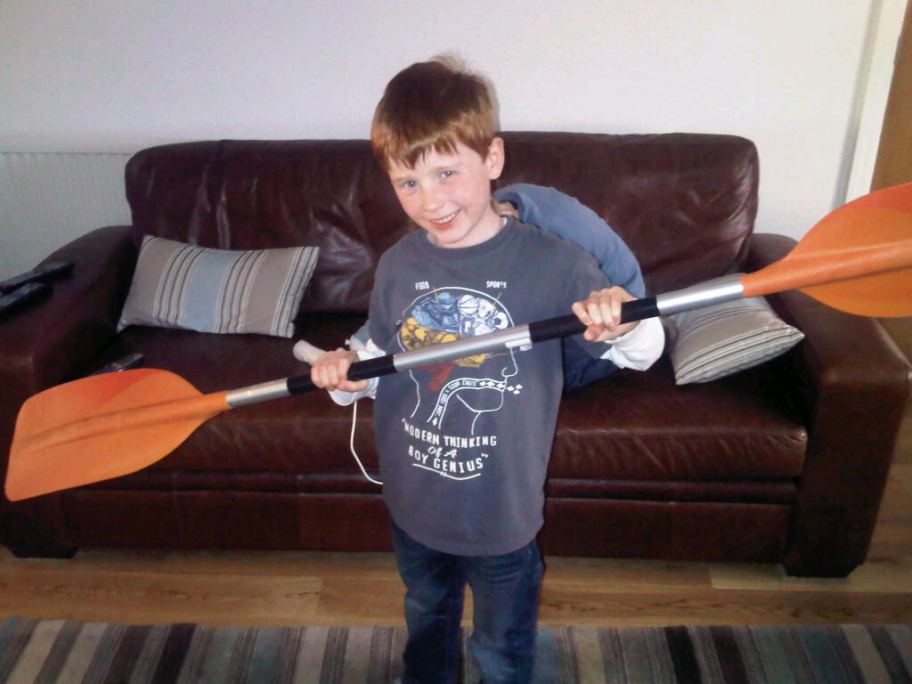
2 x 160cm R
2x 170 cm R
2x 180cm R
1 x 170cn L total about £210
If discount available may try to purchase another to make eight.

As always anyone think this is a good / bad idea, have any other suggestions.

For: Chris Murphy, Keith Steer.

From: liverpoolcc@googlegroups.com [mailto:liverpoolcc@googlegroups.com] On Behalf Of chris murphy
Sent: 15 April 2012 20:14
To: lcc
Subject: [Liverpool Canoe Club:1932] Junior paddles

Hi all

For info if you have any junior paddlers in your ranks.

I have been trying to find a reasonable priced junior paddle for my 8 year old to use at the pool and the marina. There seems to plenty available if you want to spend £60 etc but your choices are limited if you are looking for something cheaper. I have already send two paddles backs that were supposed to be junior but weighed over a kilo so were too heavy for my son to handle. In the end I have found this one. Its by RTM and weighs 0.8 kilos but better still it comes in four different kids sizes starting at 160 right through to 190. I have the 170 version and it is just the job, strong but light enough for Ollie to use.

The paddles are available from Devon Watersports and are £30 with free delivery.

Keith, how about the club buying a few of these to add to the club gear? I know we only have a couple of junior paddles at present and after the last couple of days at the docks we may have some more juniors in the club this summer.

Thanks
Chris

Chris Turner Seems good way to go. Just thinking about the Left & right handed split. Noticed with wgsca there appears to Be more left handed kids about these days.

Keith Steer Hi Chris, Nationally it is supposed to be between 1 - 2 out of 10 Who are left handed. I think it is about right ratios but will look again to make sure. Good point
“In Britain, around 13% of men and 11% of women are now left-handed, compared to just 3% of those born before 1910. There are a number of factors driving this increase:” Source
We currently have 4 left handed paddles in the club store. This is 14%. I have to say that often during sessions many of these are not used. However on the go canoeing weekend we did have one family of 5 with at least 2 if not 3 who were left handed.

Dave Reynolds Can I say we should increase left-handed paddling to right handed paddlers as this decreases the wear on the right wrist providing paddle control and power though the same side. paddlers frequently provide 80% power on their power side. Left handed paddlers should be encouraged to paddle right handed to save their left wrist. Perhaps we should start our left-handedness with our youngsters and save them discomfort later.
so I would favour increasing the number of left handed paddles Ian has suggested the use of 60 degree feather with both hand-grips oval-ed, as being suitable. Not tried this myself but would like to work with it.
“the RTMs are all set at 90 degrees – we would have to pay much more for paddles with other feathers and they may be heavier.”

In favour of purchase: Frankie Annan, Ian Bell, Chris Turner, Keith Steer, Chris Murphy, Dave Reynolds

15/04/12 Canoe England Go Canoeing Days – Saturday 14th and Sunday 15th April
North West Kayaks supported the event with their demo fleet, two staff, tent etc. Apache Canoes also provided several demo boats to try. Approximately had 70 to 80 people each day on the water with a range of activities (Junior Club Easter Egg hunt, polo, introductory courses and open boat courses)

Come and try it canoeing sessions (open to the public) Click for More.....
North West Kayaks together with Pyranha`s largest Demo fleet, A variety of courses, junior club activities and events Click for More..... ****

Photos………

09/04/12 Purchase of second hand Sea Kayak (Orca)
Boat Purchased on 12/4/12 for £400

Those in favour: dominic buckley, Ian Bell, Kirk Williams, Frankie Annan, Chris Turner, Andy Wrigg, John Pegram
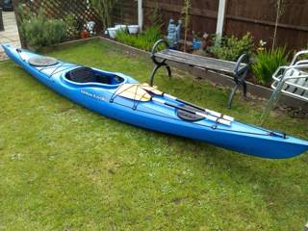
Hi All (Stewardship group),

Darren has sent in this advert for his orca sea kayak. I think this would be a good boat to have for the club as most of our sea kayaks are used regularly and we could do with one or more to add to the fleet. It has a large cockpit, is stable. We have just about £375 spare and I would like to offer to purchase it from him if he would accept that amount to keep it available to club members.

Any thoughts before I speak to him about it.???? If no one objects and we have a consensus that it is a good idea I will speak to Darren.

Daz, perhaps you could indicate if you would let the boat go for £375??

Keith

20/03/12 Real Paddling Film Festival World Tour 2012

To: 'Jon Holmes - Reel Paddling Film Festival Coordinator'
Cc: 'Pete Thomas'
Subject: RE: Reel Paddling Film Festival: I want to host the RPFF World Tour

Hi Jon,

Please find attached our host form for RPFF 12th Nov 2012. It will be great to host such an event at the Liverpool Marina conference Room.
The only costs will be the DVD / Film media as we will do all our own promotion.

Many thanks

Keith Steer / Pete Thomas
Liverpool Canoe Club
www.liverpoolcanoeclub.co.uk
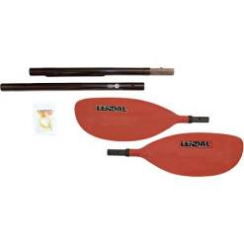
20/03/12 Purchases for 2012 Season

We eventually ordered 10 pairs of Lendal Emergency Split paddles – two for the club and 8 for club members, two 10 person bothies and 5 new kayaks .
Orange Flex with skeg £299 (similar to Approach) with hatch
Orange ?? Karnali – Size large £299
Blue / WhiteZ one – Size large£299
Orange G3 £299 (Large)
Yellow Easky 15 Sea Kayak £350 (3 Hatches – Skeg box return)
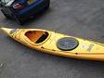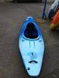
3/03/12 Purchases for 2012 Season

I have been looking into purchases to replace some of our boats and equipment.

4 Piece paddles for river leaders. – Agreed to purchase 4 of these at £25 each?
We can get TNP rapa 4 piece paddles 194 or 197cm for £87.20 with glass shafts. Alternatively we can purchase Lomo ones for £25.00 but these are 220cm - bit long for rivers but a good price. Please advise on groups thoughts. My gut feeling is to go with Lomo as a get you home paddle. (NB ebay ones turned out to be 230cm long)

2 Group Shelters. Already ordered JDS components (10% discount) 2 yellow bothies 10person with window. £35.99 each Total £76.48 including £4.50 postage. Order through club paypal account.

NW kayaks - Purchase 5 large cockpit kayaks
Agreed we needed these last year - see comments 21/7/11 and in our Top Club Action Plan .
1/10/10 | Equipment | Need for larger Cockpit kayaks for some of our club members | Stewardship Group | By end of season 2012 | Kayaks NW - Ex demo Fleet, eBay, Local ads | Lack of funds, unsuitable kayaks. Large Burn, Large Karnali, Dagger Approach, Guitti etc | Purchase up to 3 large cockpit kayaks 30% of fleet | Approach purchased 20/4/11 | ?

We have enough spare cash to order the following to supplement our fleet (NB We seem to be very short of boats at the moment)
Orange Flex with skeg £299 (similar to Approach) with hatch
Orange ?? Karnali – Size large £299
Blue / WhiteZ one – Size large£299
Orange G3 £299 (Large)
Yellow Easky 15 Sea Kayak £350 (3 Hatches – Skeg box return)

These are specials at much discounted prices £299 each and £350 for Easky.

We also need replacement decks – I have ordered 10 Pyranha ones, reinforced, Size N6, suitable for large cockpits for £16.00 each. This is a bargain compared to palm.

I recommend that we agree to purchase these items. We may also need more paddles as several have been broken recently, I will look into these at a later date.

Please circulate any comments or views.

Purchases agreed by, Keith Steer, Carl L, Pete T, Keith Scott, Chris M, Dom Buckley, Ian Bell, Roy McHale.

19/02/12 Just to let you know that the Marina now has different access cards. I have attached a form of which details we need for our systems if any new members could fill out the details for us, and any existing members just pop into the Marina office and we will change their cards for them. They will still have access to the pontoons it is just for the discount in the bar area.
The marina has a new card system. (see above)

I have a few reservations about how it will be managed but though I would canvass any views before I respond to Dave and Zoey and try to sort out a more manageable solution.

1/ Not all members will be able to exchange during office hours – minor issue but will explore a post out option with marina

2/ Amount of data required seems excessive – are there data protection issues with a commercial organisation holding this amount of data on our members or are they Marina members? Also where do we stand with passing on this data to marina to use rather than marina collecting it themselves? It may be better for them to design a page directly but the how do we link this to our members with little admin required.

3/ Major issue is with how I collect this information electronically and then pass it on. This will be difficult to manage as we currently take payment using paypal via members only area to verify full members. Mariana seem to want a return to paper. I am guessing that this is because they have not been able to collect info electronically in the past. This will probably result in fewer purchases of the card and increased administration.

Keith Steer

05/02/12 River Leaders Kit – proposal to purchase items
Shelters / Bothy bags
Mark Garrod. Have you tried http://jdscomponents.co.uk/ There the cheapest eve seen so far. We get 10% off as well but im waitin for the guy to reply to me with the discount link.
Keith Steer Looks good Mark, I guess we are looking for 2 X 10 person bothies. Let me have the discount link when it arrives. (Pete Thomas also confirms the 10% discount)

Split Paddles
Chris Murphy If you are approaching Lomo is it worth asking if these paddles can be made at a shorter length i.e. 195's? If we order a few they may be willing. It will reduce weight in the boats when not in use and also be a bit more manageable if put to use on a river.
I would be happy to purchase my own so if you could add them to the 4 club ones and yours, we are up to six pairs already.
Keith Steer sent email enquiry to Lomo about discount 7/2/12
Dinny Davies For anyone wanting a higher quality split, I really recommend these: http://www.hbcanoekayak.co.uk/canoe-kayak-paddles/1199-lendal-emergency-4pc-split-paddle.html
Feels as good as your normal paddle (and so it should for the price….) I have no idea about this vendor mind – postage sounds dear…
Keith Steer Alternative 4 piece split £29.95 http://www.ebay.co.uk/itm/Kayak-Paddle-assymetric-4-piece-split-carry-bag-/330667141551?pt=UK_Sporting_Goods_Canoeing_Kayaking_ET&hash=item4cfd4c29af
If we ultimately go for these will ask members if they want to add to order for better discount. Also possible to order direct from lendal for high quality set. http://www.lendal.com/index.php?page=shop.product_details&flypage=shafts.tpl&product_id=662&category_id=10&option=com_virtuemart&Itemid=250

Dinny Davies Indeed – all very complicated, and I have no ideal solution.

Probably far easier not to have club safety kit from a legal perspective – ridiculous that the legalistic health and safety obsessed society that we now all live in leads to that conclusion – but there you go….
I would prefer all people that I paddle whitewater (above grade three) with to have a decent throw bag and a knife, and to know how to use them. Often they don’t, but then I guess it is up to me whether to paddle with them or not…

If you do provide club throw bags – I think that you have to accept that they probably will be used on trips though, and I’m not sure how you ensure (legally or practically) that anyone who has borrowed it realises/accepts that “it is not to be used for anything other than training”.

Generally a rescuer or rescue will be unable to hold on to a rope anymore (unless using some kind of belay device) at forces way below what even an old throw bag would break at.
If you’ve rigged up some kind of pulley system, to free up a pinned boat say you could maybe just about break a damaged rope I guess – but generally no one’s life is actually in danger in those kind of scenarios.
So in 99% of cases the strength and quality of the rope probably won’t really matter too much – in the other 1% of cases a rope could be the difference between life and death.
Now in that situation I’d obviously always choose the best rope, if there’s a choice – but if it’s a choice between no rope and one that’s a bit dodgy – I’d far rather have the dodgy one than none at all….
PS – no I’m not volunteering to look after the club throw lines.
PPS I did buy myself a new throwbag this year, offer me a good price and I might be prepared to sell the club my old one, one careful owner and only about 21 years old (caveat emptor, sold as seen etc, etc…)

Keith Steer, Point taken Dinny but the general idea was / is to protect the club and equipment officers.

I do not really do rules and quite happy for people to use these if they do not have their own but does the club want to provide safety equipment??? Split Paddles are one thing but ropes, slings and karabiners are another If so are we opening up the chance of a legal comeback if it is not of a minimum standard or is not checked regularly and maintained etc I for one would not want that responsibility. The main point should be that people should have the right equipment for the planned paddle and to keep things simple it is far easier if they have their own items of safety gear. I accept that throw lines are not often used with chest harnesses or for lowers into canyons etc but I have been in that situation in the past and would not really want to have to rely on a club throwline that is used in the dock near the boats with oil, diesel etc

Maybe you are volunteering to look after the club throw-lines.??? In practice they are only used for training. If I were coordinating a club paddle on 3+ water and someone turned up without their own throw line I might suggest that they consider if they are properly equipped for the trip. I have no problem with them being used for training on trips of the lower grades, eg trips where newer paddlers hire club boats etc.

Realistically a difficulty is more likely to arise after an incident with the qualification / experience of paddlers on the (club) trip. Currently most are advertised as non-coach led ie a group of friends paddling together. The clubs BCU liability insurance may provide some cover for individuals but says nothing about safety equipment provided by the club. Maybe someone can clarify the position here.
/members/Clubmark/index.php?dir=4.1%20Affiliation/&file=BCU%20-%20Liability%20Insurance%202011-12.pdf

Dinny Davies As it stands that is a pretty daft rule, if the alternative is a trip not having a throw bag at all.
Or if someone happened to have one of these bags with them and someone was in difficulty would they not be allowed to use it?
I can see that you might wish to replace them after a set period, and that you might wish to check for frays/rub points after use when drying etc, and that if anything “bad” happened to one you would wish the user to report it. After what sort of use would you throw yours away? Presumably only when it became very old, you had accidentally poured acid over it, or it was frayed?
Or do you cut 5m off it each year and send it away to be drop tested? J

Keith Steer, Lots of very valid points. If I can add my thoughts as well.

1/ We absolutely should support any member wanting to develop leading or coaching skills. The Coaches already have a bursary scheme where monies raised from registration on coaching courses can be used to support training and / or petrol expenses for courses run. I.e. only money raised by coaches by running courses and offering their time is used so the club does not fund this.

2/ I am not sure that we should purchase equipment that will be difficult to keep track of or maintain. However, if the view of the majority was to purchase all of the items mentioned by Andy / the 4* course then we should. However, I am getting the feeling that most support purchasing equipment that can be used by all members and will be left safely in the shed at the docks. We have a number of throw bags already (donated but other clubs and individuals) but currently they are held by me at home as they need to be dried and washed after use on our club run white water course / FRST courses. I can easily put them in the shed but they will quickly deteriorate as it is not a dry environment. In a similar way any first aid kits, or group shelters would soon deteriorate unless thoroughly dried after use. On a river it may be more essential to carry a plastic survival bag to protect a causality for several hours before rescue. These may not get mildew in the same was as a shelter. Dry bags will not be dry for very long as wear and tear will allow water to enter, This will be worse than having no dry bag at all. Perhaps a bag to keep it all together is not necessary or could be a net or mesh bag that is not meant to be waterproof emphasising the need to rinse and dry all items. Splits could be useful although not essential for any club trip as it is relatively easy to walk out. However, perhaps they could be used with the club sea kayaks, river leaders as emergency spares or kept fixed together to use as a general paddle for novices at the dock when not signed out on a club trip. NB people may have been loosing paddles which are heavy and tend to sink in turbulent water (i.e. several heavy paddles regularly seem to get trapped at the bottom of rapids, e.g. Michal G`s and Judes)

3/ To sum up.

I propose that we:
• Purchase 4 of the Lomo four-piece splits (Salt water may be an issue as aluminium shaft but you cant go wrong at £25. Item is coated but is also 220cm long!! But will get you home) http://www.ewetsuits.com/acatalog/4-piece-emergency-kayak-paddle.html I will investigate a club discount with lomo and perhaps look at a group order if discount reasonable – I think I will be purchasing one for my own use. Nb they also do a two piece fibreglass split for sea kayaks http://www.ewetsuits.com/acatalog/2-piece-kayak-paddle.html that should not corrode too much.
• Add the throw bags to the club equipment list to be signed out if required (Free to river leaders / course organisers). KS or other volunteer to dry and maintain them although only lent on the understanding that they should not be used for anything other than training as we cannot verify there strength / wear and tear / history)
• Purchase two group shelters / bothies – subject to costs (Someone said they may be available on ebay for £20?) Keep them in the shed for free use on club trips. Alternatively old tent fly sheets with a stuff sack make very good alternatives. In practice I am not sure how much they will be used. Can anyone please send me links to suitable shelters to investigate purchase. http://www.amazon.co.uk/s/?ie=UTF8&keywords=group+shelter&tag=googhydr-21&index=sports&hvadid=8522399705&ref=pd_sl_8rdjmxb4du_e
• Look at a system (Net bag or elastic bands) to keep splits together.
• Look at the possibility of including river or sea leaders in the bursary scheme for training grants in future – how this will be funded may be the issue.
• Acknowledge that once people are qualified as 4* or 5* leaders their membership of the club is free.
• Look at developing advice on what safety equipment to purchase or take on club trips (Sea, Rivers, lakes and the docks)
• If active 4* leaders or coaches are running / coordinating trips then any boats or equipment used or signed out directly to them should be free.

NB Brian’s point re having any kit is of little use unless you are practiced with its correct use remains valid and generally I do feel that we should encourage members to own and look after their own safety equipment and go on training courses or run them in house.

Mike / Pete’s point also is important. , "the best plan is making sure that there is enough of this safety kit in private ownership within each river group." If there is not enough safety kit then the trip venue needs to change just as if a member attends without a suitable boat, helmet or experience.

Brian Green
Previous responses to Andy’s initial proposal have all raised many good points, and significantly Andy’s own closing remark below . . . “collectively, it will be a good idea if we raise everyone's awareness of what is required beyond the basics of a throw line” is equally relevant to those who do most of their paddling on the sea.

On occasions I have been joined on the sea by paddlers who are by no means ‘beginners’ and yet they carry no towline, no spare paddle nor other basic safety items. Perhaps by Andy raising the points he has, whether one agrees with his proposal or otherwise, we really should use this opportunity to ask folks to think about personal responsibility as a member of a group, perhaps not always just assuming that Keith or Ian or someone else will have the right equipment.

How many paddlers turn up having spent a lot of money on the latest new boat, cag, drysuit, paddle etc yet no thought of a tow line/throw line, flares, radio etc.

Whether ‘leading’ a group that may consist of one or two inexperienced paddlers or when paddling with other paddlers of a similar ability to myself I always carry VHF radio, tow line, an assortment of flares, a comprehensive first aid kit, group shelter, repair kit, spare split paddle and any number of other items depending on weather and conditions.

None of this equipment would I have expected the club to buy or provide. I bought this equipment myself as I believe that as a member, never mind a leader of a group, I would wish to be as best equipped as possible to help either myself or the friends I paddle with should difficulties or accidents arise.

Of course having all this kit doesn’t guarantee knowing how to use it properly, that involves doing plenty of rescue practice in realistic conditions, something which, as Andy has identified, we should all do a lot more of.

But that’s another discussion altogether . . .

Andy Wrigg Hi all, Thanks for taking the time to reply and for your thoughtful responses. Will just try to contextualise the points raised.

I agree that all the paddlers requires there own personal safety kit and all of the paddlers who have been leading groups recently have a good basic collection of personal equipment. This was evident when we were on the course. I threw in ( pardon the pun!!!) the throw line etc as a spares as it has amazed me how people turn up to trips lacking equipment. With that in mind I always take a spare helmet and ba now!!

The main kit requirements are the survival bag and spare paddle along with a bag to house them in. If the split paddle from lomo is good enough and light enough then £25 is not so much of a problem.

Just to clarify the loss of paddles is not a regular occurrence but when it has happened it has left people in vulnerable positions. They would still be a very useful addition to the trips run by the club and the thought of it happening in some locations such as the Alps would not bare thinking about.

This idea has come from the recent course we attended and it has dramatically raised my awareness of the safety aspects required when on a river. We have been in some situations where we have not had the required equipment. I am sure in the fullness of time we will collect all the right equipment for our group. I think that ,collectively, it will be a good idea if we raise everyone's awareness of what is required beyond the basics of a throw line.

From: Keith Scott <keith.scott156@ntlworld.com>
Hi guys, thanks for your input into the thoughts we had. . I do agree with a number of the points raised as to the preference of knowing your kit. All the people on the recent course did have our own personal kit except for split paddle and bothy bag/group shelter.

I don't get the point about no central location though Mike !!! Surely the marina bar is the club's centre and where all kit is stored and can be booked out/hired from ??? ie boats, paddles, etc so why can't a river leader kit be stored/hired in same way. I do agree that throw lines, karabiners as 'safety' kit should be personal kit. Just my thoughts, Keith

thanks for your input into the thoughts we had. . I do agree with a number of the points raised as to the preference of knowing your kit. All the people on the recent course did have our own personal kit except for split paddle and bothy bag/group shelter.

I don't get the point about no central location though Mike !!! Surely the marina bar is the club's centre and where all kit is stored and can be booked out/hired from ??? ie boats, paddles, etc so why can't a river leader kit be stored/hired in same way.

I do agree that throw lines, karabiners as 'safety' kit should be personal kit.

mike alter Hi All, I can see where the idea is coming from, and if we were a centre I would agree that having a "river bag" that contained all required kit would be a good idea. But for the club setting, without operating out of a central location or having dedicated staff to correctly check and store kit after each use, I don't see this as working correctly. Too much faff to pass around and, having been involved with several canoe clubs over the years, the kit tends to become "someones" over time - I'm not saying they took anything, it was just regarded as part of their cliques kit because it was always stored at their house and the faff of passing on to other grops.
Further, apart from the fact that some of this kit should be with everyone, it is my view that a coach / river leader should be responsible for the kit that they paddle with - and with the possible exception of splits / krabs* I would say that most of that list should be classed as normal kit for most / all (except beginners). Splits are quite often bought between regular paddling groups, when someone decides to takes on a position of responsibility or is paddling in an area where loss of paddles would be inconvenient.
Specifically with regards to throwlines and krabs, I want to know the load / storage history of my kit - or at least through the knowledge of the owner have faith in it.
I am glad this email has came out as it has perhaps pointed to a failing in our ww coaching to pass on the message about what all paddlers apart from beginners should carry - I remember from a very early age being instructed to carry throwline, repair kit, spare clothes, bivi bag, first aid etc etc. But equally we should give the skills to decide when and where kit is not necessarily needed, what can be shared between paddlers, how overloading your boat can affect its performance.
Personally, I think Pete has hit the nail on the head though, "the best plan is making sure that there is enough of this safety kit in private ownership within each river group."
Mike
* For krabs, quite often people will have them if they are carrying a sling / tape anyway, and beyond that level of usage I would have thought that a paddler with the skills to use them in advanced scenarios would most likely have them already.
Splits, how often are paddlers losing their paddles to such an extent that they cannot be retrieved either later or by a kit chaser? Yes river leaders should have them, but if loss of paddles is that common, are paddlers pushing their limits too much /often or beginners being put on rivers that whilst not technically too difficult are too remote for that type of trip?
Pete Thomas HI Andy, For what it’s worth, my opinion is that carrying this kind of safety kit is eminently sensible and I know a number of sea paddlers would have much of it distributed around various boats, even for short trips out to Hilbre Island. Obviously the gear is all privately owned but it’s likely that in many boats you would also find a first aid kit, small stove and a means of making a hot drink.
If it’s a discussion you’re after, I think you’ve hit on a couple of areas where there’s scope to go over the top; firstly in relation to “responsibility” and second in relation to “kit maintenance or ownership”. I know the whole coaching ethos of canoe and kayak clubs is totally different to that of climbing clubs but when I was active in a North Wales club I was asked to consider providing equipment for an expedition. I was advised to consider the implications if any of the equipment failed causing injury or worse. The whole story ended with the club rewriting its constitution so that it could extricate itself from direct responsibility if things went pear-shaped on club expeditions. We had heard that some family members of American climbers who had been killed on a trip had sued the club that the climbers belonged to. They apparently won their case on the grounds that the club had provided some of the equipment for the trip so there was a direct “duty of care”!
That’s what I mean by going over the top!
In the context of what you’re wanting to do I see there a number of choices; either buy the kit yourselves as 4* paddlers and take responsibility for using it and maintaining it properly.
OR
Ask club members to donate some spare kit that will be housed and maintained by one of your group who would also be responsible for meeting with trip leaders and handing over whatever safety gear is needed - might be a problem if there are a number of groups heading off to different destinations over different time periods – how many river leader bags would you need?
Lastly, the club foots the small bill for buying a number of “River Leader Bags” but doesn’t underwrite its correct use or take responsibility for accidents etc. Again, as you point out, one person would have to be prepared to house and maintain this and also meet with the groups who want to use it and then collect and maintain it after each trip. I think storing it in the club lock-up is asking for trouble as its likely to evaporate quickly.
I guess I’m talking myself into thinking that the best plan is making sure that there is enough of this safety kit in private ownership within each river group.
The discussion goes on ......... it’s a dreary Saturday morning anyway and I’ve got builders in and can’t get out on the water – hence the lengthy reply J
Bu the way I bought a decent bothy bag from http://www.summitgear.co.uk/ who also agreed to give LCC 10% discount on his advertised prices.
See you tonight at the Crosby do, Pete
Andy Wrigg Hi everyone,
As some of you may be aware a group of LCC paddlers have recently undertaken our 4* White Water training. From this a number of issues have been raised relating to river safety. There is a number of developing paddlers that have been taking a variety of different groups on the water and introducing keen paddlers to more technical white water. It seems that most of the trips being run include paddlers that require assistance and guidance when running the rivers.
This has led to us taking a greater responsibility on the water when there is no coaching cover and has resulted in us trying to achieve our 4* award for our own personal and club development.
We have all accumulated some safety and rescue equipment but after a the 4* training a discussion began as to what else we need.
I submit to the group that there is the need to purchase one or two club River Leaders bags. These would include items above and beyond that which you may normally expect a paddler to have for personal use.
I am open to further suggestions but I would think that it would include:
Large dry bag - £10-£30
Set of split paddles - Emergency 4 piece paddle from lomo £25
-Recreational paddle - brookbank £45
Emergency shelter - £ 5 from ebay (not sure how good it is!!)
- Anything from £20 upwards for a named make shelter
Spare throw line - £20 various places
Some basic boat repair kit (Gaffer tape etc)
Carabiners (to set up rescue pully system) - £10
The issue has been raised re making sure the kit does not get lost or is picked apart by different people. A designated person could be in charge of the kit and sign it out to the care of a river leader who requires it. Alternatively, it could be left in the club lock up at the marina but you then rely on people signing it out correctly themselves and it generally being rummaged through.
I have been on a number of club trips where this kit could have been invaluable. Particularly the problem of lost paddles, which can mean leaving paddlers behind and the rescue of boats/people stranded in the flow of the river.
Please discuss and let me know your thoughts. Cheers Andy
05/01/12 Catch up meeting at the Marina. (Dave Murray , Billy Cosh, Brian Green & Keith Steer)
Very useful meeting last night. Liverpool Canoe Club are extremely happy with the facilities at the Marina.
Dave - I have found the dates for the Day skipper course - from www.glaciere.co.uk and will circulate to our members with discount offered to only our members (£250 for course)
Liverpool Community College - I have looked at their website but have not been able to find a suitable contact. We could offer links with our top club programme, we could run BCU or taster courses etc If you could get me some names / contacts so that I could approach the right people or please feel free to send my contact details to key staff a the college and we can hopefully get something going.
We will look at arranging functions (weddings / parties etc) by passing on any contacts on to Emma / Claire so they can follow-up this up.
We will ask our members if there is anything that can be improved or suggestions for quick food which could be heated up after 9.00pm (Panini, burgers etc). The new discount swipe card scheme sounds very interesting and we will have to see how much our members are spending.
We will remind our members re showers and excess water etc (Car park only to be used while using the facilities, keep changing rooms as dry as possible, no wet clothes in the bar etc)
20/12/11 Winter Talks Programme Finalised
Pete Thomas has produced a poster which has been circulated to the region and put up in usual places (NW Kayaks, Marina etc)
14th May 2012
'What sailing boats do to canoeists and why.' - Adrian Mould
16th April 2012
Circumnavigation of Jura - Club trip - Frankie Annan and the team
12th March 2012
Climbing Mount Denali (Mt. Mckinley) 2011 Expedition - Michael Alexander
30th January 2012
Fast Waters, Still Moments: A multimedia lecture by Deb Pinniger (Twice World Freestyle Champion) Limited Places £4.00
10th January 2012 7:30pm Start
"A Norse Odyssey In Black Magic" Sailing to Norway - Dave & Jeanette Hardy for LYC
21/11/11 Austin Rawlinson Pool
Spoke with the Manager at the pool last Wednesday – He says that FOA have NOT given up any slots – John Moores University are temporarily using Monday nights as their pool is out of action? FOA are expected to return in a few weeks? We will just have to wait and see if a slot becomes available.

21/11/11 Role Descriptors and photos of Key members updated on website
Following the AGM a number of new roles have been filled. Photos and descriptions of duties are included on the website. If you would like to review your task descriptor and send me any changes / additions etc. /About%20us/Responsibilities.html

14/11/11 Stewardship Group Members Updated
Following the AGM a number of new appointments were made and these individuals have now been invited to join the Stewardship group.
14/11/11 Monday nights at Speke
Andy Wrigg / Roy McHale / Keith Steer / Dave Reynolds / Ian Bell generally in favour and believe it will cover the costs. Suggestion of beginners / junior session from 7.00pm and possible polo session from 8.00pm (open to all – not just committed polo players). Discussion on raising the pool fee from £3.50 to £4.00 to ensure we cover costs during slack periods. Suggestion to share storage and boats 50:50 with FOA – two top clubs working together. NB Monday night slot may now have become available not Wednesday, KS to make enquiries.

21/10/11 Possible of 2nd pool - Speke
We have been looking at several different pools for additional pool sessions. Kingsway pool is looking at offering us half the pool on Monday nights but have still not resolved issue after 9 months. Last night Martyn Hurley rang to indicate that there may be a chance of taking over 2 hour slot on Wednesdays from 7-9pm. Issues over the cost as this may have risen to £60 per hour.

We are trying to clarify today but this looks promising. NB we would keep Thursdays at Kingsway and offer additional sessions at Speke.

Met with Steve Whitehead today and he seems positive but it would depend on FOA giving up their 2 hour slot on Wednesdays because they cannot afford the costs. He indicated that it would be £65 per hour. The risk assessment (which I wrote a few years ago) is for 6 boats in small pool and upto 20 in large pool. We would need to fill the pool each week but we should be able to cover the costs. We may have to share boat storage with FOA but they currently have 10 boats there.

The 7.00pm start would be ideal for youngsters and beginners. I am thinking of running the second hour for canoe polo with rolling etc in the small pool. This has worked well in the past.

All depends upon FOA not using the slot and Steve giving it to us and not a swimming club – any comments welcome.

Keith
I like the concept of an hour in a pool for polo each week.

However given usual attendance at polo training and at tournaments – I’m not convinced that we could easily get 10 people down each week who are all prepared to pay up to £6 for an hour’s training – especially as the standard (at least initially) would be fairly low? Dinny Davies

I think the second pool is a good idea as the current slot appears to be filled each week with ease. How many boats would you be looking at storing at Speke? Do we have enough or could we use the FOA boats? Chris Turner

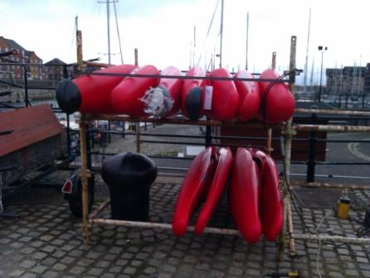
18/10/11 New Racks for boats
Don and myself have done the work we set out to do today. The locking bars are made. The top bar is longer than the bottom one. 2 padlocks per bar are needed. Due to the shape of the kayaks, you will have to top and tail them to fit. 5 boats on the bottom rack and 6 on the top one. I've tack welded some of
the joints on the main frame as they were working free. A bit of grinding will free them if the frame needs to be taken down. Tony

Chris Turner was going to paint the racks and put on plastic tube to protect them. 18/10/11
Keith has purchased new weather resistance padlocks which will be fitted on Friday 21st October – master key held in shed for all locks.

Mike Hughes has now fitted all of padding on polo boats.

18/10/11 New Padlocks and codes
Hi all,

With the new rack to lock our new boats and problems with the small keyless padlocks and wet fingers I suggest that we move back to chunky padlocks that are all keyed alike. They need to be weat

herproof with stainless parts but if all operate under one key should be relatively easy to unlock. We need 9 to lock everything at the moment. The best I have seen so far is http://www.nothingbutpadlocks.com/products/keyed-alike-padlocks/keyed-alike-brass-weatherproof-40mm

Suggest we get 10 or 11 to have some as spare. Single key will hang inside the shed and we only then have one code on shed padlock to change regularly. Anyone suggest anything better? Keith

The single key is the best idea, however make sure the key is attached to a bulky key ring so it is not lost. Carl L

I use Abloy Padlocks on my boat as I can’t afford to be locked out if they corrode. They get hit by sea water regularly and have survived well for years with no sign of corrosion and I never have to use any silicone grease.

http://www.screwfix.com/p/abloy-high-security-padlock-14mm-dia-shackle/90360?cm_mmc=GoogleBase-_-Datafeed-_-Security-_-Abloy%20High%20Security%20Padlock%2014mm%20dia.%20Shackle

I bought them from a locksmith in Heswall and they all match with matching keys. Pull up a chair before you look at the price. Pete

Result
10 X Keyed Alike Brass Weatherproof (40mm) - £87.70 Shipping - £5.95 VAT - £18.73 order by KS from http://www.nothingbutpadlocks.com

13/9/11 Liverpool College Link
Contact: Dave Ridley 07988607992 dridley@liverpoolcollege.org.uk

Dave Ridley is a member of Liverpool Canoe Club and works at Liverpool College. Proposal is to start a canoe club at the college which is linked / affiliated to Liverpool Canoe Club to use our facilities, coaches and boats. They have four Grumman aluminium canoes and paddles which they can / will leave on our racks.
More information / School – club agreement….

Guidelines for affiliation or link with Liverpool Canoe Club:
- That the benefit to affiliation or link should be mutual.
- Affiliation would require at least one member of the organisation joining for the full adult rate and who would be the point of contact.
- Members of the affiliated organisation would use our facilities / boats / coaches (if available) so as not to restrict our members eg on an alternative night to a club night. The dates and times of sessions would be notified to the club via website@liverpoolcanoeclub.co.uk and added to the club calendar.
- The affiliated group would operate under their own guidelines and ratios and would always have their coach or leader in charge of any of their members while paddling.
- If individuals wanted to come along to club sessions then they should join Liverpool Canoe Club as individual members in their own right.

9/9/11 Boat Maintenance Myself and Don Brooks would like to put our names forward to help maintain the boats as requested
Cheers Mike Hughes Also Martin McCoy volunteered.

8/9/11 Pontoon
To: "'Steve Thomas'" <stevethomas@noblesconstruction.co.uk>
Hi Steve,
I notice that you have not been paddling for a while but hope you are still well. I have a favour to ask - things have been moving on at a pace at the Marina.
We desperately need a second mini pontoon the same size as the previous one you made last year. It has been fabulous but we now need access to the
other side.
Can you remember any of the details of the design of the old one? Hopefully Chris Fletcher can get hold of 13 or 14 barrels. The marina can fix it to
the big pontoons for us. (I could even get the decking put on to same you time) We are happy to pay all costs of the materials etc

I have attached the pontoon design and would happily make another but I am getting a knee operation tomorrow and am unsure as to how long it will put me out of action.
If you need any practical advice on assembly, materials etc please get back to me .

Dave Collins, John Smith and Pete Stone, Anthony Brockway, Dave Lynch willing to help construct it.
2/9/11 Liverpool College Enquiry

David Ridley enquired about possible affiliation – He is a L1 (teacher) wanted to possibly store open boats at our facilities and be signed off to use sheltered water with the college. We could use his boats.
30/8/11 Hilbre Island Race – 1st October 2011

Hi each,
Just been down to Hoylake Lifeboat Day and apart from spotting a few LCC members in the crowd. I also had a word with West Kirby Lifeboat crew who said they could arrange for an “exercise” to coincide with the “dry run” in October and also the main event next year. Crewman Bill Cross (m: 07769725605) also said he was a member of Mersey Canoe Club who still retain a club hut on Hilbre. He suggested that perhaps this might be made available as a safety base during the race. Mersey CC captain is Charlie Warren (m: 07973846346). More soon.

Pete

The Scout rescue boat is 2 West Kirby, Steve Dogson, same group as Andrew Tate. His email is Steve Dodgson <steve.dodgson@live.co.uk>
Ian Bell

Fantastic work Pete,

Ian, can you forward the name and contact number for the rescue boat we spoke to at the Mersey swim as I am trying to put the list of rescue boats together?

The date of this years event will be 1st of October. After some discussion it will run from West Kirby Slip. We propose two races initially, a round the little eye for juniors and boats under 4m and a round Hilbre island race for sea kayaks and competitive entrants. I am working on an online entry page for today.

Proposed date for next year: Sunday 16th September 2012
9.4m tide.

Keith

Hi each,
Just been down to Hoylake Lifeboat Day and apart from spotting a few LCC members in the crowd (was that really Davy Reynolds going into the gypsy fortune teller’s caravan) I also had a word with West Kirby Lifeboat crew who said they could arrange for an “exercise” to coincide with the “dry run” in October and also the main event next year. Crewman Bill Cross (m: 07769725605) also said he was a member of Mersey Canoe Club who still retain a club hut on Hilbre. He suggested that perhaps this might be made available as a safety base during the race. Mersey CC captain is Charlie Warren (m: 07973846346).

More soon.

Pete

20/8/11 New Buoyancy Aids and boat maintenance

Following discussion with coaches re courses we have been short of smaller and larger sized Buoyancy Aids. As money is available in the account I have purchased 7 more BA from Decathlon (Same price and spec as previous ones - £20 each). I have also purchased a junior polo ball for £1.99 so our juniors can play polo.

I have 4 helmets at home which are broken and will attempt to repair them with my pop riveter.

We are still missing one of the two white helmets with a face guard that Dave R put in the store. If anyone knows where it might be let me know.

We have a few kayaks that now need running repairs and could do with a team of people to mend boats / buy fittings to replace those lost or stolen (mainly footrest items and bow grab tapes / handles).

PS anyone using polo boats with bumpers MUST NOT Seal launch as it damages tape holding them on.

Keith Steer, Steve Bond, John Smith, Michael Alexander.

17/8/11 Hilbre Island Kayak Race re-established

A number of us have been discussing getting the Hilbre Island Kayak Race re-established.

It used to be run in Memory of Allan Harwood from Thurstaston Sailing club using their slip.

My favoured option is to probably start from the usual place at West Kirby Sailing club with a race that starts about 1 hour before HW, out around Hilbre and back. This distance raced is less (about 8km) and more spectator friendly with the Sea Wall from the marine lake nearby. Shorter distance means less area to cover, quicker times etc

Much discussion has already taken place over classes etc. Possible options could include:

Main race (Sea kayaks and similar)
Touring option (No time but a completion certificate – possibly undertaken in groups or pairs)
Short boat race (to marine wall end or possibly around little eye)

(Do we disallow C2 - opens, non-spray decked boats, minimum standards for main race???
Small entry fee with certificate and or trophies (pots of jam with race logo or carved prizes aka paddler of year awards)
Safety issues: Enough powered rescue craft to cover the event. Use club members to lifeguard it from kayaks??? Cut off times to redirect slow paddlers, alternative course to Thurstaston and back in bad weather (or possibly marine lake in extreme conditions)

Having looked at our calendar and suitable tides the best day seems to be Saturday 1st October HW 9.5m at 2.20pm BST for an in-house dry run of an annual event open to all paddlers from next year. Start time of 1pm from West Kirby.

Do we have enough support to run the event?? Do we have contacts with West Kirby Sailing Club (other sailing clubs with use of possible safety craft) RNLI etc

Volunteers required
Safety boats and crew
Time keepers
Spotters on Hilbre and Little Eye
Event Organiser / coordinator

Any other positions needed or suggestions or points we may have missed. Please let us have your thoughts.

Dave Reynolds / Ian Bell / Keith Steer

Hi all,

Definitely a good idea, especially as there appears to be an upsurge in the popularity of organised sea kayak racing at the moment. This is evident from the following newish website - http://www.
performanceseakayak.co.uk/Pages/Races.html - amongst others.

As always, safety is the paramount concern in an event like this, especially given the nature / spread of the course. So it could be worth speaking with John Willacy from the above website or looking at the following three sites who all take a slightly differing approach.

Oban - http://www.obanseakayakrace.org/index.php

Anglesey - http://www.oceankayakrace.com/index.php

Coquet - http://www.john_rae.dsl.pipex.com/Race.html#Safety

The idea of shorter (8km) race for spectators sounds great, especially when combined with the great viewing opportunity from the sea wall.
Thurstaston back up works well, could even be reduced to a one way race if necessary.

As for classes, you may wish to consider adding skis. Some of the top end ski's are built specifically for this type of event, but as they are generally open topped you could add a caveat to entering that none decked boats will be weather dependant etc.

Unfortunately I don't have any contacts that side, so that just leaves two questions for consideration:

1) The slipway is a great launch spot, but I could see this being very popular with resultant impact on parking etc, so how would we cope? Do we have Le Mans style starts or on water starts.

2) Any youth race would have to be very carefully supervised. Due to the tidal window, would we be able to put on enough cover to cover youth racing? Similarly, simultaneous types of racing / tours?

Mike

Hi, this sounds great. I would be interested in a short boat race as there would be more competition. A le mans style start is fun too.

Paul

Happy to help with any of the list you’ve detailed below. Will also try to secure a safety boat from LYC (as I’m still an active member there). If WKSC aren’t staging their own race on the lake it may be possible to access the launching area for car parking; similarly at Thurstaston where the Dee Sailing Club is based. Also have a couple of contacts in these two clubs.

Depending on the range on the day you should note that the footpath / lake wall frequently covers on springs so spectators will have to beat a swift retreat close to HW

Also happy to produce race certificates and jam labels!!!

I only live around the corner so happy to pop in and talk to RNLI about safety cover – there is also a beach patrol that uses jet bikes with recue platforms that frequently get used to recover windsurfers.

Another note of caution is to consider the birders. They have a very strong lobby especially during winter months when migratory birds fill the estuary and compete for food. Best to arrange date of actual race outside this period.

There is a camping area at Thurstaston for competitors visiting from far afield.

Cheers

Pete

I counted 73 paddlers out on the Estuary in January 09 from various clubs local and not so local so I think it's on as far as numbers/entrants are concerned.
One hour before HW is going to be on the water starts. (No sand/mud left exposed at that time).

I still have some contact at the local sailing clubs so I'll ask them if they would be willing to assist.
It may take a formal approach from our Commodore to their Commodore to set things going.
When were you thinking of the actual Main Event?

What were you thinking of on land, perhaps a 'do' at the bar of West Kirby afterwards? It may cost us to hire the hall, etc.
Bear in mind that the boatyard will be full of boats on 1st Oct, as they tend to come off the moorings after September and onto winter storage.
However outboards cost a fortune to run so are we going to set an entry fee?

The Crux point is the far side of Hilbre. We either go for a staggered start with realistic times to get everyone in/through the overfalls at the same time (hopefully close to slack) with the rescue kayaks and RIBS concentrated in one place then spreading out again on the run for home.
Or we Stagger the competitors through. I've no opinion on that other than last time there were some very uncomfortable paddlers who were not keen on turning in the rough stuff.
We could also do with a lot of cockpit covers for if we need to tow empty boat back, possibly at high speed if an evac is called for.

The Thurstaston start for the last 'Alan Harwood' worked well as you can hold the competitors on the land until you get a report on the actual conditions of the course (trollies to Little Eye from the North End of West Kirby lake and course report by VHF or mobile phone for the marshalling
crew) and can brief alternatives / postpone more easily and safely than trying to herd a start line in possibly deteriorating conditions. If starting from Thurstaston, you could still have a Buoy at West Kirby near the slipway so competitors would be in a narrow corridor for the first part of the race and so spectators could still watch them. It works out around 14 km and you get a lot more leeway as there is water there for a lot longer.
That was the turn Buoy for the youth and short course last time.

I'm well up for having a go a at getting the 'Alan Harwood' race going again and will help out where I can. I've done a fair bit of RIB driving and a good bit of Race Officering (starting, recording results on the water, etc)

Adrian Mould

16/8/11 Response from Matt Bostock positive

I have ordered the kayaks (if red does not work they will cancel the order. Face guards to be added onto order for free Keith S

11/8/11 No objections received re proposed purchase of polo fleet

Having agreed the purchase with most of Stewardship group I have today asked for clarification that only red boats will be produced (Robson polo kayaks are available in Red for about the same price from Brookbanks. GECKOs and Vuvubat also considered (Later is more expensive at £599 each). Intention is to purchase a fleet of 10.

I have also asked for a faceguard to be thrown in for each boat. Will wait for a response from Mat.

Keith Steer, Pete Thomas, Ian Bell, Mark Garrod, Dave Reynolds, Dominic Buckley, Kirk Williams & Dinny Davies
21/7/11 Quote received from NW Kayaks for polo boats in club colours (Red)

I’ve had a word with our production manager about running the new red powder and he’s agreed to run it for us, however should the first two or three attempts turn out to be scrap they are going to cancel the run and change colour.

So we need to have a back up colour ready to go if needed.

The quote:
10 x RX300 £3,832.00 inc VAT
8 x RX300 £3,180.56 inc VAT
We would look to run the boats during late August and have them ready to collect during the first two weeks of September.

Regards
Matt
We have the budget to purchase 10 which would be better if we are to develop polo in the club properly and this would take most of our current funds for this year. I am tempted to suggest that we will only purchase the boats in red to help develop a club identity. I will speak to Matt later today to clarify our options.

Re: other boats for the club we are still looking for a couple of large cockpit kayaks (Approaches or similar) and possibly Wavehoppers and plastic slalom kayak to widen our fleet. NB white K2 is currently being repaired by Mike Bell.
Keith / Dave R / Dinny D / Steve B / Stu H / Mike Bell
20/7/11 Clubmark and Top Club discussion
Dominic Buckley and Keith Steer met at the Marina to go over documentation and meeting with Gareth Field on Thursday. Action points included role descriptors and commentary of how evidence explains how we meet the criteria for each element.

Dave Reynolds suggested starting up the Hilbre Island Sea race again. Some discussion of how this could be run with perhaps a small club sized event later this summer for a race publicised nationally for next year.
07/7/11 Clubmark and Top Club application
Confirmation from Gareth that a digital Clubmark file would be absolutely fine. Work underway to develop it in time for Dominic’s meeting with Gareth on Thursday 21st July.
Two club coaches / members to go on Safeguarding and Protecting Children course. Alastair Randall and Dave Reynolds have booked on course – Club to fund 100% if Bursary forms returned. In addition Pete Stone is forwarding a copy of his certificate for a similar course undertaken 2 months ago

Title | Safeguarding & Protecting Children
Type | General
Date | 6/7/2011
Time | 6pm-9pm
Venue | Greenbank Sports Academy, Greenbank Lane, Aigburth, Liverpool L17 1AG
Contact Name | Teri Wainwright
Telephone | 0151 427 3919
Email | t.wainwright@merseysidesport.com
Website | www.merseysidesport.com
Dave Reynolds / Alastair Randall / Dominic Buckley / Keith Steer
01/7/11 Coaching fund
Application received from John Pegram re-L1 Coaching course run at Marian by Alistair Randall. Cost was £150 plus registration with BCU fee. Club would contribute 50% @ £75 contribution from coaching fund. John P has already put a lot into the club and would like to help run coaching courses in future when qualified or help out during the training stages. Dave Reynolds / Ian Bell / Keith Steer
22/6/11 Charity status and claiming gift aid / VAT back
Discussion on how we could move towards this. Alison Bell may have details of how to claim gift aid on membership. Perhaps we could seek a expert or someone with experience of this and ideally oversee the procedure.. Dave Reynolds / Ian Bell / Stuart Haywood / Keith Steer
Action point - Keith Steer to send out an email asking for advice or help
I don't know much about charity status - its just something that Scouts are! - suggest you look at the charity commission website and decide whether it is actually the best thing for the Club - the only thing I can think of as an advantage is that some funding ie Scout Post and the like, will only give funding to charities but there are plenty of other funding opportunities that don't worry about this.

If you do go down the charitable line then the accounts for the club become under scrutiny and have to be submitted each year to the charity commission for publication if they are over £5000 income.

Gift aid - look at the Revenue and Customs site - yes the club would have to be a charity to claim this back but its only really on subscriptions - ie membership fees. You cannot claim against activity payments if you understand me. Its a paperwork exercise once a year but is it worth the hassle? Members have to voluntarily decide to sign up and not everyone will be eligible because of their financial status eg the all have to pay tax!

These clubs have registered as charities maybe contacting one or two of them might show up any advantages/disadavantages or the reasons why they did?

Registered NumberCharity Name 1121456 CANOE FOUNDATION Registered 1062583 FALCON ROWING AND CANOE CLUB Registered 1104728 FROME CANOE CLUB Registered 1109618 HERITAGE COAST CANOE CLUB Registered 1099468 LEIGHTON BUZZARD CANOE CLUB Registered 1135991 PHOENIX CANOE CLUB Registered 1047632 ROYAL CANOE CLUB TRUST Registered 1122984 SEAPOINT CANOE CENTRE Registered 1097797 SOLIHULL CANOE CLUB Registered 1062925 THE CANOE SLALOM AND EIGHTH EARL SPENCER CENTRE FOR YOUNG PEOPLE Registered 1089828 THE WELLAND CANOE CLUB Registered 1111262 WYRE FOREST CANOE CLUB Registered
Registered NumberCharity Name 1096293 DURHAM KAYAK CLUB Registered 1092848 THE CHILDRENS KAYAK CHARITABLE TRUST Registered

Alison
22/6/11 Coaching funds raised from coaching courses could be given as a bursary to help aspiring coaches within the club.
Discussion on how this could be achieved with the limited funds available. Some kind of application form should be used to apply for a contribution to coaching or leadership awards. Action point KS. It was suggested that up to 50% of the course fee could be covered but that each application be considered individually. Only monies raised from booking fees / in the coaching fund could be used for bursaries and therefore the amounts would be relatively low. We currently have about £300 in the fund but £100 may go to coaches running current courses for contribution towards petrol expenses.
Dave Reynolds / Ian Bell / Stuart Haywood / Keith Steer
Coaching Bursary Application Form….
22/6/11
Affiliation of other groups.
This had been agreed in principle but it has been suggested that we trial an affiliate membership scheme to be approved at Octobers AGM.

The affiliated groups to date are:
Clifford Holroyde School – Contact: Vikki Palmer – Would store some of their open canoes at the club to be used by both groups. They would use some of our canoes/ kayaks if they are not being used by our club members. (other Volunteers – Alistair Randall)
Liverpool University Canoe Club – Contact: Fionnán Mainstone – Would use the venue for “Freshers” session in September and possibly leave some spare paddles or kayaks for use throughout the year. (Other volunteers – Stuart Haywood / Sam Hardy)
4th Allerton Sea Scouts – Contact: Dave Hope – Would store some of their kayaks on a trailer in our storage area to be used by both groups. They would use some of our canoes/ kayaks if they are not being used by our club members. (other Volunteers – Chris Franks, Martyn Hurley)

Wirral Guide and Scout Canoe Association – Contact: Ian Bell – Would make their trips / equipment available to members of LCC and LCC would reciprocate. (Other volunteers – Chris and Michele Turner)
Guidelines for affiliation or link with Liverpool Canoe Club:
- That the benefit to affiliation or link should be mutual.
- Affiliation would require at least one member of the organisation joining for the full adult rate and who would be the point of contact.
- Members of the affiliated organisation would use our facilities / boats / coaches (if available) so as not to restrict our members eg on an alternative night to a club night. The dates and times of sessions would be notified to the club via website@liverpoolcanoeclub.co.uk and added to the club calendar.
- The affiliated group would operate under their own guidelines and ratios and would always have their coach or leader in charge of any of their members while paddling.
- If individuals wanted to come along to club sessions then they should join Liverpool Canoe Club as individual members in their own right.

03/6/11 It has been suggested that we adopt a grading system for Sea Trips
The club would adopt a simple A/B/C grading system to give members an idea of intended standard and whether it would be suitable for them. This would be the same grading system used in the recent Sea Kayaking Guides (Presda Press)
Grade A | Relatively easy landings with escape routes easily available. Offering relative shelter from extreme conditions and ocean swell. Some tidal movement may be found, but easy to predict with no major tidal races or overfalls.
Grade B | Some awkward landings and sections of coastline with no escape routes should be expected. Tidal movement, tidal races, overfalls, crossings, ocean swell and surf may be found on these trips. They will also be exposed to the weather and associated conditions.
Grade C | These trips will have difficult landings and will have no escape routes for long sections of the trip. Fast tidal movement, tidal races, overfalls, extended crossings, ocean swell and surf will be found on all these trips. They will be very exposed to the weather and sea state, therefore require detailed planning and paddlers to be competent in rough water conditions.

Frankie Annan / Mike Alter / Ian Bell / Keith Steer

29/5/11 Discussion of worth of a club minibus and Box Trailer
This was discussed and was felt that it would be useful as the club regularly hires a bus for the Alps - £1500. If it were to be kept at Marina could have club logos and Marina Logos on. Would bring club together for Trips etc.
Key points: Must be self financing, limited drivers
Issue of cost (Own, Lease or Hire?) Some were for / against the move
KS would look into the finances again.
Ian Bell / Keith Steer / John Pegram, Helen Siertsema / Kathy Morton
04/4/11 Three big names for summer lectures
12th September 2011
Sea Kayaking - Nick Cunliffe (www.kayakessentials.co.uk)
11th July 2011
Merseyside Mountaineers & Explorers - Talk from the author Allan McDonald (This lovely book tells the story of Merseyside greats - Bill Tilman, Menlove Edwards, Alan Rouse etc)
13th June 2011
Sea Kayaking in Northern England & Isle of Man - Jim Krawiecki (Pesda Press)

Brian Green / Frankie Annan / Keith Steer
04/4/11 Meeting with Billy Cosh and Keith Steer - Marina Festival Week, developments and Risk Assessments
Discussion over risk assessments and members of public, mechanics of how the week would work. Copy of clubs civil liability given for Billy’s records. Come and try it session consent forms discussed and improved from 2010 go paddling forms.
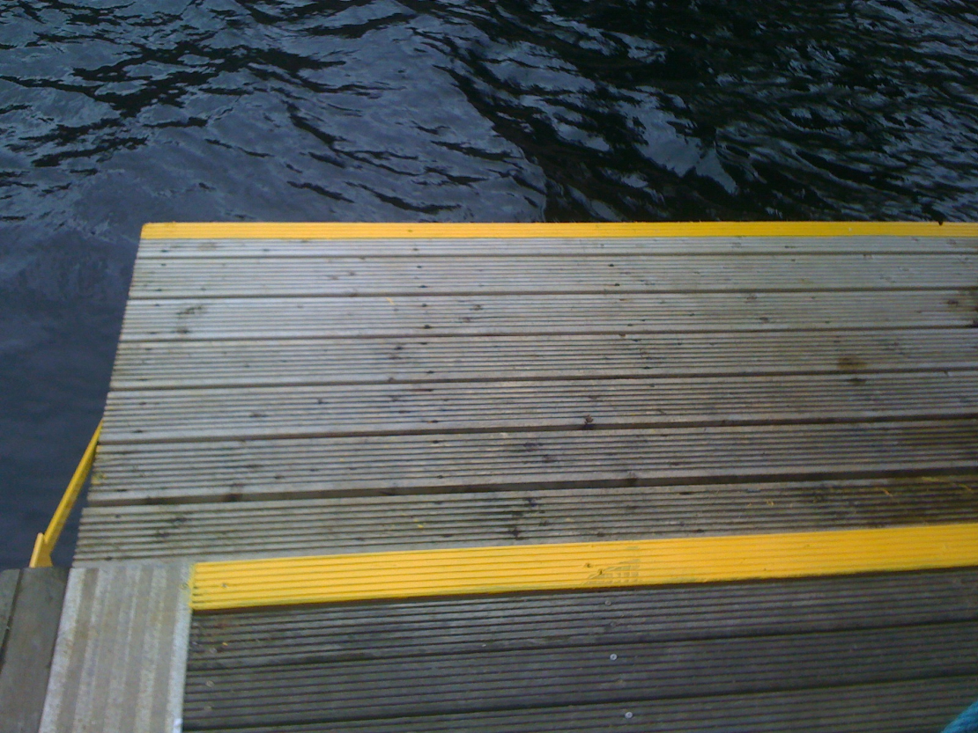
Action point from club:
a) Notification of paddling at the slipway – needs to be on calendar so the office can check via the website. There had been incidents of members of the public trying to launch kayaks from the slipway, clearly nothing to do with LCC, no BA`s etc.
b) Need to keep all pontoons clear of boats to allow access for boat owners. Please clear the pontoons as soon as possible.
Billy then gave a tour of work done to facilitate the Canoe Club.
1/ Our pontoon had a metal frame made and is now bolted to main pontoon so it does not move. Damaged decking repaired and yellow warning paint added to indicate trip hazards. Pump out boat and old pontoon moved to allow clear access.
2/ Two flood lights turned around to illuminate the kayak racks and access point. Will greatly help during dark evenings.
3/ Trailers and van moved from kayak storage area to allow easy access lift canoes and kayaks from racks. Wayfarer and kayak trailers moved to facilitate this. There is now a large camper van parked on left but this will greatly aid security and they are very friendly. (own the boat on the end and look after the Glacier)
4/ £4000 of automated gate opening devices ordered and to be fitted on the gates onto the pontoons. Will be fitted over the summer to allow for easy access with boats etc.
28/3/11 Marina Festival Week
Conscientious was not to order a tent but to try to borrow Bala Party tent – Alison Bell asked Bala committee and they agreed to lend it to us for the bank holiday weekend.
Pete Thomas redrew and improved the club logo and designed the main banner. These have now arrived and one has been placed on the railings next to our boat racks so it is visible from the bridge in front of Merseysport. (4th April 2011). Club stickers have been ordered and now placed on all club paddles and boats. (8th April 2011).
26/3/11 Polo goals constructed by working party at the Docks
Sam Godsell is arranging for the scaffold tubes etc to be delivered to the docks on Friday 25th March Hopefully John Pegram will have the rest of the
steel soon for the goal frames and we can get them Welded at Karl Young’s House (John Youngs brother).
Team built and position the goals in the dock on the Saturday.
John Pegram, Theo G, Chris F, Keith S, Dave Collins, University team
24/3/11 Marina Festival Week
As part of Marina Festival week we have said we will have banners and a tent to give us presence at the dock. Please let me know any thoughts on the three items below.
1/ I have sourced banners – best seems to be an 8 foot by 2.5 foot banner at £35 each. I propose to get two
2/ Tent – best seems to be from Argos but am a little reluctant as not sure we will really get use out of it
<http://www.argos.co.uk/static/Product/partNumber/3400047/Trail/search...
eTENT.htm> more details on Handy Tent.Handy tent price £69.50
3/ I am also looking at getting club stickers made up to put on all our paddles and boats 8cm x 8cm on white water resistant vinyl. They will cost
about 50p each but we could sell them for £1.00
11/3/11 Pyranha Demo Evening confirmed
From: Matt Bostock [mailto:mattbost...@Pyranha.com]
Sent: 11 March 2011 10:58
To: 'Keith Steer'
Subject: RE: Pyranha Demo Day - Wednesday May 4th from 6:00pm until 8:30pm.
Hi Keith, Thanks for getting in touch.
May 4th sounds good for us, we'll probably bring 2 vans over and try to bring most of the range for you this year, I thinks its been a while since people saw the full set. Should people want specific boats please let me know at least a week in advance and ill get it sorted. In terms of gear we can help with paddles but not too much else im afraid.
Best regards Matt
6/3/11 Polo Pitch and permanent Goals
The plans for the goals look great. The aim would be to complete this project as soon as possible:

John P to forward A1 plans via word document
Sam G to order Scaffold tubes and joints (thanks to his work)
John P to get /order steel tube for goals
Keith to ask John Young (via brother who is a welder) or Dave Collins to weld steel into two goal frames.
Ian Bell to drop off netting for goals (or Keith to order two nets)
John P to devise clamp for goal frame (possibly use Scaffold bracket)

Joints and poles to be painted when constructed to protect joints.

Would be great to get main frame built one evening or weekend morning. KS to arrange a work party when scaffold stuff available.

02/03/11 Meeting with Dave Murray / Keith Steer at the Marina to discuss developments
a) Only negative point from 2010 season was people occasionally eating sandwiches in or near the restaurant and bar.
b) Discussion of the river festival week starting 29th April 2011. A possible program could be:

Fri 29 April Come and try it sessions for Public 10am and 2pm
Saturday 30 April Pyranha Demo Day (to be confirmed)
Sunday 1 May Come and try it sessions for Public 10am and 2pm
Monday 2 May Come and try it sessions for Public 10am and 2pm
Tuesday 3 May – Club Session 6:00pm
Wednesday 4 May – Dock paddle / tour 6.00pm
Thursday 5 May – Club Session 6:00pm and canoe polo match
Friday 6 May – beginner Course
Saturday 7 May BCU Lifeguard training event for NW (Venue to be confirmed – Liverpool or Salford)
Sunday 8 May BCU Lifeguard training event for NW (Venue to be confirmed – Liverpool or Salford)

To promote the Marina and Canoe Club
We would have a tent placed on / near the slipway with large 4m banner advertising the club with brochures etc over the weekends. All events would take place from the Marina – access ramp or Coburg Dock slipway.
c) Liverpool Canoe Club – Marina Wish List.
(We understand that some or all of these may not be possible)
1/ Swipe card gate to pontoons – ideally a motorised opening for 10 seconds or so as currently gate only opens 2/3rds and swings / slams closed on boats being carried through. If this is not possible then can the gate be made to open a little further as it is difficult to get kayaks through at present.

2/ Lights around our storage area – currently the lamp post above our kayak racks does not work. Can this be fixed or possibly a second movement sensitive flood light be linked into the one by the cooks door?

3/ Obstructions to kayak rack – Currently a trailer and parked white van make it very difficult to access canoes on the rack. Last year this area was left clear and it made it easier to lift boats on and off the racks.

4/ Pontoon access and our little pontoon – Problems last year with the pump out barge ripping out cleat and now ties ropes directly to bridge making launching for kayaks difficult. The current arrangement of pontoon under the bridge would be ideal if decking repaired and should alleviate access problems with white electrical box to West of ramp. Our little pontoon could then be tied across the end for launching kayaks. (see diagrams)
Our Lower Pontoon
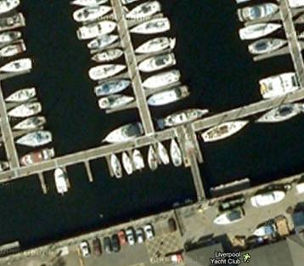
New pontoon needs repairing and keeping clear to allow access by canoeists
Pumpout barge
Ramp

5/ Polo Goals – We need an area to play canoe polo near to the Marina club. Ideally this needs to be away from moored yachts. The best place to have these is near the beach. The canoe club could build them and they would be free standing resting on the shallow bottom in line with the end of the slipway into Coburg dock. (see Diagram)

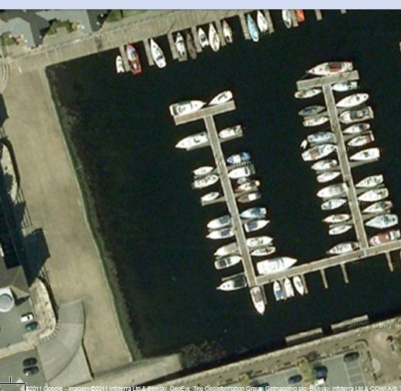
Design of polo Goal.

These will be of a tidy construction to fit in with surroundings, are movable and the red goal frames will be clearly visible.
Two polo goals1m square placed in 4 feet of water in line with end of launching ramp
Waterline

14/02/11
Interview with Local Radio Station 99.8 FM KCC Live
Pete Thomas was interviewed about the club and how to start paddling on Merseyside by 99.8FM KCC Live, a local radio station.You can hear the full interview by clicking here………. Pete Thomas,

  Mike Atkinson  Head of Sport |  | 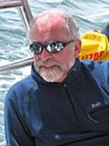  Peter Thomas  Liverpool Canoe Club

14/12/10
Club Range of Clothing with Club Logos.
Pete Thomas and Chris Murphy refined the design of the club logo over several weeks. Online shop ready for Christmas orders. Range can be seen at
http://liverpoolcanoeclub.co.uk/shop
Chris Murphy, Pete Thomas, Keith Steer
25/11/10
Club Range of Clothing with Club Logos.
Chris Murphy has arranged cost price on club clothing range through Apparelmaster
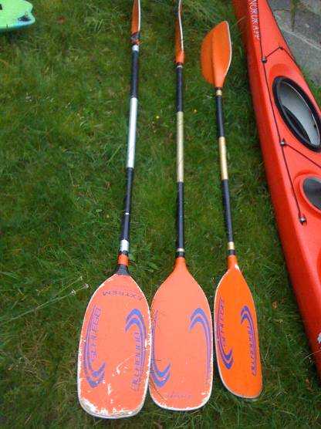
* First of all I can get the items at cost so the prices I gave you the other day are about right.
* The logo's are embroidered directly on to the garments themselves and are usually charged by the stitch. The prices will vary depending on the
colours chosen obviously with a complex design costing more. The logo can also be made up as a badge which itself is embroidered on to the garment. This
again would cost more and some of the badges we produce can cost up to £4 each to be added to a garment. I will bring some samples of badges down to
the pool on Thursday and will also hopefully have some examples of designs and prices to share on-line as well.
* The logo can be transferred on to the garments using a heat seal technique but they do not look as good as embroidered and can cause problems
with ironing at a later date.
* The are no limits to the amount of colours but again we need to think about the colour of the garments that will be embroidered when designing
a logo. (If this was a badge it would be less of an issue.)
* Good news on the the question of minimum runs etc. Once the badge is set up we would not have to commit to any minimum orders. I would place the
orders as they come in so we are not left with any unwanted stock. To help reduce the unwanted returns I will have samples that people could try on for
size before they ordered. If there was a need for a return because of sizing
issue, the club would have to bear that cost until an order was placed again for that particular item when we could recycle it.
* Members would place the order using PAY PAL and the club would be invoiced once a month.
* Orders would typically be fulfilled after 7 days but then the courier (me!) would get the garments to the Pool/ Marina asap.
* Lastly we could embroider/transfer the logo on to any kit that you want to source elsewhere and we would be invoiced accordingly. I think you
will be pleased with the quality of the garments but the range doesn't include everything out there, so if there is a need to go elsewhere for a
particular item this would not be a problem. Chris Murphy
30/9/10
Club short of paddles. After the move to the pool we do not have enough paddles to run intro course for October (Steve Bond) Three Schlegel paddles that were being sold privately for £40 each were sold to the club for £25 each. Funds were not currently available to purchase our chosen paddles – TNP Rapa which retail at £58 – £65 each. Coaching course fees would then pay for this purchase over the next 6 months.
Keith Steer, Steve Bond
2/9/10
AGM arrangements. Main lecture theatre booked for the meeting with Alaska presentation being the main event. This year it was thought to offer members some food. This would enhance the evening and keep some part of our agreement with the Marina club. Finger buffet ordered with Emma for 40 people – cost £80 KS

Meeting to be run by our elected officials. This year we need to confirm role(s) for key helpers. Motions from the membership as per constitution…….
Keith Steer, Mike Alter, Ian Bell, Steve Bond, Dave Reynolds, Dom Buckley, Brian Green
18/8/10
Purchase of Simon English`s Open Boat and Kirk Williams Capella / cost of hire of boats – wear and tear. This was discussed and agreed to leave these boats on the rack for general use as club boats and when sufficient funds in club accounts the boats would be purchased from Kirk and Simon.
Prospector open boat – Simon English £500
Capella Sea Kayak – Kirk Williams £400

Cost of day hire for sea kayaks and open canoes to go up to £10 per day used to reflect replacement costs of worn out boats.

Keith Steer, Mike Alter, Ian Bell, Steve Bond, Dave Reynolds, Simon English, Kirk Williams, Brian Green
14/7/10
Club notice boards for foyer of Marina bar and restaurant. Permission sought by KS with discussion with Dave Murray. This would give us an enhanced presence at the Marina – events, photos, newsletter etc could all be posted. Mike Bell to purchase wood and construct frames, Steve Thomas would order toughened glass if polycarbonate pieces he has at home not big enough.

Keith Steer, Ian Bell, Steve Bond, Dave Reynolds, Dave Murray, Mike Bell and Steven Thomas

17/6/10
Affiliation of other groups. This had been agreed in principle but it has been suggested that we trial an affiliate membership scheme to be approved at Octobers AGM.
The two affiliated groups who have expressed an interest are:
4th Allerton Sea Scouts – Dave Hope – Would store some of their kayaks on a trailer in our storage area to be used by both groups. They would use some of our canoes/ kayaks if they are not being used by our club members. (other Volunteers – Chris Franks, Martyn Hurley)
Wirral Guide and Scout Canoe Association – Ian Bell – Would make their trips / equipment available to members of LCC and LCC would reciprocate. (Other volunteers – Chris and Michele Turner)

Guidelines for affiliation:
- That the benefit to affiliation should be mutual.
- Affiliation would require at least one member of the organisation joining for the full adult rate and who would be the point of contact.
- Members of the affiliated organisation would use our facilities / boats / coaches (if available) so as not to restrict our members eg on an alternative night to a club night. The dates and times of sessions would be notified to the club via the googlegroups emails.
- The affiliated group would operate under their own guidelines and ratios and would always have their coach or leader in charge of any of their members while paddling.
Keith Steer, Martyn Hurley, Ian Bell, Steve Bond, Dave Hope, Dave Reynolds, Karl Leungs, Dominic Buckley
23/4/10
Floating pontoon to aid egress and entry at the docks. A working party was formed to design and construct the pontoon.
Ade Mould | Volunteered to make it - needs to be wider
Theo Gaussen | Off on Thursday - available to help
Keith Steer | Glue on lids (water tight)
Chris Franks | 25 litre containers.
Mike Thomas | I work for Joseph Parr Timber & Builders Merchants. Quote re wood
Mark Moore | Finishes work at 1400 next week willing to help
Darren Wilkinson | I have two lengths of timber decking - spare from last weeks DIY project. They are treated and stained dark and are both 2.4m in length.
Chris Fletcher | 20 litre containers - 20 to deliver free to docks
Steve Thomas | Design and build it in hard wood

22/4/10
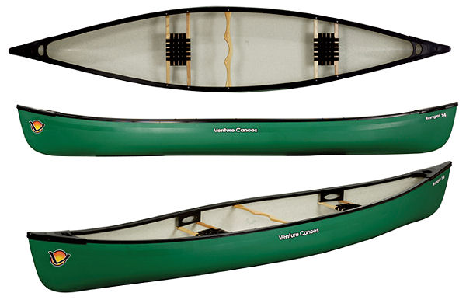
To support our coaching and appeal as a balanced club the need for several open boats to complement our fleet for club nights has been discussed and agreed. This would then complete the fleet of boats for this year as the intention is to have a small number of boats available for new members and to encourage members to purchase their own equipment as they progress. KS obtained a competitive quote for two ex demo boats from NW kayaks. A Symphony 16 and Ranger 16 (with air bags) for £1000. (4 paddles were also added to the deal with a little begging / friendly persuasion). Although we do not have funds to support this purchase currently; it is thought to be essential if the club is to move on. (BCU awards require experience in open or single bladed craft and it is vital that our members develop this experience) It was suggested that it could be financed by asking for unsecured loans from members of 4 x £250. The club would pay the kind individuals back when funds are raised later in the year (triathlon and pool fees in October). Keith Steer, Mike Alter, Steve Bond, Ian Bell, Dave Reynolds, Dom Buckley

19/4/10
Affiliated membership of LCC. Allerton Scout unit have suggested via Martyn Hurley that they keep their kayaks and paddles (and possibly trailer) with our boats. LCC would be able to use them and Allerton scouts could come down as a group (supervised by their leaders/ adults) and use our coaches / facilities during club nights or other times if they have suitable cover. At all times they would be operating under scouting guidelines and insurance. Keith Steer, Martyn Hurley, Ian Bell, Steve Bond

7/4/10
Monday night talks / meetings arranged for next year. KS booked dates with Emma / Hayleigh We decided to have meetings on a regular basis every second Monday of each Month. Keith Steer, Pete Thomas, Ian Bell, Dave Reynolds
7/4/10
Discussion about paddle and buoyancy aid storage – Advised to purchase a plastic shed. Permission sought from Dave Murray and Billy Coysh (Marina Manager). Agreed with Steve Bond, Brian Green, Ian Bell and Keith Steer. Approximate Cost £450
26/3/10
Meeting at the Marina to plan and design the canoe racks for 2010 season. Stephen Thomas, Keith Steer, Brian Green, Jim Slater, Dave Collins, Mark Garrod, Karl Young
12/3/10
Meeting with Brian Green, Keith Steer and Dave Murray (General Manager of Liverpool Marina)
Liverpool Canoe Club will make Liverpool Marina its permanent home. We will promote the Marina, Marina bar, restaurant and lecture rooms for all club events and encourage the use of the facilities by our members and their families / work colleagues.

To facilitate our paddling we were offered at no charge:

- Storage of our canoes – this will be in the area indicated during the meeting. We will move our trailer there and look at a storage box / solution for paddles and buoyancy aids etc. The area is for the storage of boats but must be kept tidy and not cause friction with local residents.
- Canoes will be carried down onto the pontoons for launching underneath the ramp. We will investigate a lower floating step to facilitate launching by our members.
- Members using the changing rooms, pontoons, secure area where the canoes are to be stored will apply for a swipe card. This membership will be available for £10 (Exact membership form, application process etc to be discussed with Tracey). We would hopefully incorporate it into current online membership system as soon as possible. The membership / swipe card would give members 10% discount in the bar and restaurant. Members will also receive a parking permit for the area in front of the Marina.
- A small notice board or area will be allocated in the main foyer area to promote the club and facilities at the Marina.
- We will continue to use the meeting rooms for courses and lectures and hope to promote major events (eg the Simon Willis premiere back in November) to bring in users.
- Liverpool Canoe Club will apply for its own British Waterways licence from Andrew Goudie and publish its own risk assessments and insurance documents.

18/2/10
Meeting with Keith Steer and Chris Gasgill (manager of Crosby Waterports Centre) to discuss the use of the watersports centre by LCC.
Liverpool Canoe Club have been invited to base ourselves at the water centre and could enjoy its state of the art facilities. This would comprise of the hire of containers (£ 250 to £500 per year) or our trailer could have a space in the boat park (£100 per year).The latest suggested fees for groups would be £50 per person per year but this would only be using club boats stored at the centre but they could be used at anytime subject to lake rules (Still to be confirmed). This would cost the club £500 for 10 people at a time on the water or £1000 for up to 20. Although the system is not yet clear, it is envisaged that LCC would hold a swipe card for each club boat and this would need to be presented every time a boat was used. The real sticking point seems to be if you wanted to use your own boat then you would need to be an individual member. This is available to anyone for £85 per year and you would then have free use of the lake at any time.

19/10/09 Agenda for AGM
8:00 to 8:30pm Slide show – The club trip to the Alps 2009
8:30 to 9:00pm AGM
1. Apologies for Absence.
2. Minutes of the previous AGM (Inaugural meeting on 18.06.09).
- Signed as a true record by the Chair
- Matters arising.
3. Treasurers report
4. Motion 1 – Change to membership fees.
Following item 5 from minutes on 18.6.09 the club needs to introduce a membership fee to ensure it only pays BCU affiliation (insurance) fee for paying members. It is proposed to have the following classification of memberships: Family £7.50, Full £5, Junior £2.50, Coach (L1 and above) Free, Associate (Web) Member Free.
Motion 2 - Revised Constitution. With an online payment scheme there is no need for a grace period and our constitution should be amended
5 Election of Officers.
Chair – Dominic Buckley (Proposed Keith S, 2nd Steve Bond), Secretary – Sean Burke (Proposed Keith S, 2nd Jim Slater) to take over on 17/12/09, Treasurer – Samuel Godsell (Proposed Jim Slater, 2nd Jonathan Strange). Establishment of “Discipline Representatives” to advise members / act as a point of contact (Sea, Opens, Coaching, Freestyle, Rivers, Polo)
6 Paddler of the Year Award. – Presented by the chair.
9:00 to 9:30pm Slide show – Turner Tours Ltd (Club Trip to Canada 2009)
9:30pm onwards – Socialise in the bar
17/9/10 Kingsway pool Session Slot – decided to try and take up this Thursday night Slot with the use of KCC boats.
Mike Wells, 'ian and alison bell; Griffiths, Rob; Griffiths, Rob; Jacobs, Darrell; Kelly, Jack; Stringfellow, Rob @ home; Tom Jefferies

15/9/10
Meeting with Mike Wells, Keith Steer, Debbie Byrne and Karen Jones to discuss use of the Kingsway leisure centre. Risk assessments, insurance and general operating procedures.

11/9/10
Discussion re: taking over Kingsway Kayak Clubs assets if they were to terminate. John Cooke, Keith Steer, Dave Reynolds, Gareth Fields

18/6/09
Committee Meeting held at Toby Carvery on Aigburth Road.
1/ Club to Affiliate to BCU
2/ LCC Constitution Agreed
3/ Key principles of membership agreed.
4/ Move to a Full member category agreed
Martin Hurley, John Young, Brian Green, Kirk Williams, Dinny Davies, Mark Benson, Yung Leungsangnam, Carole Thomas, Pete Thomas,
Sara Bergqvist, Steve Bond, Jim Slater
22/4/09
Need for a Pool Venue discussed with Ian Bell, Kirk Williams, Keith Steer, Dave Reynolds and Martyn Hurley. A number of local pools contacted but the best option was I.M.Marsh pool. A booking for Thursday nights was confirmed with Averil Mooney
23/10/08
Meeting at the West Cheshire Sailing Club on Sunday 26th October 2008 to form a new canoe and kayak club which would always put its members first. This club would be called Liverpool Canoe Club. Ian Bell, Steve Bond, Mike Alter, Keith Steer, Alison Bell, Brian Green

